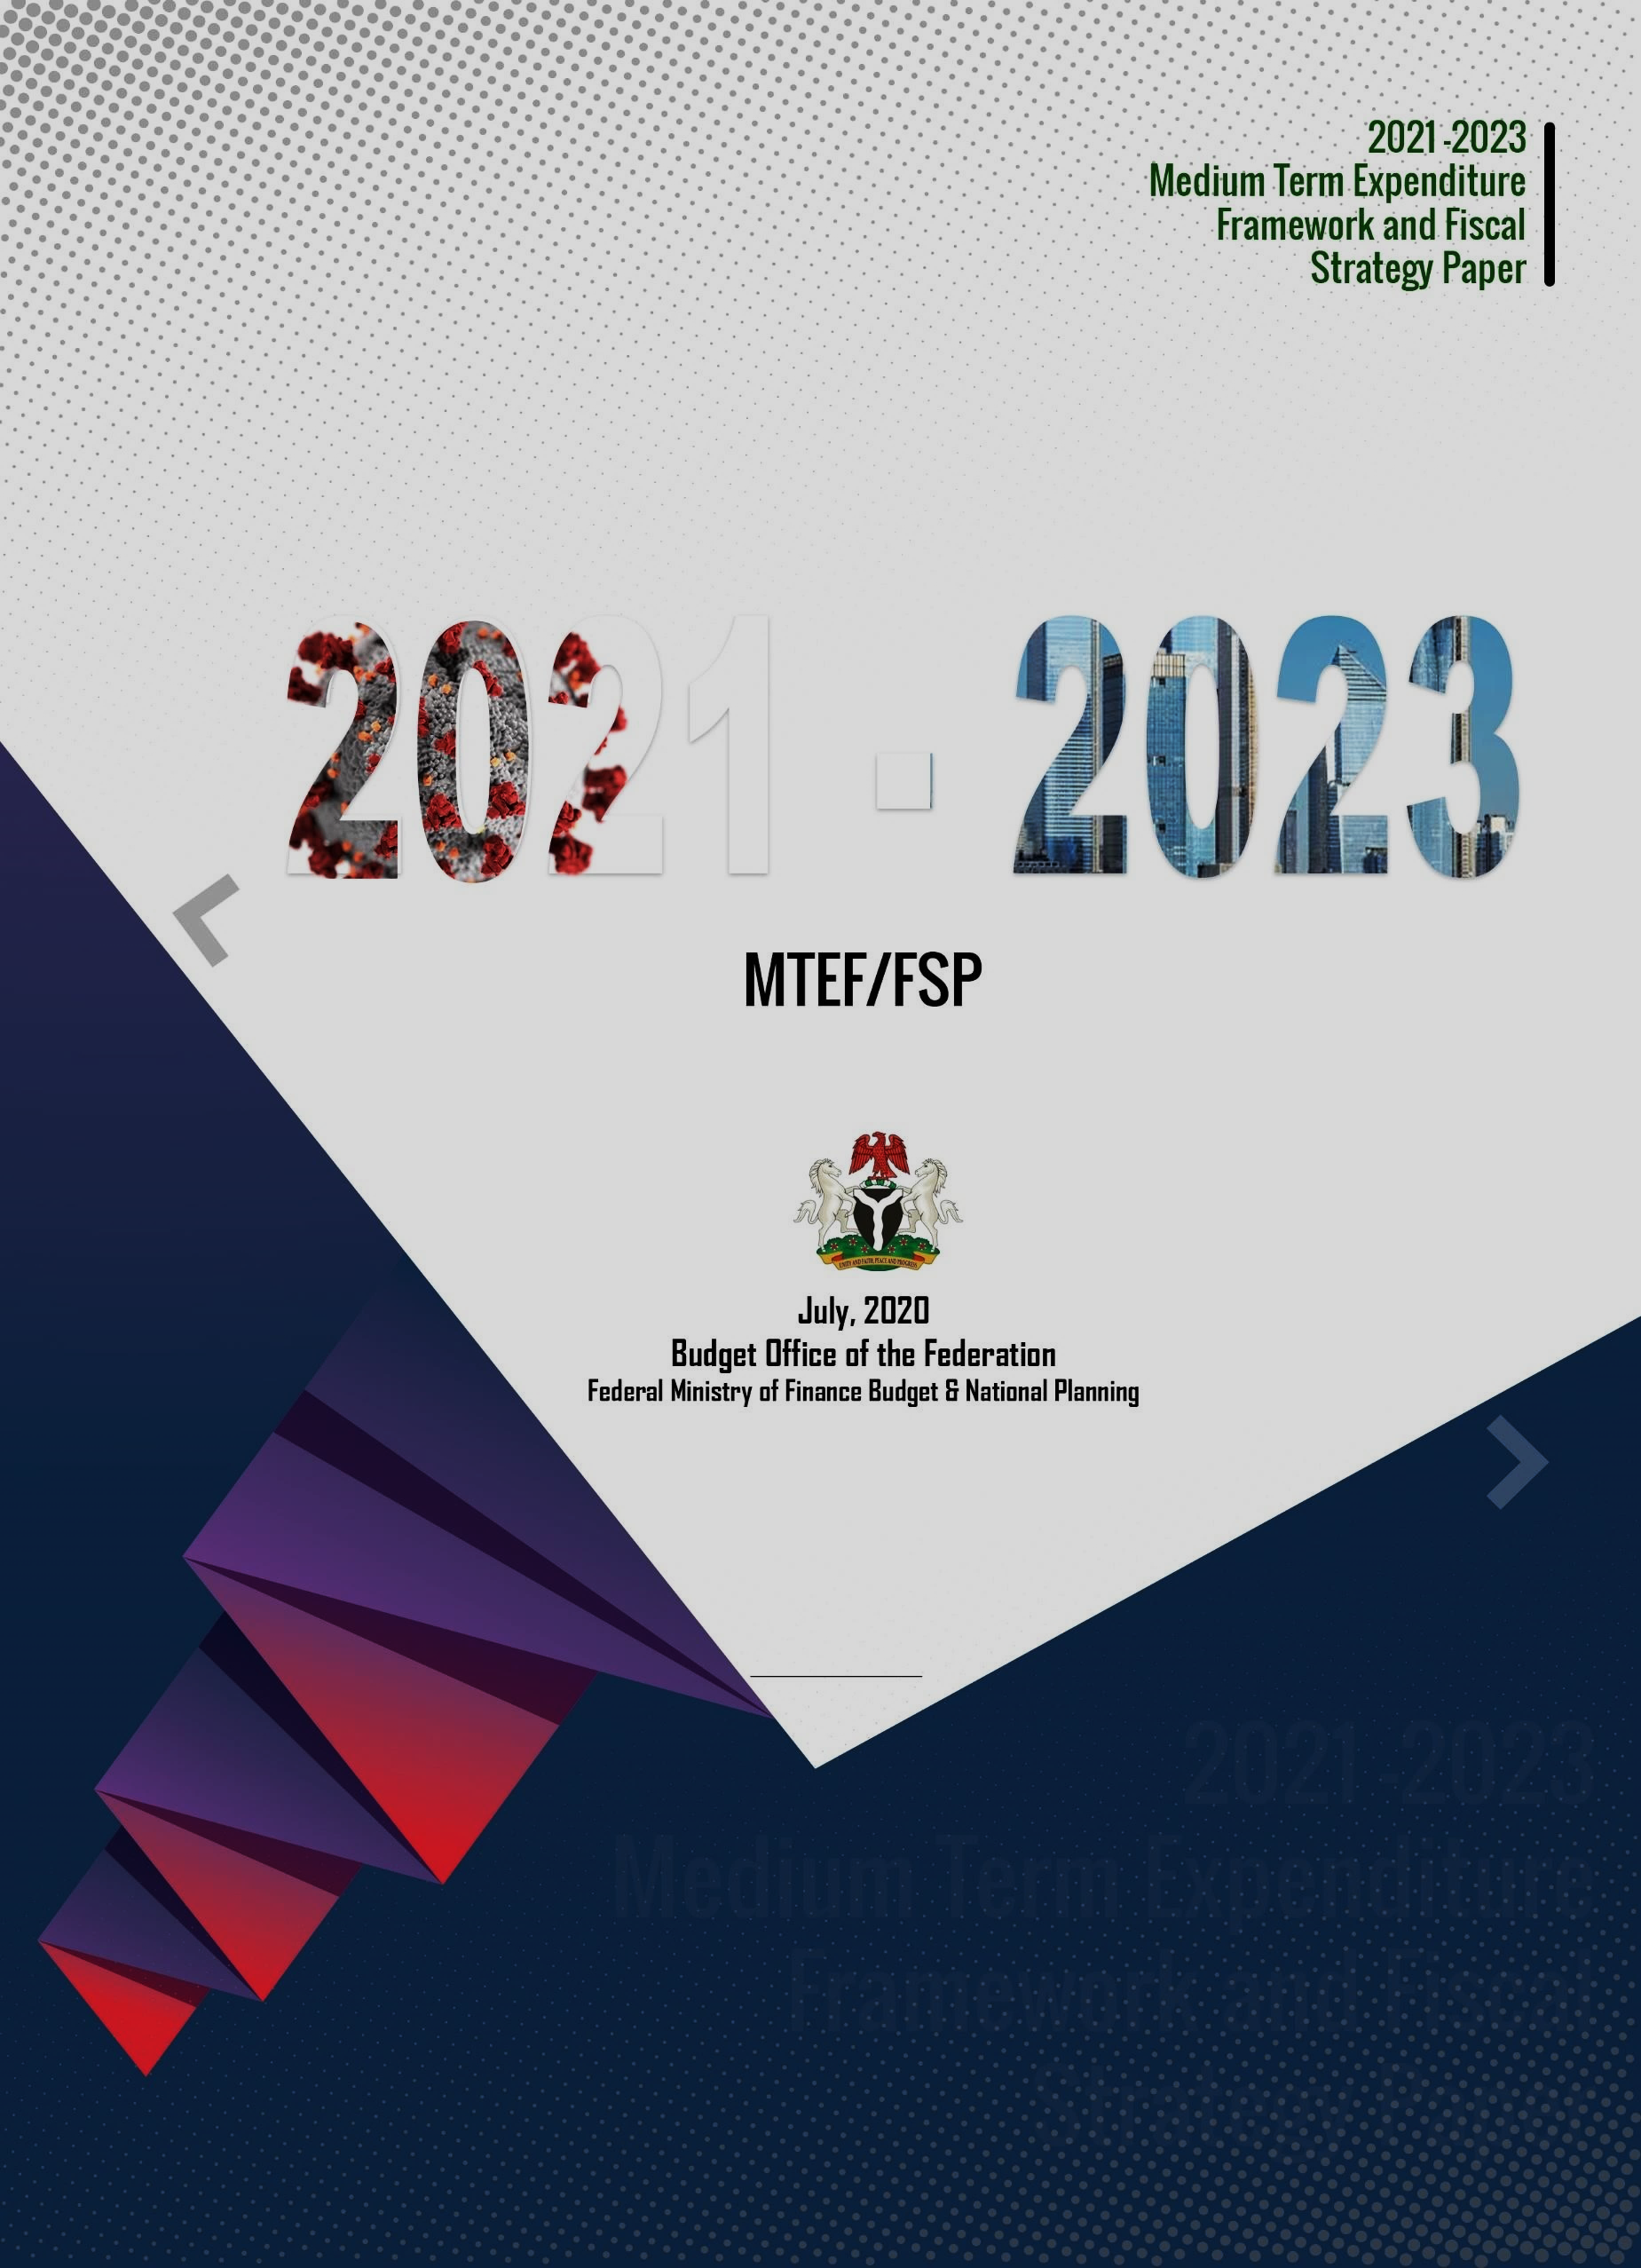

**Table of Contents**

1. Introduction 1

2.0 Economic and Fiscal Outlook 1

2.1 Global Economic Developments and Implications 1

2.2 Macroeconomic Performance of the Nigerian Economy 2

2.2.1 Real Sector 3

(a) GDP growth and Sectoral Performance 3

(b) Unemployment and Underemployment 4

2.2.2 Monetary Sector 4

(a) Inflation 4

(b) Interest Rate 4

2.2.3 Fiscal Sector 5

2.2.4 External Sector 6

(a) Trade 6

(b) External Reserves and Capital Flows 6

2.2.5 Tax Expenditure Statement 7

3.0 Review of 2019 Budget Performance 7

3.1 Revenue Outturns 8

3.1.1 Oil Revenue 8

3.1.2 Non-Oil Revenue 8

3.1.3 Main Federation Account Pool and VAT Pool Accounts Distributable 8

3.1.4 FGN Revenue 9

3.2 Expenditure Outturns 9

4.0 Review of 2020 Budget Implementation 10

4.1 Revenue Outturns 10

4.1.1 Oil Revenue 10

4.1.2 Federation and VAT Pool Accounts Distributable 10

4.1.3 FGN Revenue 11

4.2 Expenditure Outturns 11

5.0 Assumptions Underlying Oil and Non-oil Revenue Projections In 2021 - 2023 12

5.1 Assumptions Underlying Oil Revenues 12

5.1.1 Crude Oil Production and Export 12

5.1.2 Global Crude Oil Supply and Demand 12

5.1.3 Crude Oil Price Benchmark 13

5.2 Non-Oil Revenue Baseline Assumptions 14

Customs Collections: Import Duties, Excise, Fees and Special Levies 14

Companies Income Tax (CIT) 14

Value Added Tax (VAT) 15

FGN Independent Revenue 15

6.0 Medium term Macroeconomic framework: parameters and targets for 2021-2023 15

6.1 Macroeconomic Projections 15

6.2 2020-2022 Medium Term Fiscal Framework (MTFF) 16

**6.2.1** **Federation Account Revenues** 16

6.2.1 Revenue Framework 17

6.2.2 FGN Expenditure Framework 18

6.2.3 Aggregate Expenditure 18

6.2.4 Fiscal Deficit and Deficit Financing 19

7.0 Medium Term Objectives, Policies and Strategies 20

7.1 Macroeconomic Policy Objectives 20

7.1.1 Sustaining Economic Growth and Ensuring Inclusiveness 20

7.1.2 Supporting Employment Creation and Preserving Jobs 22

7.1.3 Ensuring Macroeconomic Stability 22

7.2 Fiscal Policy Objectives and Strategies 23

7.2.1 Optimizing Government Revenue 23

7.2.2 Creating Fiscal Space for Infrastructural Development 26

7.2.3 Enhancing Fiscal Prudence and Transparency 27

7.2.4 Ensuring Sustainable Deficit and Debt Levels 28

7.3 Monetary Policy Objectives and Strategy 28

7.3.1 Monetary Policy Objectives 28

7.3.2 Monetary Policy Stance 29

7.3.3 Challenges to Monetary Policy and Outlook for the economy 31

7.4 Key Sectoral Policy Initiatives 31

7.4.1 Extensive Public Works and Road Construction Programme 31

7.4.2 Support for Micro, Small & Medium Enterprises 32

7.4.3 Energy Sector Policy Initiatives 32

7.4.4 Mass Agricultural Programme 32

7.4.5 Strengthening the Social Safety Net 32

7.4.6 Digital Technology 33

8.0 Analysis & Statement on Consolidated Debt & Contingent Liabilities 33

8.1 Nigeria’s Current Debt Profile 33

8.1.1 Debt Stock 33

8.1.2 Debt Service Payments 34

8.2 Debt Management Strategy 34

8.3 Nature and Fiscal Implications of Contingent Liabilities 35

9.0 Risks to the MEDIUM-TERM Outlook 37

9.1 Global Economic Trends & Geo-Political Tensions 38

9.2 International Oil Market Developments 38

9.2.1 Oil Prices 38

9.2.2 Oil Demand & Supply Risks 39

9.3 Exchange Rate Risks 39

9.4 Risks to Non-Oil Revenue 39

9.5 Sensitivity of Budget aggregates to Macro-economic conditions 40

10. CONCLUSION 43

ANNEXURE 1: 2021 - 2023 Medium Term Fiscal Framework 45

ANNEXURE 2: Tax Expenditures Statement Policy Overview 2019 50

The economic and fiscal estimates presented in the 2021-23 MTEF/FSP incorporate assumptions, narratives and judgments based on information available at the time of

preparation. These estimates are subject to uncertainty. This MTEF/FSP provides details of

the historical performance of Budget forecasts for the macroeconomic aggregates of real and

nominal GDP, as well as for estimates of government revenues & expenditure. The Fiscal

Strategy Paper also presents a number of economic forecasts / projections and key underlying assumptions as well as Government’s medium-term outlook.

This document is available at – [www.budgetoffice.gov,ng](http://www.budgetoffice.gov,ng/)

**LIST OF TABLES**

2.1 Global Economic Growth (%) 2

3.1 Performance of Selected Indicators and Key Parameters, 2019 7

3.2 Oil & Non-Oil Revenue Profile FY 2019 8

3.3 Federation Account Revenue and VAT Distributable FY 2019 8

3.4 FGN Revenue Profile FY 2019 (N’Billion) 9

3.5 FGN Expenditure Outturn FY 2019 (N’Billion) 9

4.1 Revenue Performance (Jan- May) 2020 10

4.2 Federation Account Revenue and VAT Distributable, 2020 10

4.3 FGN Revenue Profile (Jan-May) 2020 11

4.4 FGN Expenditure Performance (Jan-May) 2020 11

6.1 Key Parameters & Macroeconomic Projections (2021 - 2023) 15

6.2 Federation Account and VAT Revenues (2021 - 2023) 17

6.3 Overview of the Revenue Framework 17

6.4 Overview of the Expenditure Framework 19 6.5 Deficit, Financing and Critical Ratios 20

7.1 Selected Macro Indicators 30

8.1 FGN Contingent Liabilities (2018 - 2023) 36

9.1 Risks Likelihood, Impact and Mitigation Strategies 41

**LIST OF FIGURES**

2.1 Real GDP Growth Rates 2014Q1 – 2020Q1 3

2.2 Sectoral Quarterly GDP Growth Rates 2014Q1 – 2020Q1 3

2.3 Unemployment and underemployment Rate 2010 – 2018 4

2.4 Inflation Rate 2014 – May 2020 4 2.5 Exchange Rate 2015 – May 2020 5

2.6 Money Market Rate 2015 – May 2020 5 2.7 Foreign Trade (Q1 2008 – Q1 2020) 6

2.8 External Reserves (June 2016 - May 2020) 6

5.1 Crude Oil Production and Export in Nigeria 12

5.2 Medium-Term Oil Demand Outlook 13 5.3 Medium-Term Oil Supply Outlook 13

5.4 Unplanned OPEC Crude Oil Supply Disruptions (mbpd) 13

5.5 Bonny Light Crude Oil Price (Moving averages versus benchmark price) 13 8.1 Trend in Nigeria’s Total Public Debt (2014 – 2020) 34

8.2 Debt Service Payments (2014 – 2020) 34

###### **LIST OF ACRONYMS**

|  |  |
| --- | --- |
| **ACRONYM** | **DESCRIPTION** |
| AfDB | African Development Bank |
| AfCTA | Africa Continental Free Trade Agreement |
| ADF | African Development Fund |
| ADR | Average Duty Rate |
| AKK | Ajaokuta-Kaduna-Kano |
| BHCPF | Basic Healthcare Provision Fund |
| BOF | Budget Office of the Federation |
| BOI | Bank of Industry |
| BOT | Balance of Trade |
| BPE | Bureau for Public Enterprises |
| CBN | Central Bank of Nigeria |
| CET | Common External Tariff |
| CIF | Cost, Insurance and Freight |
| CIT | Companies Income Tax |
| CPIA | Country Policy and Institutional Assessment |
| CRF | Consolidated Revenue Fund |
| CRR | Cash Reserve Ratio |
| DISCOs | Distribution Companies |
| DMO | Debt Management Office |
| DSA | Debt Sustainability Analysis |
| ECA | Excess Crude Account |
| ELTS | ECOWAS Trade Liberalisation Scheme |
| ERGP | Economic and Recovery Growth Plan |
| EU | European Union |
| FAAC | Federation Account Allocation Committee |
| FCDA | Federal Capital Development Authority |
| FCT | Federal Capital Territory |

|  |  |
| --- | --- |
| FDI | Foreign Direct Investment |
| FG | Federal Government |
| FGN | Federal Government of Nigeria |
| FMBN | Federal Mortgage Bank of Nigeria |
| FMFBNP | Federal Ministry of Finance, Budget and National Planning |
| FRA | Fiscal Responsibility Act |
| FSP | Fiscal Strategy Paper |
| FX | Foreign Exchange |
| FY | Financial Year |
| GAVI | Global Alliance for Vaccines |
| GDP | Gross Domestic Product |
| GENCOs | Electricity Generation Company |
| GOEs | Government Owned Enterprises |
| IAT | Import Adjustment Tax |
| ICT | Information and Communication Technology |
| IDA | International Development Association |
| IEA | International Energy Agency |
| IGR | Internally Generated Revenues |
| IMF | International Monetary Fund |
| IPPIS | Integrated Personnel and Payroll Information System |
| JV | Joint Venture |
| MBPD | Million Barrels Per Day |
| MDAs | Ministries, Departments and Agencies |
| MPC | Monetary Policy Committee |
| MSMEs | Micro, Small and Medium Enterprises |
| MTFF | Medium-Term Fiscal Framework |
| MTEF | Medium-Term Expenditure Framework |
| NASS | National Assembly |
| NBET | Nigerian Bulk Electricity Trading |
| NCS | Nigeria Customs Service |
| NEXIM | Nigerian Export-Import Bank |
| NIRP | Nigeria Industrial Revolution Plan |
| NNPC | Nigerian National Petroleum Corporation |
| OAGF | Office of the Accountant General of the Federation |
| OECD | Organisation for Economic Cooperation and Development |
| OPEC | Organisation of Petroleum Exporting Countries |
| PBC | Peoples Bank of China |
| PCOA | Put-Call Option Agreement |
| PIGB | Petroleum Industry Governance Bill |
| PMS | Premium Motor Spirit |
| PPP | Public Private Partnership |
| PPT | Petroleum Profit Tax |
| PRG | Partial Risk Guarantees |
| PSRP | Power Sector Recovery Program |
| SDG | Sustainable Development Goals |
| STEM | Science, Technology, Engineering and Math |
| SWV | Service Wide Votes |
| TES | Tax Expenditure Statement |
| TSA | Treasury Single Account |
| UK | United Kingdom |
| USD | United States Dollar |
| VAT | Value Added Tax |
| VOARS | Voluntary Offshore Assets Regularisation Scheme |
| WEO | World Economic Outlook |

# 1. INTRODUCTION

Planning and Budgeting are rigorous scientific processes of government in resource allocation in a prioritized manner that ensures funds reach where they are required most. Budget is a tool that government employs to drive economic policies aimed at uplifting underprivileged sections of the society, facilitating financial inclusion, mitigating disparity within and among various geographical areas in providing proper educational and health facilities. This underscores the utmost importance government attaches to the preparation, implementation and monitoring of a well-planned budget. The Medium-Term Expenditure Framework and Fiscal Strategy Paper (MTEF/FSP) provides estimates and projections that guide annual budget planning and fiscal management over a three-year period.

Apart from the general provisions in the 1999 Constitution of the FRN as Amended, the Sokoto State Fiscal Responsibility Law (2007) is the main legal instrument driving the development of the Medium-Term Fiscal Framework as well as the Annual Budget. This law was domesticated after the Federal Government enacted the Fiscal Responsibility Act (FRA) 2007 with the aim of promoting fiscal transparency and accountability. Preparation of Sokoto’s annual budget is thus guided by provisions of the Sokoto State Fiscal Responsibility Law (2007). Specifically, Parts II-V of the Law stipulates the processes for preparing the Medium-Term Expenditure Framework (MTEF), the Annual Budget, Budgets of Corporations and Related Agencies as well as Budget Executions and Achievement of Targets. The MTEF/FSP highlights revenue projections, expenditure plans and fiscal targets over the medium term based on a reliable and consistent fiscal outlook.

. The design of the 2020-2023 MTEF/FSP is coming at a time of complex severe health and economic crises inflicted by the COVID-19 pandemic. Though global in effect, the macroeconomic evolutions have significantly impacted the Nigerian/Sokoto state economy. The Administration recognizes that a strengthened implementation framework is required to achieve the objectives of this medium-term plan. Government has instituted improved intersectoral linkages; strengthened partnerships; and reinvigorated governance and inclusive stakeholder relations. This is to strengthen implementation processes and ensure that the plan delivers on its promise.

This MTEF/FSP is not simply an internally drafted blueprint, but rather a framework that has been informed by a process of broad-based dialogue with stakeholders. It is meant to minimize the adverse impacts of the COVID-19 pandemic and other crises, accommodate changing realities, propel the economy on the path of accelerated growth as well as serve as a reference point for further dialogue and planning.

## 

## 2.0 ECONOMIC AND FISCAL OUTLOOK

### **2.1 Global Economic Developments and Implications**

The global economy practically came to a standstill as a result of COVID-19 pandemic, which has spread to over 200 countries and territories, with negative implications for global growth. Every country has witnessed reduced economic activities in the first half of 2020 owing to global supply chain collapse and depressed demand. The economic crisis, the worst since the Great Depression has been exacerbated by collapse in commodity prices across the world.

Extreme uncertainties still exist around the global growth trajectory. A combination of factors has increased the unpredictability of economic output across the globe. The intensity and efficacy of containment efforts in territories, the extent of supply disruptions and productivity losses, the repercussions of the dramatic tightening in global financial market conditions, shifts in spending patterns and behavioural changes have raised world output volatility. The progress in finding a vaccine and/or therapies will significantly define the path of recovery.

The International Monetary Fund (IMF) hinted that the global economy is already in recession, with lockdowns in most countries. COVID19 has severely impacted the global economy. Except for China, whose econoic growth is expected to taper to 1%, all major economies are projected to slide into recession in 2020. Global economic growth is projected to decline from 2.9% recorded in 2019 to a negative 4.9 % in 2020. Growth in the United States will recede to -8.0%, while emerging and developing economies will decline to -3.0% in 2020. Emerging and frontier economies have seen a reversal of growth trajectories. Growth in Sub Sahara Africa (SSA) has been further reviewed to fall sharply to -3.2%. Propitiously, the IMF forecasts a rapid rebound of the global economy in 2021. World output growth is projected to accelerate by 5.4%, Emerging Market & Developing Economies (EMDEs) are projected to rebound to growth at 5.9%.

Countries are implementing several stimulus packages to mitigate the impact of the crisis on the welfare of their citizens. EMDEs’ capacity to activate and sustain economic stimulus packages is however constrained. Poor government revenue performances are also compounding debt problems.

### **2.2 Macroeconomic Performance of the Nigerian Economy**

The Nigerian economy has grappled with acceleration in real GDP growth since the exit from recession in Q2 2017. In spite of twelve consecutive quarters of positive growth, GDP growth rates remained below desirable targets (growing below population growth rate).

The NBS projects that the Nigerian economy will contract by - 4.2% in 2020, as the COVID-19 pandemic and resultant oil price shock have exacerbated the vulnerability of Nigeria’s fiscal and monetary landscape. Prior to the outbreak of the pandemic, the Nigerian economy had been characterised by wavering external sector and improving internal economic indicators. Over-dependence on oil revenue, constrained fiscal space, low foreign and domestic investments, declining foreign reserves made the economy disproportionately vulnerable to the twin shocks of oil price collapse and a health crisis. The informal sector, which accounts for over half of Nigeria’s GDP will be severely negatively impacted.

#### 2.2.1 Real Sector

##### *(a) GDP growth and Sectoral Performance*

Figure 2.1: Real GDP Growth Rates Q1 2014 – Q1 2020

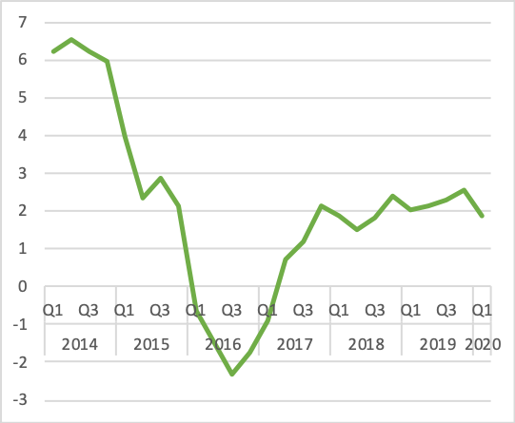Gross Domestic Product (GDP) grew by 1.87% (year-on-year) in real terms in Q1 2020. Growth in the non-oil sector was driven mainly by Telecommunications, Financial Institutions, Crop Production, Mining and Quarrying and Construction subsectors. Nevertheless, the performance recorded in Q1 2020 represents a drop of 0.23% compared to 2.10% growth in Q1 2019, and 0.68% decline from 2.55% growth in Q4 2019, reflecting the earliest effects of disruption caused by COVID-19 pandemic and crash in oil price.

Figure 2.2: Sectoral Quarterly GDP Growth Rates, (2014 Q1 - 2020 Q1)

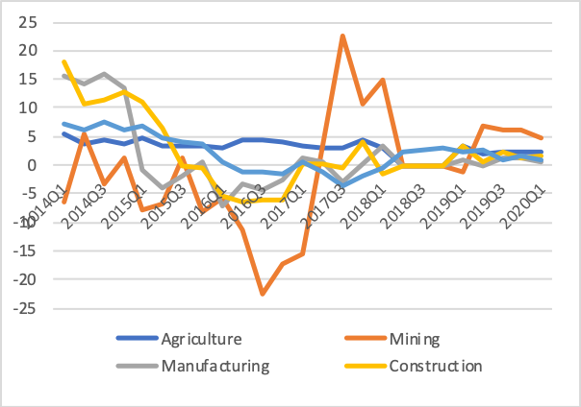 Sectoral GDP growth saw a contraction in key contributors to the GDP. Trade contracted by 2.82%, while Information Communication Technology slowed to a growth of only 7.65% from 11.08% 2019 full year growth. As a whole, the non-oil sector grew by 1.55% in real terms during Q1 2020, a decline by -0.93% compared to 2.47% recorded in Q1 2019. Economic sectors that recorded weaker performance relative to Q1 2019 include Quarrying, Road

transport, Accommodation and Food Services as well as real estate. The oil sector grew by 5.06%, showing a decline from 6.36 percent recorded in Q4 2019.

##### *(b) Unemployment and Underemployment*

Figure 2.3: Unemployment & Underemployment Rate (Q1 2014 –Q3 2018)

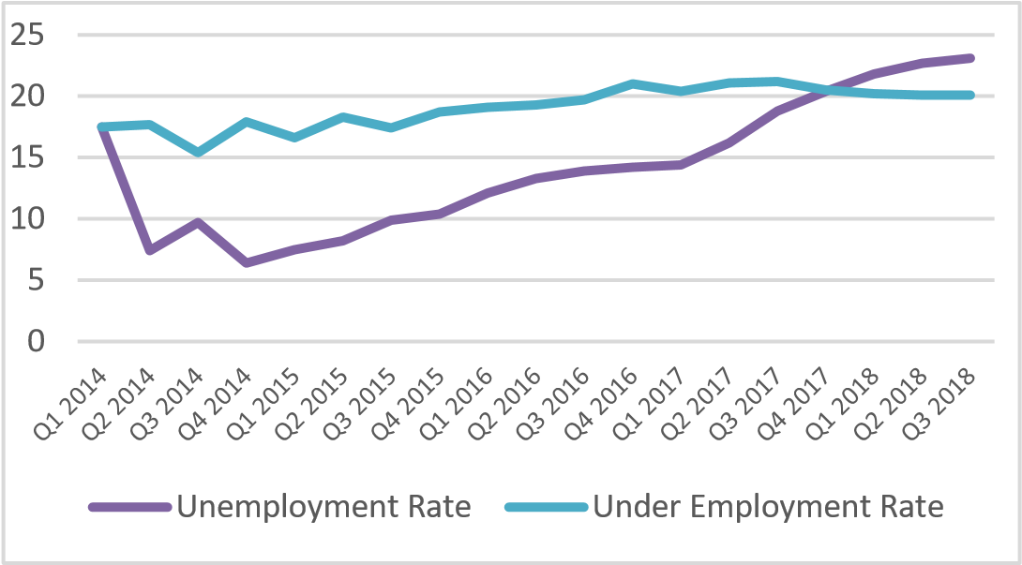 Unemployment rate was 23.1 percent (or 20.9m people) as at Q3

2018 while underemployment was 30.1%. The rise in youth unemployment, has fueled the rising spate of criminal activities and antisocial behaviour. Government is currently implementing various schemes tailored to productively engage the teeming youth population.

#### 2.2.2 Monetary Sector

##### *(a) Inflation*

Figure 2.4: Inflation Rate (Jan 2014 – May 2020)

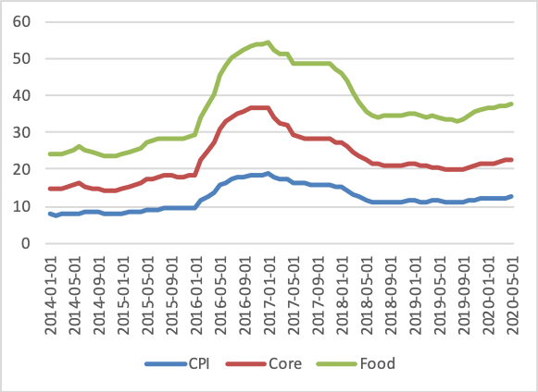 Consumer Price Index (CPI), which measures inflation, increased by 12.40% (year-onyear) in May 2020 rising for the ninth consecutive month, and represents the highest rate recorded since May 2018. This is 0.06% higher than the 12.34% recorded in April 2020 owing largely to the increase in the cost of food.

The composite food index rose by 15.04% in May 2020 compared to 15.03% in April

2020. The rise in the food index is exacerbated as clashes between herders and farmers worsen insecurity in addition to the disruption in inter-state travels owing to the coronavirus pandemic.

##### *(b) Interest Rate*

The Central Bank of Nigeria (CBN) has adopted measures to rein in inflation and reduce pressure on the Naira in the foreign exchange market. The Monetary Policy Committee (MPC) recently reduced the monetary policy rate by 100 basis points to 12.5%, the first rate cut since March of 2019. The decision was aimed at alleviating the economic impact of the coronavirus pandemic and collapsing oil prices.

The lower rate is expected to stimulate credit expansion to critical economic sectors to support employment. The Bank however kept the Cash Reserve Ratio (CRR), Liquidity ratio, and asymmetric corridor unchanged.

*Figure 2.5: Exchange Rate (USD/NGN) Figure 2.6: Money Market Rate*

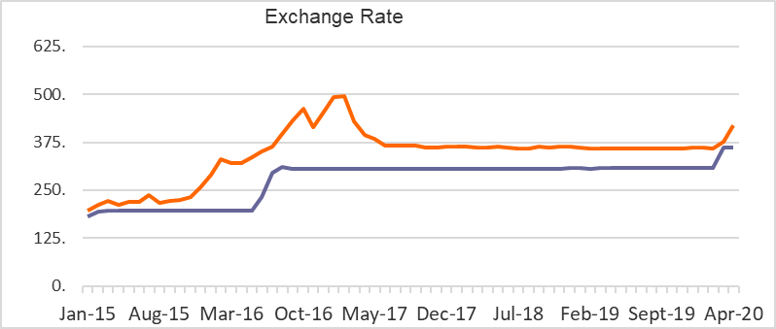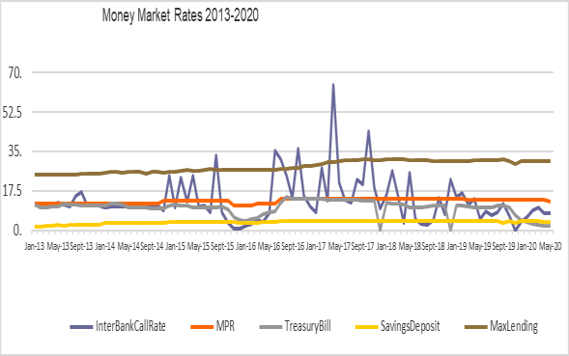

#### 2.2.3 Fiscal Sector

Fiscal buffers are currently very lean. The recent cut in oil production by OPEC and its allies to stabilize the world oil market has further squeezed projected net government revenues from the oil and gas sector, with consequences for foreign exchange inflows into the economy. External debt balance at end of Q1 2020 stood at USD 27.67 billion and Excess Crude Account (ECA) barely USD71 million. With the Balance of Trade (BOT) at UDS18.7 billion and widening fiscal deficit on account of lower oil revenue, the fiscal space is critically constrained.

Fiscal measures are being instituted to improve government revenues and entrench a regime of prudence with emphasis on achieving value for money. Some of the reforms contained in the Finance Act 2019, including the increase in VAT rate to 7.5%, are being implemented to shore up government revenues. The goal of fiscal interventions is to keep the economy active through carefully calibrated regulatory measures designed to boost domestic value-addition, de-risk the enterprise environment, attract external investment and sources of funding while managing existing debt obligations in the most fiscally sustainable manner.

Government is seizing the opportunity of the crisis to intensify economic diversification to ensure growth in non-oil exports, reduction in the import bill and improve economic competitiveness. Nigeria is currently implementing a modest stimulus package and providing palliatives for the most vulnerable members of the society. Fiscal support is also being provided to sub-national Governments and selected business sectors negatively impacted by the COVID-19 pandemic.

#### 2.2.4 External Sector

##### *(a) Trade*

Figure 2.7: Foreign Trade (NGN’ Billion) (Q1 2008 – Q2 2020)

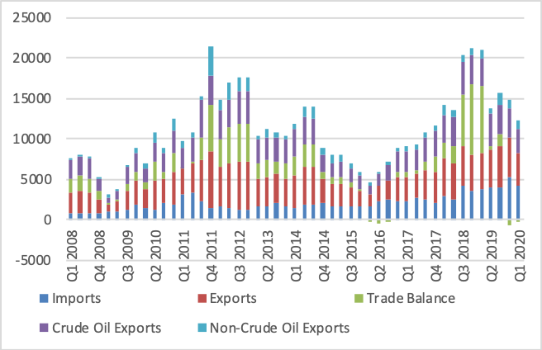Foreign trade in Q1 2020 was estimated at N8.3 trillion. The value of exports reduced to N4.08 trillion from N4.77 trillion recorded in Q4 2019, while import stood at N4.22 trillion in Q1

2020 when compared to

N5.35 trillion recorded in Q4 2019, indicating a 21.08% decline.

Trade balance maintained the negative trend standing at -N138.99 billion, from N579.06 billion in Q4 2019. The downturn recorded in the value of balance-of-trade could be attributed to the decline recorded in the value of both crude oil exports and non-crude oil exports. In Q1 2020 Crude oil exports stood at N2.944 trillion while non-crude oil exports recorded was N1.14 trillion.

##### *(b) External Reserves and Capital Flows*

Figure 2.8: External Reserves (USD Billion) (Jan 2015 – May 2020)

Accretion to foreign reserves is slowing down, with the total declining to US$36.38 billion in

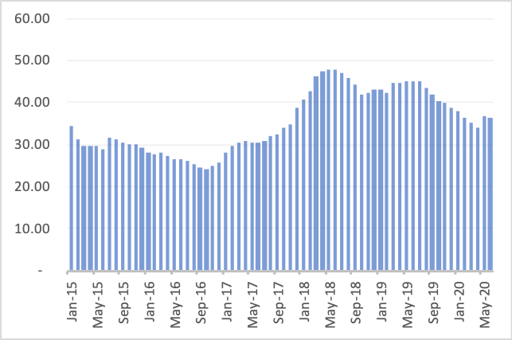June 2020 from US$44.7 billion in April 2019, an 18.6% drop. COVID-19 compounded the steady decline in external reserves which is largely attributable to low foreign investment flows and the impact of the decline in the international oil price on crude oil receipts. The moderate recovery in crude oil prices in

May 2020, and the disbursement of IMF’s

US$3.4 billion rapid financing instrument momentarily eased the pressure on external reserves.

Monetary policy rates have been relatively high and stable with the goals of checking capital outflows to slow down external reserves erosion.

The uncertainty and general decline in global economic activities caused by the COVID-19 pandemic have inspired a flight to safety, and further dimmed the prospect of reversing the downward trend in foreign portfolio investments (FPIs) in the Nigerian Treasury Bills (NTBs), a major source of dollar inflow into the country.

#### 2.2.5 Tax Expenditure Statement

Improving the tax administration framework to optimize government revenues has been a major thrust of the Administration’s Public Finance Management PFM) reforms. Government has taken the view that preparing a Tax Expenditure Statement (TES) will further entrench accountability and transparency in the management of the economy.

The purpose of the tax expenditure statement is to provide further transparency around policymotivated ‘expenditures’ made through the tax system. Government understates public expenditure when tax waivers/concessions are excluded from expenditure estimates in the annual budget. The result is similar whether government chooses to spend directly on, or forego revenue from, certain individuals, groups, or activities. Government expenditures therefore can be explicit as in direct expenditure outlays on public health, education and infrastructures or implicit as in tax expenditures. Tax expenditures in Nigeria take the form of an exemption, allowance, preferential tax rate, deferral, or offset that reduces a tax obligation to achieve a specific policy objective.

The statement is not intended to be an evaluation of policy effectiveness or desirability. Estimating tax expenditures is expected to facilitate formulation of evidence-based policies. The Statement is also intended to create incentives for taxpayers to change their behaviour in ways consistent with economic policy direction. A fuller discussion of the objectives and modus of preparing the TES is attached as annexure 2 to this MTEF/FSP. A detailed TES including estimates of the tax expenditure will accompany the 2021 budget.

## 3.0 REVIEW OF 2019 BUDGET PERFORMANCE

The performance of the 2019 budget parameters shows that GDP growth and oil production fell below target, while inflation and oil price closed better than projected.

Table 3.1: Performance of key 2019 budget parameters

|  |  |  |  |
| --- | --- | --- | --- |
| **S/No** | **Description** | **FY Budget** | **Actual** |
| 1 | GDP Growth Rate (%) | 3.01 | 2.27 |
| 2 | Oil Production (mbpd) | 2.30 | *1.96 |
| 3 | Oil Price Benchmark (US$/b) | 60 | 67.2 |
| 4 | Inflation (%) | 12.50 | **11.98 |
| 5 | Exchange Rate (N/$) | 305 | 305.9 |

* This excludes Incremental production for repayment of cash call arrears.

** This represents inflation rate as at December 2019.

*Source: BOF, NBS, CBN, NNPC, OPEC*

### **3.1 Revenue Outturns**

##### *3.1.1 Oil Revenue*

Gross oil and gas budget revenue was projected at N9.33 trillion for FY2019, but only N4.60 trillion was realized. This represents 49.4% performance. After deductions (including 13% derivation), net oil and gas revenue inflows to the Federation Account amounted to N2.831 trillion. This represents a shortfall of N4.77 trillion (or 62.8% of the budget). Lower than projected oil production, high production cost, as well as higher costs incurred by NNPC on federally-funded projects, were largely responsible for the shortfall.

Table 3.2 Revenue Performance (Jan–Dec) 2019

##### *3.1.2 Non-Oil Revenue*

N3.83 trillion was generated as non-oil revenues as against N4.35 trillion projected. This implies a collection performance of 88.1%. Of this, Corporate Tax and VAT collections were N1.52 trillion and N1.19 trillion, representing 86.2% and 69.7% collection performance respectively. Customs collection was N842.46 billion or 3.7% more than the target.

*Source:* BOF, OAGF, PRMRC

##### *3.1.3 Main Federation Account Pool and VAT Pool Accounts Distributable*

Table 3.3 Federation Account Revenue and VAT Distributable, 2019 (N’Billion)

|  |  |  |  |  |  |
| --- | --- | --- | --- | --- | --- |
|  | **Fiscal Items** | **2019**  **Approved**  **Budget** | **Actuals (Jan-Dec)** | **Variance** | |
|  | **Billions of Naira** | | **Naira** | **%** |
| A | **Net Main Pool**  **Distributable\*** | **10,139.46** | **5,051.50** | (5,087.96) | -50.2% |
| i | FGN's Share (52.68%) | 5,341.47 | 2,661.13 | (2,680.33) | -50.2% |
| ii | States' Share (26.72%) | 2,709.26 | 1,349.76 | (1,359.50) | -50.2% |
| iii | Local Govt.'s Share (20.60%) | 2,088.73 | 1,040.61 | (1,048.12) | -50.2% |
|  |  |  |  |  |  |
| B | **Net VAT Pool Account**  **Distributable** | **1,638.14** | **1,141.04** | (497.10) | -30.3% |
| iv | FGN's Share (15%) | 245.72 | 171.16 | (74.56) | -30.3% |
| v | States' Share (50%) | 819.07 | 570.52 | (248.55) | -30.3% |
| vi | Local Govt.'s Share (35%) | 573.35 | 399.36 | (173.98) | -30.3% |

The amount available for distribution from the Main Federation Account Pool was N5.05 trillion. Of this, the Federal Government received N3.19 trillion while the States and Local Governments received N1.36 trillion and N1.25 trillion respectively. Federal, State and Local governments received N171.16 billion, N570.52 billion and N399.36 billion respectively

from the VAT Pool Account. *Source:* BOF, OAGF, PRMRC

##### *3.1.4 FGN Revenue*

Table 3.4 FGN Revenue Profile (Jan – Dec) 2019 (N’Billion)

|  |  |  |  |  |  |
| --- | --- | --- | --- | --- | --- |
|  |  | **2019**  **Actuals**  **Approved**  **(Jan-Dec) Budget** | | **Variance** | |
|  |  |  | | **Billions of**  **Naira %** | |
| **S/N** | **FEDERAL RETAINED REVENUES** | **6,998.49** | **4,540.44** | **(2,458.05)** | **-35%** |
| **A** |  |  |  |  |  |
| 1 | Oil Revenue | 3,688.28 | 1,791.66 | (1,896.63) | -51% |
| 2 | Share of Dividend (NLNG) | 39.89 |  | (39.89) | -100% |
| 3 | Minerals & Mining Revenue | 1.29 | 2.11 | 0.82 | 64% |
| 4 | Non-Oil Revenue: | **1,409.19** | **1,234.43** | **(174.75)** | **-12%** |
| i | CIT | 813.37 | 694.70 | (118.67) | -15% |
| ii | VAT | 229.34 | 159.75 | (69.59) | -30% |
| iv | Customs Revenues | 310.87 | 357.26 | 46.39 | 15% |
| v | Federation Account Levies | 55.62 | 22.73 | (32.88) | -59% |
| **B** |  | **1,859.84** | **1,512.24** | **(347.60)** | **-19%** |
| 1 | FGN Independent Revenue | 631.08 | 557.34 | (73.74) | -12% |
| 2 | FGN Balances in Special Accounts/Levies | 21.24 | 549.10 | 527.86 | 2485% |
| 3 | FGN's Share of Signature Bonus | 84.23 | 348.67 | 264.44 | 314% |
| 4 | Domestic Recoveries + Assets + Fines | 203.38 | 55.78 | (147.60) | -73% |
| 5 | Earmarked Funds (Proceeds of Oil Assets Ownership Restructuring) | 710.00 |  | (710.00) | -100% |
| 6 | Grants and Donor Funding | 209.92 | 1.36 | (208.56) | -99% |

FGN’s actual revenues totaled N4.54 trillion by year-end 2019. Out of this, oil revenue was N1.79 trillion (representing 39.5% performance) while Non-oil tax revenue was N1.23 trillion (88% performance). Company Income Tax (CIT) and Value Added Tax (VAT) collections were N694.70 billion and N159.75 billion respectively, representing 85% and 70% of the Budget.

Customs collections amounted to N379.99 billion, of which N357.26 billion was from import duties, excise and fees, while N22.73 billion

was from Special Levies. Other revenues amounted to N1.51 trillion. This includes independent revenues of N557.34 billion.

### **3.2 Expenditure Outturns**

Table 3.5 FGN Expenditure Performance (Jan – Dec) 2019

|  |  |  |  |  |  |
| --- | --- | --- | --- | --- | --- |
|  | **Fiscal Items** | **2019**  **Actuals**  **Approved**  **(Jan-Dec) Budget** | | **Variance** | |
|  | **Billions of**  **Naira** | | **Billions of**  **Naira %** | |
| **S/N** | **FGN EXPENDITURE** | **8,916.96** | **8,298.82** | **618.15 6.9%** | |
| **A** | **Statutory Transfers** | **502.06** | **428.46** | **73.60** | 14.7% |
| **B** | **Recurrent Expenditure** | **6,319.95** | **6,704.85** | **(384.90)** | **-6.1%** |
| 1 | **Non-Debt Recurrent Expenditure** | **4,065.94** | **4,251.11** | **(185.17)** | **-4.6%** |
| a | Personnel Costs | 2,288.57 | 2,288.58 | (0.00) | 0.0% |
| b | Pensions & Gratuities including Service wide pension | 528.07 | 307.38 | 220.69 | 41.8% |
| ii | Overheads | 268.13 | 250.24 | 17.89 | 6.7% |
| iii | Service Wide Votes | 364.55 | 354.55 | 10.00 | 2.7% |
| iv | Presidential Amnesty | 65.00 | 65.00 | - | 0.0% |
| v | Special Intervention Programme | 350.00 | 340.43 | 9.57 | 2.7% |
| vi | SWV Power Sector Reform  Programme (Transfers to NBET) | 150.40 | 110.48 | 39.92 | 26.5% |
| vii | Basic Health Care Fund (1% of CRF) | 51.22 | 10.00 | 41.22 | 80.5% |
| viii | Payment from Special Accounts |  | 524.45 | (524.45) |  |
| 2 | **Debt Service** | **2,254.01** | **2,453.74** | **(199.72)** | **-8.9%** |
| i | Domestic Debt | 1,710.22 | 1,661.03 | 49.19 | 2.9% |
| ii | Foreign Debt | 433.80 | 448.66 | (14.87) | -3.4% |
| iii | Sinking Fund | 110.00 | 4.59 | 105.41 | 95.8% |
| iv | Interest on Ways & Means |  | 339.45 | (339.45) |  |
| **C** | **Capital Expenditure** | **2,094.95** | **1,165.51** | **929.44** | **44.4%** |

Of the appropriated Budget of

N8.92 trillion, N8.29 trillion

(representing 93% of the Budget) was spent. The spending was largely on recurrent expenditure, including N2.45 trillion for debt service, and N2.60 trillion for Personnel cost (including pensions). As at the end of year, N1.17 trillion (representing 55.6% of the capital budget) was spent on capital expenditure despite the fact that the Budget was only signed into law in June 2019. Implementation of the capital budget was targeted at critical priority projects.

## 4.0 REVIEW OF 2020 BUDGET IMPLEMENTATION

The FY 2020 started with some subdued optimism for global growth due to downward revision of growth projections attributed mainly to “negative surprises” to economic activity in a few emerging market economies. The subdued optimism was further intensified by the SaudiRussian oil price war in the wake of the outbreak of the COVID-19 pandemic.

### **4.1 Revenue Outturns**

##### *4.1.1 Oil Revenue*

Table 4.1 Revenue Performance (Jan–May) 2020

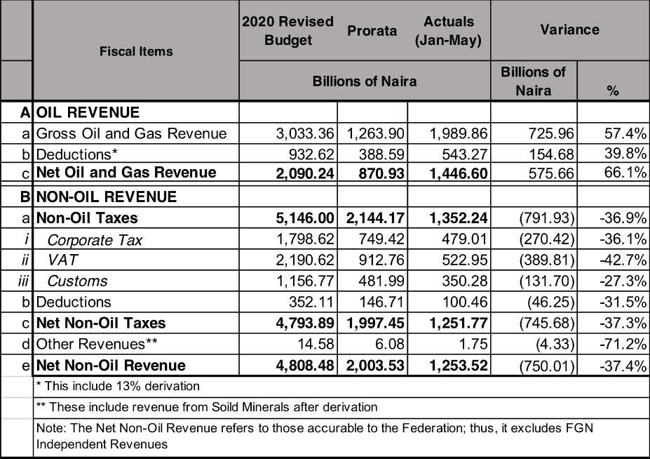Following the revision of key parameters of the Budget, gross oil and gas revenue was revised downwards to N3.03 trillion from N7.67 trillion for

FY2020. As at May, N1.99 trillion was realized out of the prorated sum of N1.26 trillion. This represents 57.4% more than the prorata. After netting out deductions (including 13% derivation), net oil and gas revenue inflows to the Federation Account amounted to N1.45 trillion –

N575.66 billion or 66.1% more than the projection as at May. This record performance can partly be attributed to activities in Q1, where actual crude oil price was higher than the revised budget benchmark.

##### *4.1.2 Federation and VAT Pool Accounts Distributable*

Table 4.2 Federation Account Revenue and VAT Distributable, 2020 (N’Billion)

|  |  |  |  |  |  |  |
| --- | --- | --- | --- | --- | --- | --- |
|  | **Fiscal Items** | **2020 Revised Actuals**  **Prorata**  **Budget (Jan-May)** | | | **Variance** |  |
|  | **Billions of Naira** | | | **Naira** | **%** |
| A | **Net Federation Account**  **Distributable\*** | **4,869.40** | **2,028.92** | **2,213.78** | 184.86 | 9.1% |
| i | FGN's Share (52.68%) | 2,565.20 | 1,068.83 | 1,166.22 | 97.38 | 9.1% |
| ii | States' Share (26.72%) | 1,301.10 | 542.13 | 591.52 | 49.39 | 9.1% |
| iii | Local Govt.'s Share (20.60%) | 1,003.10 | 417.96 | 456.04 | 38.08 | 9.1% |
|  |  |  |  |  |  |  |
| B | **Net VAT Pool Account**  **Distributable** | **2,029.39** | **845.58** | **486.34** | (359.24) | -42.5% |
| iv | FGN's Share (15%) | 304.41 | 126.84 | 72.95 | (53.89) | -42.5% |
| v | States' Share (50%) | 1,014.69 | 422.79 | 243.17 | (179.62) | -42.5% |
| vi | Local Govt.'s Share (35%) | 710.29 | 295.95 | 170.22 | (125.73) | -42.5% |

The amount available for distribution from the Federation Account was N2.21 trillion. Of this, the Federal Government received N1.17 trillion while the States and Local Governments received N591.52 billion and N456.04 billion respectively. Federal, State and Local governments received N72.95 billion, N243.17 billion and N170.22 billion

respectively from the VAT Pool Account. *Source:* BOF, OAGF, PRMRC

##### 

##### *4.1.3 FGN Revenue*

Table 4.3 FGN Revenue Profile (Jan–May) 2020 (N’Billion)

|  |  |  |  |  |  |  |
| --- | --- | --- | --- | --- | --- | --- |
|  |  | **2020**  **Pro Rata Actuals**  **Revised**  **(Jan-May) (Jan-May) Budget** | | | **Variance** | |
|  |  | **Billions of Naira** | | | **Billions of**  **Naira %** | |
| **S/N** | **FEDERAL RETAINED REVENUES (excl.**  **GOEs)** | **5,365.42** | **2,622.00** | **1,624.65** | **(997.35)** | **-38%** |
| **A** |  |  |  |  |  |  |
| 1 | Oil Revenue | 1,013.77 | 422.40 | 844.97 | 422.56 | 100% |
| 2 | Share of Dividend (NLNG) | 80.38 | 33.49 |  | (33.49) | -100% |
| 3 | Minerals & Mining Revenue | 1.90 | 0.79 | 0.85 | 0.06 | 7% |
| 4 | Non-Oil Revenue: | **1,624.93** | **677.06** | **439.32** | **(237.73)** | **-35%** |
| i | CIT | 821.67 | 342.36 | 213.24 | (129.12) | -38% |
| ii | VAT | 284.11 | 118.38 | 68.09 | (50.29) | -42% |
| iv | Customs Revenues | 450.70 | 187.79 | 149.28 | (38.52) | -21% |
| v | Federation Account Levies | 68.46 | 28.52 | 8.72 | (19.80) | -69% |
| **B** |  | **2,644.45** | **1,101.85** | **339.51** | **(762.34)** | **-69%** |
| 1 | FGN Independent Revenue | 932.84 | 388.68 | 80.22 | (308.47) | -79% |
| 2 | FGN Drawdowns from Special Accounts/Levies | 645.00 | 268.75 | 189.31 | (79.45) | -30% |
| 3 | Signature Bonus / Renewals / Early  Renewals | 350.52 | 146.05 | 69.99 | (76.06) | -52% |
| 4 | Domestic Recoveries + Assets + Fines | 237.01 | 98.76 |  | (98.76) | -100% |
| 5 | Stamp Duty | 200.00 | 83.33 |  | (83.33) | -100% |
| 6 | Grants and Donor Funding | 42.70 | 17.79 |  | (17.79) | -100% |
| 7 | Grants and Donations for COVID-19 Crisis Intervention Fund | 186.37 | 77.65 |  | (77.65) | -100% |
| 8 | Grants and Donor Funding | 50.00 | 20.83 |  | (20.83) | -100% |

As at end of May 2020, FGN’s retained revenue was N1.62 trillion. The share of oil revenue was N844.97 billion (representing 100% above the prorated sum) while Nonoil tax revenue was N439.32 billion (65% less performance). Company

Income Tax (CIT) and Value Added Tax (VAT) collections were N213.24 billion and N68.09 billion respectively, representing 62% and 58% of the prorata. Customs collections was N158 billion (73% of target). Other revenues amounted to

N339.51 billion, of which

independent revenues was N189.31 billion.

### 4.2 Expenditure Outturns

Table 4.4 FGN Expenditure Performance (Jan-May) 2020

|  |  |  |  |  |  |  |
| --- | --- | --- | --- | --- | --- | --- |
|  | **Fiscal Items** | **2020**  **Pro Rata Actuals**  **Revised**  **(Jan-May) (Jan-May) Budget** | | | **Variance** | |
|  | **Billions of Naira** | | | **Billions of**  **Naira %** | |
| **S/N** | **FGN EXPENDITURE (excl. GOEs and**  **Project-tied Loans)** | **9,973.67** | **4,155.69** | **3,975.32** | **180.37 -4.3%** | |
| **A** | **Statutory Transfers** | **428.03** | **178.35** | **233.53** | **(55.18)** | 30.9% |
| **B** | **Recurrent Expenditure** | **7,585.57** | **3,160.65** | **3,362.94** | **(202.29)** | **6.4%** |
| 1 | **Non-Debt Recurrent Expenditure** | **4,633.86** | **1,930.77** | **1,787.69** | **143.09** | **-7.4%** |
| a | Personnel Costs | 2,827.65 | 1,178.19 | 1,174.15 | 4.03 | -0.3% |
| b | Pensions & Gratuities including Service wide pension | 536.72 | 223.63 | 150.33 | 73.30 | -32.8% |
| ii | Overheads | 243.18 | 101.32 | 123.73 | (22.41) | 22.1% |
| iii | Other Service Wide Votes | 397.33 | 165.56 | 143.03 | 22.53 | -13.6% |
|  | Other Service Wide Votes (COVID-19) | 213.98 | 89.16 |  | 89.16 | -100.0% |
| iv | Presidential Amnesty | 65.00 | 27.08 | 21.67 | 5.42 | -20.0% |
| v | Special Intervention Programme | 350.00 | 145.83 |  | 145.83 | -100.0% |
| vi | Payment from Special Accounts |  | - | 174.78 | (174.78) |  |
| 2 | **Debt Service** | **2,951.71** | **1,229.88** | **1,575.26** | **(345.38)** | **28.1%** |
| i | Domestic Debt | 1,873.34 | 780.56 | 987.77 | (207.21) | 26.5% |
| ii | Foreign Debt | 805.47 | 335.61 | 210.96 | 124.66 | -37.1% |
| iii | Sinking Fund | 272.90 | 113.71 | 376.53 | (262.82) | 231.1% |
| iv | Interest on Ways & Means |  | - |  | - |  |
| **C** | **Capital Expenditure** | **1,960.07** | **816.70** | **378.85** | **437.85** | **-53.6%** |

On the expenditure side, N9.97 trillion was appropriated, while N3.98 trillion (representing 95.7% of the prorate, N4.16 trillion) was spent. Of the expenditure, N1.58 trillion was for debt service, and N1.32 trillion for Personnel cost and Pensions. As at end of May 2020, only N378.85 billion has been released for capital.

## 5.0 ASSUMPTIONS UNDERLYING OIL AND NON-OIL REVENUE PROJECTIONS IN 2021 - 2023

### 5.1 Assumptions Underlying Oil Revenues

#### 5.1.1 Crude Oil Production and Export

Crude oil output continues to have important implications for government revenues in Nigeria. In the first quarter of 2020, crude oil production accounted for 9.5% of Nigeria’s real GDP. However, crude oil receipts constituted about 50% of federal government’s revenues during the same period and about 90% of Nigeria’s foreign exchange earnings.

As Figure 5.1 shows, actual daily crude oil production has mostly been below budget projections since 2013 until recently. Average daily production declined from 2.47 million barrels per day (mbpd) in 2010 to 1.81mbpd in 2016. Although Nigeria’s total production capacity is 2.5mbpd, about 1.4mbpd of crude is currently being produced in compliance with the OPEC+ production quota and an additional 300,000bpd of condensates. Between January and May 2020, 1.88mbpd of crude oil was produced on average, not counting about 127,000 bpd of production devoted to repayment of pre-2105 Joint Venture cash call arrears.

According to NNPC, total crude oil production in Nigeria decreased in January 2020 by 1.32 million barrels or 2.22% at 60.80 million barrels with daily average of 1.96 mbpd. Production was disrupted by shutdown of Forcados for repairs while Bonny was shut down due to pipeline leakages. Production was also interrupted due to lube oil loss, pump issues, loss of power,

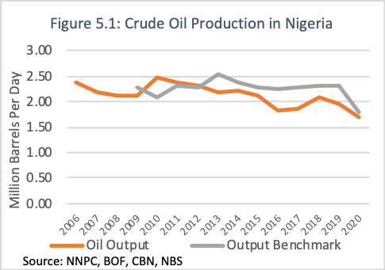riser protector replacement, pipeline repairs and flare management.

As reported by NNPC, 60 pipeline points were vandalized in January 2020 alone. This represents about 50% increase from the 40 points vandalized in December 2019. The incidence of vandalism has continued to undermine expected crude oil revenues.

Hence, NNPC in collaboration with the local communities and other stakeholders continuously strive to reduce and eventually eliminate it.

Considering the fact that crude oil production has averaged 1.97mbpd over the last 3 years, a very conservative oil output benchmark has been adopted for the medium term in order to ensure greater budget realism. Therefore, following consultations with stakeholders, crude oil production is estimated at 1.86mbpd, 2.09mbpd, 2.38mbpd in 2021, 2022 and 2023 respectively.

#### 5.1.2 Global Crude Oil Supply and Demand

Global crude oil demand is expected to continue growing at relatively healthy rates in the medium-term. The Organization of Petroleum Exporting Countries (OPEC) forecasts demand to reach 104.8 million barrels a day (mbpd) by 2024. This represents an increase of 6.1 mbpd above the 2018 level. The average growth will be about 1 mbpd over the medium-term period, declining from a projected 1.1 mbpd in 2019 to 0.9 mbpd in 2024. Incremental demand is forecast to come primarily from non-OECD countries.

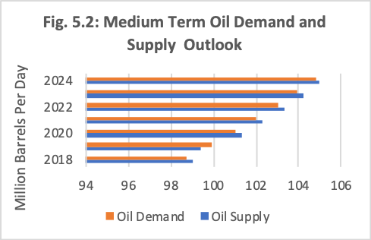However, OPEC estimates a steady rise in global oil supply from an average of 99.4mbpd in 2019 to 101.3mbpd in 2020,

102.3mbpd in 2021 and 105.0mbpd in 2024 (Fig. 5.2). According to OPEC, the main driver of medium-term non-OPEC supply growth remains overwhelmingly US tight oil, but Brazil, Norway, Canada, Guyana and Kazakhstan will also likely contribute.

The recent sharp decline in crude oil prices in the international market is due to both

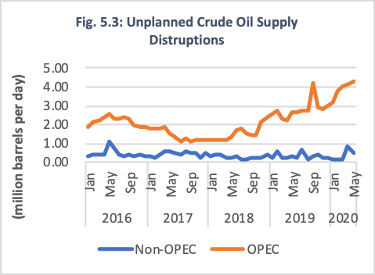global demand shocks and market concerns over crude oil oversupply. The COVID-19 pandemic severely affected the demand for transportation and industrial fuels worldwide. Nevertheless, demand is projected to normalize in the medium term. Hence, global supply of crude oil is projected to outstrip demand slightly by 0.3mbpd over the period 20202023.

Energy Information Administration reported a sharp increase in unplanned crude oil supply disruptions from 22.1mbpd in 2018 to 37.5mbpd in 2019. However, unplanned supply disruptions declined significantly to 21.3mbpd between January and May 2020. As Figure 5.3 shows, over 90% of unplanned crude oil supply disruptions occur in OPEC member countries.

#### 5.1.3 Crude Oil Price Benchmark

Crude oil prices collapsed recently in the world oil market due to various measures introduced to contain the COVID-19 Pandemic. Cargoes traded for as low as US$7.15 a barrel on

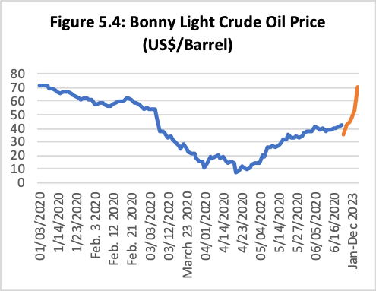Tuesday April 21, 2020. Like many crude oil exporting countries, Nigeria faced great difficulty in selling its crude cargoes during this time. As Figure 5.4 shows, Bonny Light crude oil price declined sharply from US$72 per barrel on January 6 2020 to US$56.6 per barrel on February 11, 2020 and an average of US$40.23 per barrel in June 2020.

The sharp decline in oil prices was due to both global demand shocks and market concerns over crude oil oversupply. In addition, the price war between Saudi Arabia and Russia has further exerted downward pressure on crude oil prices.

Considering the difficulty of predicting oil prices in a globally integrated market, the outlook for world oil price remains highly uncertain. Nonetheless. the outlook indicates prolonged period of low crude oil prices which is not in Nigeria’s favour. The World Bank forecasts that crude oil prices will average US$35 per barrel in 2020, down from an average of US$61.4 per barrel in 2019. In the medium term, the World Bank expects crude oil price to rise gradually from an average of US$42 per barrel in 2021 to US$44.5 per barrel in 2022, rising afterwards to US$47 per barrel in 2023 and $52.7 per barrel in 2025. EIA expects Brent crude oil prices to average US$41 per barrel during the second half of 2020 and US$50 per barrel in 2021, reaching US$53 per barrel by the end of 2021.

In consultation with the Nigerian National Petroleum Corporation (NNPC) and other stakeholders, a benchmark oil price of US$40 per barrel has been proposed for 2021, 2022 and 2023. Recent experience underscores the importance of setting the budget oil price benchmark below the forecasts in order to insulate the budget from the adverse effects of volatile oil prices. In addition, it is essential to build fiscal buffers which can be used to respond effectively to negative oil price shocks in the medium term.

### **5.2** **Non-Oil Revenue Baseline Assumptions**

The assumptions underlying the non-oil revenue forecasts for the period 2021-2023 are outlined below. Over the years, Government has increasingly embarked on several non-oil sector reforms in the effort to widen the revenue base and enhance revenue collection. In view of the declining fortunes of the oil and gas sector, improvement in non-oil revenue collection has assumed greater significance for funding the FGN budget in the medium term. In general, non-oil revenue projections for the period are guided by expected growth of the different tax bases, the effective tax rate, and the projected improvement in collection efficiency, taking account of tax administration reforms.

##### *Customs Collections: Import Duties, Excise, Fees and Special Levies*

Customs collections are estimated based on the cost, insurance and freight (CIF) value of imports, applicable tariffs, an efficiency factor. The nominal growth of the tax base is assumed to be driven by tax elasticity in the medium term. In view of the lingering effects of COVID-19 on global trade, a less aggressive tax elasticity was assumed to drive the nominal growth of the tax base in the medium term. Other considerations include the new foreign exchange rate regime, introduction of Common External Tariff (CET), implementation of the Africa Continental Free Trade Agreement (ACFTA), gradual removal of Import Adjustment Tax (IAT), expected decrease in annual Average Duty Rate (ADR), expected increase in Import CIF as a result of new strategic plans in Nigerian Customs Service (NCS), and Import Duty on vehicles which has the highest tariff line in terms of revenue generation.

##### *Companies Income Tax (CIT)*

The projection of CIT is based on estimated nominal GDP, Companies’ Profitability Ratio, and an efficiency factor. Estimates were also derived with due consideration for the effects of COVID-19 on domestic economic activities, efforts aimed at improving the business environment as well as the strategic implementation of the Nigeria Economic Sustainability Plan. Other important assumptions include improved collection efficiency and successful broadening of the tax net. Specifically, a 10% year-on-year improvement in collection efficiency is envisaged.

##### *Value Added Tax (VAT)*

This was estimated using projected aggregate nominal consumption, taking into account vatable items and collection efficiency. Aggregate consumption is estimated at N118.89 trillion in 2021 from N117.91 trillion estimated for 2020. Like the CIT, more VAT payers are expected to be brought into the tax net with the effective implementation of the provisions of the Finance Act 2019 and improving collection efficiency. The VAT projections over the medium-term are based on holding the rate at 7.5%.

Wider coverage and improved collection efficiency will be achieved through continuous nationwide VAT registration and monitoring, as well as the use of technology for auto-collect platforms in more sectors of the economy. In addition, the solution to deduct and remit VAT and WHT from State government contract payments is to be deployed to all the 36 states. Efforts will be made to increase VAT collection efficiency significantly in the medium term.

##### *FGN Independent Revenue*

Government-Owned Enterprises (GOEs) are still characterized by revenue leakages, excessive expenditures and weak accountability. Hence, the estimation of Operating Surpluses (the main component of FGN Independent Revenues) is predicated on strict and effective implementation of recent measures aimed at ensuring that GOEs operate in a more fiscally responsible manner. We believe that if government were to put the reins on fiscal indiscipline among the GOEs, revenues from this source could be considerably higher than projected.

## 6.0 MEDIUM TERM MACROECONOMIC FRAMEWORK: PARAMETERS AND TARGETS FOR 2021-2023

### **6.1 Macroeconomic Projections**

Since the recent revision of the 2020-2022 medium term fiscal framework, the key parameters as well as other macroeconomic projections driving the medium-term revenue and expenditure framework have been further revised in line with emerging realities. The new figures are presented in the table below.

Table 6.1: Key Parameters and other Macroeconomic Projections

|  |  |  |  |  |  |
| --- | --- | --- | --- | --- | --- |
| **Description** | **2019 Actual** | **2020**  **Budget** | **2021** | **2022** | **2023** |
| Oil Price Benchmark (US$/b) | 67.2 | 28.0 | 40.0 | 40.0 | 40.0 |
| Oil Production (mbpd)* | 1.96 | 1.80 | 1.86 | 2.09 | 2.38 |
| Exchange Rate (N/$) | 305.0 |  |  |  |  |
| Inflation (%) | 11.98 | 1.86 | 2.09 | 2.38 | 1.86 |
| Non-Oil GDP (N'bn) | 131,810.1 | 131,155.5 | 132,592.2 | 134,154.5 | 139,304.9 |
| Oil GDP (N'bn) | 12,400.4 | 8,691.9 | 10,102.2 | 12,640.0 | 12,159.5 |
| Nominal GDP (N'bn) | 144,210.5 | 139,517.5 | 142,192.1 | 146,072.8 | 150,497.7 |
| GDP Growth Rate (%) | 2.27 | (4.20) | 3.00 | 4.68 | 3.86 |
| Nominal Consumption (N'bn) | 119,281.6 | 117,913.7 | 118,887.3 | 120,835.4 | 125,157.3 |

***Source****: Ministry of Finance, Budget & National Planning; NNPC; BOF; NBS*

*Base Production Including Condensate

Oi

|  |  |  |  |
| --- | --- | --- | --- |
| 360.0 | 360.0 | 360.0 | 360.0 |

l GDP growth rate has a strong positive correlation with real GDP growth in Nigeria. Consequently, changes in the underlying drivers of oil GPD will significantly affect real GDP performance. With oil price projected to remain low and volatile in 2020 and Nigeria’s compliance with the OPEC+ cuts by reducing base production to 1.412 mbpd, 1.496mbpd and 1.579 mbpd for the corresponding periods, growth in Oil GDP is expected to decline in 2020. Oil GDP is expected to contract by 12.96% in 2020, year on year, causing an economy-wide drag resulting in slower growth in non-oil GDP by -3.6%, year on year. Based on this real GDP is expected to decline by 4.20% in 2020.

As the global economy recovers from the effects of lockdowns, improved oil prices, as well as stronger global demand for oil in 2021 will result in oil GDP growing by nearly 8%. This is also reflective of the base effect resulting from the preceding year’s sharp drop in oil GDP in 2020. By 2022, stable production and prices bring oil GDP to just about its pre-COVID-19 crisis.

The recovery in oil GDP translates to a weaker but positive growth in non-oil GDP in 2021. Year on year, non-oil sector growth is projected at 2.43% in 2021, 4.42% in 2022 and 3.82% in 2023. As a result, annual real GDP growth is forecast to recover in 2021 to 3.0% and reaching 4.68% by 2022, fully recovering to pre-crisis levels within the immediate post-crisis years, before stabilizing at 3.86% growth rate by 2023.

The nominal GDP is expected to increase from N139,517 billion in 2020 to N142,192.1 billion in 2021 and then up to N150,497.7 billion in 2023. Similarly, consumption expenditure is projected to stay flat at N117.913.7 billion in 2020 and N118,887.3 billion in 2021 and grow to N125,157.3 billion by 2023, reflecting a gradual steadiness in the growth recovery. Inflation, however, is expected to remain slightly above single digit over the medium term.

### **6.2 2020-2022 Medium Term Fiscal Framework (MTFF)**

#### **6.2.1 Federation Account Revenues**

Based on the key parameters and other macroeconomic projections, the net amounts accruable to the Main Pool and VAT Pool Federation Account are projected at N6.67 trillion and N1.70 trillion respectively in 2021. The share of oil revenue is about 61.3% of Federation Account receipts. Other components of the Federation Account revenues include revenues from Corporate Tax N1.41 trillion, Customs Revenue N1.05 trillion, Special Levies N124.76 billion, and Solid Minerals N5.46 billion.

The share of the Federal Government from the Main Federation Account Pool is N3.52 trillion while the States and Local governments are projected to get N1.78 trillion and N1.37 billion, respectively in 2021. For VAT, the Federal Government is projected to receive N255.46 billion, the States N851.52 trillion, and the Local governments N596.07 billion.

Table 6.2: Federation Account and VAT Revenues (2021 – 2023)

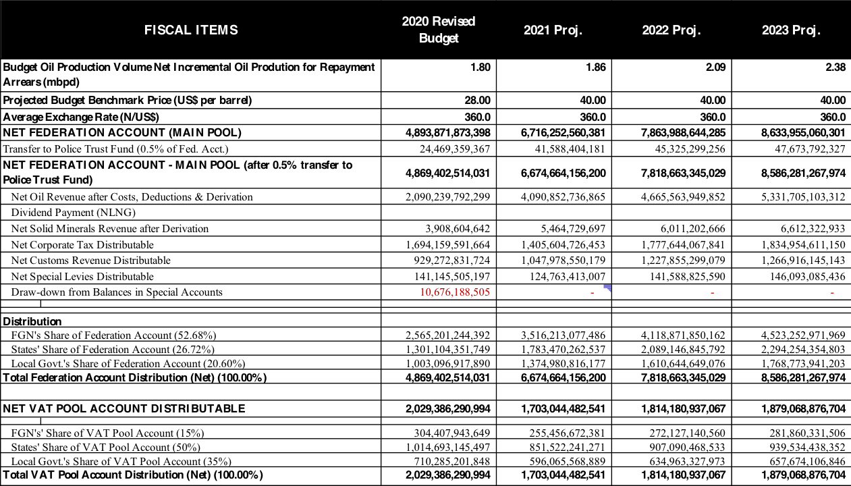

#### 6.2.1 Revenue Framework

The aggregate revenue available to fund the 2021 Budget is projected at N6.15 trillion (14.6% or N783.32 billion more than the 2020 revised Budget). Of this, N2.53 trillion or 41.1% is projected to come from oil related sources while the balance is to be earned from non-oil sources. The provision for Stamp Duty is projected at N500 billion, up from N200 billion, while Signature Bonus is down to N343.38 billion from the revised N350.52 billion in 2020. With the retained revenues of the Government-Owned Enterprises (GOEs), excluding the NNPC and CBN, the aggregate FGN revenue is projected at N7.50 trillion.

Table 6.3: Overview of the Revenue Framework

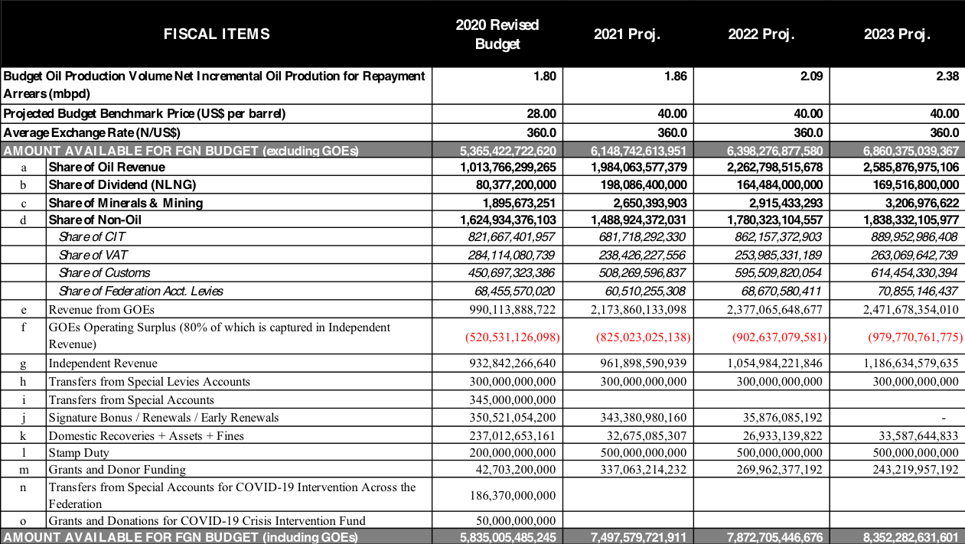

#### 6.2.2 FGN Expenditure Framework

#### 6.2.3 Aggregate Expenditure

The FGN’s 2021 aggregate expenditure is estimated at N12.66 trillion (this includes GOEs’ expenditures of N1.35 trillion and grants/donor funded projects/programmes amounting to N337.06 billion). This provision is higher than the corresponding 2020 FGN aggregate expenditure estimate of N10.81 trillion by 17.1% (or about N1.85 trillion). The sums of N13.27 trillion and N13.37 trillion are projected to be spent by the FGN in 2022 and 2023 respectively.

The 2021 expenditure estimate includes statutory transfers of N481.41 billion; non-debt recurrent expenditure of N5.75 trillion (including N350 billion for recurrent component of the Special Intervention Programme).

Of the 2021 budgeted expenditure, debt service is estimated at N3.12 trillion, and provision for Sinking Fund to retire maturing bonds issued to local contractors/creditors is N220 billion. A total of N4.31 trillion (inclusive of N701.16 for GOEs) is provided for personnel and pension costs, an increase of N724.67 billion over 2020. Personnel costs have continued to rise yearly, in great part to unrestrained recruitment by several agencies of government, oftentimes without compliance with the due process. At 70% of projected revenues for 2021, this level of personnel cost is not sustainable.

In addition, N34.76 billion (representing 1% of the consolidated revenue fund) has been earmarked for the Basic Health Care Provision Fund (BHCPF) as a Statutory transfer. A provision of N29.46 billion has also been made for the North East Development Commission (NEDC) as a Statutory transfer and N45.19 billion has been set aside in the service-wide votes for GAVI/Routine Immunization.

Having made these provisions, the aggregate amount available for capital expenditures in the 2021 budget is N3.33 trillion, which represents 26.3% of total expenditure (short of the 30% target set by the current federal government), and is 24% higher than the 2020 provision of N2.69 trillion. The 2021 provision comprises of N1.48 trillion for MDAs, N234.20 billion capital supplementation, N245.08 billion capital component of statutory transfers, N20 billion capital component of the Special Intervention Programme, N335.59 billion capital budget of GOEs, N337.06 billion for donor/grant funded expenditures and N674.10 billion funded by project-tied loans.

It is noteworthy that the N1.48 trillion available for MDAs’ capital is N135.0 billion (representing 10%) higher than the provision for MDAs in the revised 2020 Appropriation Act. The inadequate provision for development expenditure, and underperforming revenues, underscore the urgent need for new revenue sources, cost-saving measures and effective implementation of revenue growth initiatives.

Table 6.4: Overview of the Expenditure Framework

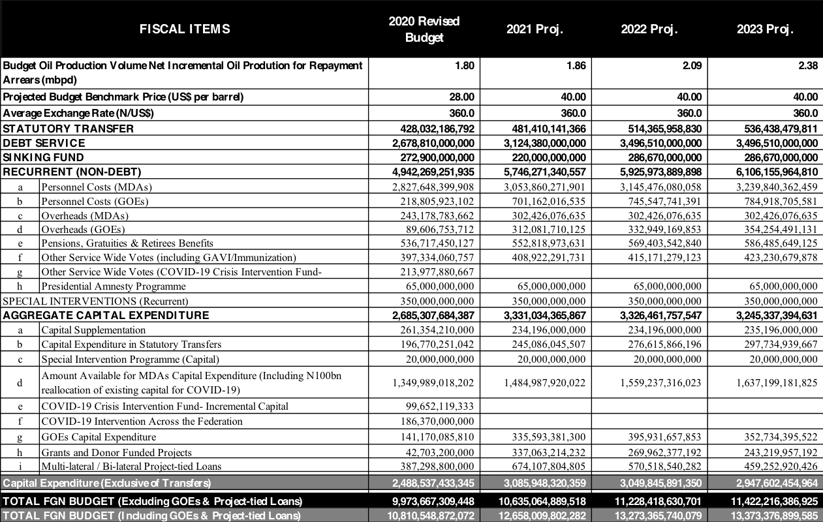

#### 6.2.4 Fiscal Deficit and Deficit Financing

Budget deficit is projected to be N5.16 trillion in 2021 up from N4.98 trillion in 2020. This represents 3.62% of estimated GDP, well above the threshold of 3% stipulated in the Fiscal Responsibility Act (FRA), 2007. Unless we can find new revenue sources, given the limited scope for cost-cutting, it will not be feasible to keep budget deficits within the 3% target set in the Fiscal Responsibility Act 2007.

The deficit will be financed by new foreign and domestic borrowings of N4.28 trillion, N205.15 billion from Privatization Proceeds, and N674.11 billion drawdowns on existing project-tied loans.

The projected Debt Service/Revenue ratio at 47% (actual for 2019 was 58%) raises some concern about the sustainability of FGN debt. However, it is more indicative that the country is faced with a serious revenue problem rather than a classic debt problem. Efforts must therefore be geared towards tackling the revenue problem so it does not degenerate to a real debt sustainability issue.

Table 6.5: Deficit, Financing and Critical Ratios

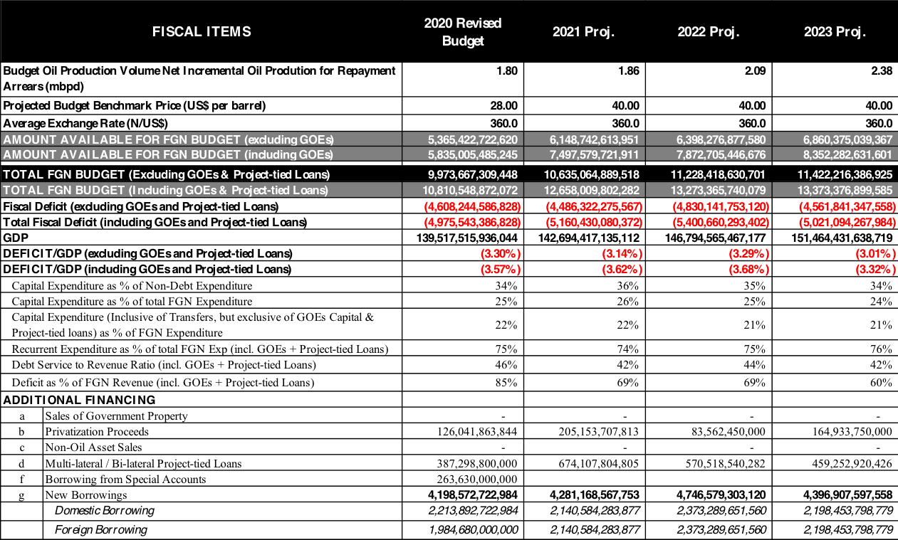

The full Medium-Term Fiscal Framework (MTFF) is attached as annexure 1 to the 2021 – 2023 MTEF/FSP

## 7.0 MEDIUM TERM OBJECTIVES, POLICIES AND STRATEGIES

This Fiscal Strategy Paper highlights the macroeconomic objectives of the government over the period 2021-2023 and the policy measures to be implemented to achieve them. In the medium term, government aims at sustaining economic growth and facilitating economic recovery, supporting jobs creation, achieving macroeconomic stability and promoting poverty reduction and equity.

### **7.1 Macroeconomic Policy Objectives**

Government’s economic objectives include:

i. Improving and sustaining economic growth and ensuring inclusiveness; ii. Supporting Employment Creation and Preserving Jobs; and iii. Ensuring macroeconomic stability.

To achieve these objectives, fiscal, monetary and trade policies will need to be aligned and implemented in a very coordinated manner.

#### 7.1.1 Sustaining Economic Growth and Ensuring Inclusiveness

In view of the COVID-19 Pandemic, the Nigerian economy is projected to recess in 2020, with real GDP growth now projected by the NBS to be -4.2%, as against the previous projection of 2.93%. Therefore, the immediate concern of the Government of Nigeria is to boost the economy and ensure quick recovery from the effects of the COVID-19 Pandemic. In the medium term, focus is on sustaining and accelerating economic growth.

To forestall a deep and prolonged recession, critical and complementary measures are being introduced. The Government recently established a N500 billion COVID-19 Crisis Intervention Fund to address emerging and priority funding needs. The N500 billionis proposed to be used for key programmes and projects including the following:

* N36 billion to support State Governments;
* N56.46 billion for **Jobs and Food for All: Agriculture and Food Security programme;**
* N12.43 billion for Energy for All: Mass Rural Electrification/Solar Power Strategy programme;
* N75.0 billion for Supporting Small Businesses/ MSME Survival Fund;
* N60.0 billion for Maintenance of Roads through Contract and Direct Labour in the 6 Geo-Political Zones;
* N9.59 billion for Job Creation Scheme for Youth and Women Post Covid-19;
* N52.0 billion Public Works Programme;
* N32.46 billion for Social Intervention Programme;
* N5.0 billion bail-out for support to the Aviation Sector;
* N126 billion for upgrading healthcare infrastructural facilities and operations across Federal Medical Centres, Teaching Hospitals and others;
* N2.98 billion for the Ministry of Interior;
* N6.0 billion for Artisanal and Small-Scale Miners;
* N9.89 billion for Water, Sanitation and Hygiene programme; and
* N750 million for Monitoring and Evaluation and Reporting.

The following fiscal stimulus measures are also being introduced:

* Fiscal relief for taxpayers and key economic sectors
* Incentives for employers to retain and recruit staff
* Measures to stimulate investment in critical infrastructure (Roads, Rail and Ports)

To cushion the adverse effects of the COVID-19 outbreak on the economy and safeguard the Nigerian financial system from the headwinds, the CBN also introduced the following monetary and macro-financial measures:

1. Reduction of interest rates from 9% to 5% on existing intervention programmes over the next one year;
2. Extended moratorium on loans by an additional year beginning from March 2020 to ease pressure on borrowers from loan repayments;
3. Regulatory forbearance to restructure loan terms and tenors to households and businesses affected by COVID-19;
4. Unification of the exchange rate around the Importers & Exporters foreign exchange market rate to remove distortions;

(v) Injection of about N1.8 trillion stimulus through the following interventions:

1. N1.0 trillion to support local manufacturing and boost import substitution
2. N100 billion for provision of loans to pharmaceutical companies, hospitals and other health practitioners for building or upgrade of hospitals and health facilities
3. N50 billion fund to support households and Small and Medium Enterprises (SMEs) affected by COVID-19; and iv. Assistance to pharmaceutical companies to re-establish drug manufacturing in Nigeria and curtail the spread of the corona virus.

There is also N1.5 trillion private sector driven Infraco Project fund to finance construction of critical infrastructure across the country;

It is expected that the effective and coordinated implementation of the stimulus packages targeted at the worst-hit sectors of the economy may prevent the economy from experiencing a contraction as high as the projected 4.2% in 2020, and also hasten recovery. It is hoped that the economy will grow faster in the medium term, rising from 3.0% in 2021 to 4.68% in 2022 and 3.86% in 2023. The expenditure plans set out in 2021-2023 will support the achievement of these real GDP growth targets.

#### 7.1.2 Supporting Employment Creation and Preserving Jobs

A key consequence of the COVID-19 Pandemic is massive job losses worldwide. In Nigeria, unemployment rate is expected to rise from 23.1% (or 20.9 million people) at Q3 2018 to about 33.6% (or 39.4 million people) at Q2 2020. Hence, urgent action is required to ensure the productive engagement of the very large population of unemployed youths to prevent them from engaging in criminal activities and anti-social behaviour.

Therefore, the immediate priority is to ensure that growth continues to be jobs-rich. In the medium to long-term, growth in Nigeria depends on continually improving **productivity**, which in turn, depends on investment in people, and boosting competition and innovation.

Barriers to growth will be identified and removed in the key sectors of our economy. The Government will open up sheltered sectors of the economy to competition and investment, and intensify efforts to enhance the capacity of the workforce, through investment in education and training, and through measures to support people to set up business or move between jobs and sectors as the economy grows.

The N-Power Programme is providing a pipeline of skilled workers to help rebuild the economy post-COVID-19. Over 109,823 of the beneficiaries have established businesses from savings accrued from the scheme. The Government has commenced enrolment of new beneficiaries to provide opportunities for more Nigerian youths to gain skills for employability and entrepreneurship.

#### 7.1.3 Ensuring Macroeconomic Stability

Efforts will be made to stabilize the macroeconomic environment in the medium term. Inflation rate increased for the ninth consecutive month by 12.4% (year-on-year) in May 2020, the highest rate recorded since May 2018, driven largely by rise in cost of food exacerbated by insecurity and inter-state travel disruptions owing to the coronavirus pandemic. It is expected that inflation will decelerate as the security situation improves, the economy opens up and output expands,

It is also projected that the exchange rate will generally remain relatively stable as the monetary, fiscal and trade policies are better aligned. This outcome will be achieved through policies that seek to remove uncertainty in the exchange rate regime and restore investors’ confidence in the market. This includes strategies to moderate inflationary pressures; provide critical infrastructure to lower the cost of doing business; and stabilize the exchange rate. In addition, government is redoubling its revenue generation efforts to moderate fiscal deficits. These, in addition to a healthy debt sustainability framework, will support stability in the macroeconomic environment.

### **7.2 Fiscal Policy Objectives and Strategies**

The thrust of Government’s fiscal policy in the medium-term is to cushion the long-lasting impact of the COVID-19 pandemic on households and businesses and ensure fiscal and debt sustainability. This will be achieved through the following:

1. Optimizing government revenue;
2. Creating fiscal space for infrastructural development; iii. Enhancing fiscal prudence and transparency; and, iv. Ensuring sustainable deficit and debt levels, including new fiscal rules.

#### 7.2.1 Optimizing Government Revenue

The immediate economic impact of COVID-19 is the sharp decline in oil revenue receipts and the decline in taxable economic activities. Nevertheless, the Pandemic has necessitated significant expenditure to improve health infrastructure and moderate the impact on households and businesses. Therefore, more than ever before, there is urgent need to significantly improve government revenues. Government is committed to using innovative ways to raise revenues required for financing its expenditure and diversifying its revenue sources thereby significantly increasing the Revenue-to-GDP ratio. The medium-term target for this remains 15%. Higher revenue collections will enable Government to effectively deliver public services, enhance infrastructure investment, and mitigate the health and economic effects of the COVID-19 Pandemic.

To underscore the importance of revenue to the FGN budget, revenue lines have been introduced into the new Appropriation Bill format. In effect, MDAs will be required to commence the preparation of the budgets from revenues likely to be generated during the fiscal year.

Oil Revenue**:** In order to increase oil revenues, upfront fiscal deductions by the Nigerian

National Petroleum Corporation for federally funded projects have been significantly reduced. The NNPC is taking measures to further reduce the cost of crude oil production to $10 per barrel or below by 2021. This will be achieved by reducing key cost drivers including logistics, security and transportation. In addition, under-recovery costs by the NNPC in the course of importing petrol for the country has been eliminated with the recent elimination of subsidies in PMS pricing. Other measures include accelerating licensing of Marginal Oil Fields and renewals of existing licenses as well as ramping up production from previously shut-down oil wells.

Non-Oil Revenues**:** Non-oil revenues are relatively more stable than oil revenue. Hence, concerted efforts will be made to improve non-oil receipts through improved tax and Customs administration and expanded non-oil revenue base. In addition, the tax system will be further strengthened over the medium term by improving collection efficiency, enhancing compliance, and reorganizing the business practices of revenue agencies as well as employing appropriate technology. In addition, government will ensure that more businesses in the informal sector are brought into the tax net.

In order to widen the revenue base, the Government recently activated stamp duty collection which has been neglected for more than 20 years. Towards this end, the Federal Inland Revenue Service Adhesive Stamp was recently introduced and the Inter-Ministerial Committee on Audit and Recovery of Back Years Stamp Duties has been inaugurated.

Government targets about N1 trillion revenue annually from Stamp Duties. In addition,

Government will re-introduce the 2012 Corporate Tax (Exemption of Profits) Order granting Job-creation Tax Rebates for Employers. Also, non-essential tax waivers will be reviewed to optimize revenues.

To further shore up Nigeria’s tax revenue, the Executive Order 008 on the Voluntary Offshore Assets Regularisation Scheme (VOARS) was amended recently to facilitate the enforcement of the order originally signed in October 2018. The VOARS provides incentive for taxpayers who have defaulted in the payment of taxes in respect of their offshore assets and foreignsourced income to voluntarily declare their offshore assets and regularise their tax affairs. Such taxpayers are required to pay a one-time levy of 35 percent to avoid penalties for tax evasion.

Under the amended order, domestic or foreign banks, asset managers or intermediaries that enable defaulters to conceal offshore assets and obligations are liable to pay to the Federal Government of Nigeria a penalty on the total of such offshore assets, in addition to other penalties provided for under Nigerian laws or laws of foreign countries from which Nigeria can benefit.

Customs Revenue: To improve collections over the period 2021-2023, the following strategies will be implemented by the Nigeria Customs Service:

1. Full automation of all forms of manual payments in every Customs formation. In addition to improved revenue performance, this would further promote sanity and integrity of Service operations;
2. Advocacy for expansion of excisable items beyond alcoholic beverages and tobacco, including imported goods that have similar production line in Nigeria;
3. Holistic assessment and monitoring of all revenues collected on behalf the Service by the various designated commercial banks. This will create avenue for genuine reconciliation of all accrued revenues against claimed remittances to the various designated government accounts. This will also guide against diversion of any collectible revenue;
4. Automation of all transit procedures from mother Ports to Bonded terminals and/or from Command to Command to drastically reduce transit leakages occasioned by diversion of cargo among others;
5. Acceleration of the modification and automation of excise and export platform in the

Nigerian Integrated Customs Information System II (NICIS II);

1. The use of the Government Integrated Financial Management Information System (GIFMIS) module to enhance collection, reconciliation and audit trail of all relevant proceeds to block all opportunities to defraud the system;
2. Installation of scanners in various key Customs formations to streamline the current inefficient manual cargo examination method and aid trade facilitation;
3. Staff capacity development through training of the existing workforce and recruitment of new officers;
4. Intensification of anti-smuggling campaign beyond common boundary in order to curb trade irregularities and economic sabotage. Towards this end, the Nigeria Customs Service is collaborating with other government enforcement agencies including the Nigeria Army, Nigeria Immigration Service, Nigeria Police, etc. to fight against smuggling activities in Nigeria;
5. Collaboration with stakeholders and relevant players in various economic units to enhance compliance by bridging gaps and building confidence among players in the trade chain;
6. Deployment of Artificial Intelligence Instrument in border surveillance under the eCustoms Project to check smuggling and enhance revenue collection; and xii. Automation of the processing of arriving international passengers under the Passenger Entry System (PES) at the Arrival hall of all international entry points to enhance revenue collection, unlike the extant passage of passengers without appropriate assessment.

In addition, the temporary closure of the nation’s land borders is intended to:

* + Enhance imports through the Sea Ports and Air Ports;
  + Protect the national economy from dumping;
  + Discourage illicit activities along the trade chain; and
  + Enforce and promote collaboration with the neighbouring countries

Independent Revenues: To enhance independent revenue generation and collection, Government will maximize the huge potentials and optimize the operational efficiency of GOEs to generate significant revenues to fund the FGN budget as obtainable in other countries. Current sub-optimal revenue performance will be addressed through the effective implementation of the approved Performance Management Framework. The key elements of the reform initiative include:

* + Performance contracts for Chief Executive Officers (CEOs) and key Management Staff, which will set Financial Indicators and Targets for each GOE;
  + Limiting cost-to-revenue ratio to maximum of 60%-70%;
  + Regular monitoring and monthly publication of revenue and expenditure performance of GOEs by the Office of the Accountant General of the Federation;
  + Quarterly tracking and publication of budget performance (revenue, expenditure and remittances) of GOEs by the Budget Office of the Federation;
  + Mainstreaming of annual GOEs’ budgets into the Federal Government’s Budget to ensure they are subjected to the same level of scrutiny, procurement and monitoring processes;
  + Mandatory use of the Treasury Single Account for all financial transactions;
  + Quarterly remittance of interim operating surplus and reconciliation of cumulative remittances at year end after audit;
  + Submission of annual budgets to the Budget Office of the Federation for review and compilation for submission to the National Assembly along with the national budget;
  + Consideration and passage of budget of GOEs alongside the main budget of the Federal Government;
  + Exclusion of agencies with capacities for self-funding from allocations in the Federal Budget;
  + Imposition of appropriate sanctions for unauthorized use of Internally Generated Revenues;
  + Introduction of incentive mechanism for good performance in revenue generation; and
  + Amendment of relevant sections of the Acts establishing some of the GOEs to reflect current economic realities and policy thrust of government.

The Ministry of Finance, Budget and National Planning has identified GOEs that remit operating surpluses less than is required by law and/or financial regulations, and the amounts expected from each of them. The Auditor General of the Federation may have to directly deduct these funds from the accounts of the GOEs forthwith. A dashboard is being developed to facilitate the budget performance monitoring process. To ensure transparency, the GOEs will be required to prepare their budgets using the GIFMIS platform.

#### 7.2.2 Creating Fiscal Space for Infrastructural Development

The rise in recurrent costs has resulted in restriction of amount available for capital investment. Government was unable to allocate a minimum of 30% of budgeted expenditure to capital projects in 2019 in line with the ERGP. This situation is further exacerbated by the impacts of the COVID-19 pandemic. Nonetheless, Government will continue to pursue its fiscal strategy of targeted public sector infrastructure spending in 2021-2023. Resources will be allocated to most productive and growth-enhancing sectors including Security, Infrastructure (including Power and Transportation), Agriculture, Manufacturing, Housing and Construction, Education, Health and Water Resources. This is with the aim of improving socio-economic infrastructure, supporting employment and stimulating economic growth. In addition, government support will be geared towards further stimulating activities of Micro, Small and Medium-Scale Enterprises (MSMEs).

Government will also leverage private and donor capital to supplement capital allocations from the Budget. To this end, Government will accelerate the construction of over 800km of roads and bridges under the Road Infrastructure Tax Credit Scheme. Furthermore, Government will strengthen the frameworks for concessions and public private partnerships, including working with the Legislature to address legislative and regulatory challenges to private investments in key sectors of the economy. It is expected that growth, in the medium term, will generate the revenue necessary for future expansion of public service delivery, rebuilding fiscal space, and narrowing new borrowing requirement.

#### 7.2.3 Enhancing Fiscal Prudence and Transparency

Government recently relaxed the fiscal consolidation earlier proposed to anchor the 2020 Budget to accommodate the special outlays required to address the COVID-19 Pandemic, protect the poor and vulnerable, as well as to resuscitate the economy. Nevertheless, Government remains committed to improving the efficiency and quality of its spending. Thus, public expenditure will continue to be properly scrutinized to ensure value for money.

In order to enhance fiscal prudence and transparency, the Government is implementing or intends to implement the following measures:

* Review and implementation of Oronsaye Report to reduce the number of MDAs;
* Transition to a PMS price modulation mechanism to be driven by underlying international oil and gas prices in the global markets;
* Review of Sectors eligible for Pioneer Tax Holiday Incentives under the Industrial Development Income Tax Relief Act (‘IDITRA’);
* Review of Fiscal Incentives of the National Automotive Policy;
* Review of process and approvals of Import Duty Exemption Certificates;
* Evaluation of current suite of Fiscal Incentives including Auto Policy Incentives and Import Duty Exemptions;
* Tax Expenditure studies & review of Tax Expenditures;
* Consolidation of Government rental accommodation and centralization of electricity payment;
* Strengthening treasury financial controls to speedily detect, eliminate and sanction instances of waste, misappropriation and corruption.
* Reintegration of cash management function into core budgeting system to ensure that in-year budget Monitoring & Evaluation (M&E) results inform fund releases on a real time basis, and that future budget projections are also guided by evidence of funds utilization. This will ensure conversion of liquidity into the achievement of outputs and outcomes.

A detailed review of recurrent and capital expenditures will be undertaken in advance of 2021 Budget. Spending trends and pressures will be examined to help identify ways of addressing the challenges arising in the context of fiscal policy. Review of capital expenditure is key in identifying and eliminating non-priority MDA expenditure so as to accommodate critical, propoor and growth-enhancing capital expenditures.

An important fiscal strategy to keep public expenditures at sustainable levels in the medium term is to rationalize the Government wage bill. The aim is to gradually clean the Government payroll. Towards this end, efforts will be intensified to complete the extension of the Integrated

Payroll and Personnel Information System to all MDAs to improve the effectiveness and efficiency of payroll administration. In addition, all modules of the Integrated Personnel and Payroll Information System (IPPIS) will be fully implemented across all agencies of government.

Personnel and pension costs account for the largest single item of expenditure, rising steadily in recent times from N1.88 trillion in 2016 to N2.06 trillion in 2017 and N2.56 trillion in 2019. In 2017, personnel costs accounted for about 77% of total revenues as against 64% in 2016. In 2019, personnel costs amounted to 63% of revenues. Similarly, personnel emoluments accounted for about 37% of total Federal Government expenditure between 2015 and 2017 and 31% in 2019. To realise the goal of controlling personnel costs, Government has introduced measures such as a temporary freeze on non-critical recruitment outside of the Security and Healthcare sectors.

To further improve fiscal transparency, the Tax Expenditure Statement will become a key component of the Federal Government’s reporting on the Nigerian tax system. The Statement would provide estimated cost of main tax expenditures in a year in terms of revenue forgone.

#### 7.2.4 Ensuring Sustainable Deficit and Debt Levels

Fiscal deficits have been rising recently as government adopted an expansionary fiscal stance to get the economy back on the path of sustainable growth. This has further worsened with the effects of COVID-19 on government finances. However, government deficit will be moderated in the medium-term in a gradual, phased manner through a combination of revenue and expenditure measures. As measures to improve revenue collections yield results, government will ease off significant deficit budgeting.

The lower budget deficit will help to reduce the rate of domestic debt accumulation and the resulting debt service payments, contain deficit monetization and the attendant macroeconomic dislocations. To ensure debt sustainability, total public debt will be kept at our self-imposed debt sustainability threshold of 40% of GDP. It has however become necessary to consider setting other prudential limits like Debt Service/Revenue Ratio to ensure continuing sustainability of FGN’s debts. Government will also negotiatiate a break on debt service with the Central Bank of Nigeria.

### **7.3 Monetary Policy Objectives and Strategy**

The direction of monetary policy by the Central Bank of Nigeria in the medium term (20212023) is outlined below. It is premised principally on key assumptions and underlying macroeconomic conditions as projected by the Bank in the period under consideration.

#### 7.3.1 Monetary Policy Objectives

In the first quarter of 2020, the economy witnessed a slower quarterly GDP growth rate, rising inflation, increasing balance of payment deficit, bearish capital market condition, rising national debt profile, exchange rate pressures, sharp decrease in oil prices, declining government revenue and rising unemployment rate. These macroeconomic conditions, if not abated by the third and fourth quarters of 2020, would mean negative year-on year output growth and deteriorated financial system conditions for the year.

Given these, the goal of monetary policy over the medium term would be to minimize the adverse impacts of these headwinds and ensure that the emerging recessionary conditions are rapidly reversed. The Central Bank of Nigeria will continue to align the conduct of monetary policy with the overall macroeconomic goals as enshrined in the Medium-Term Expenditure Framework of the Federal Government.

Thus, the Bank’s monetary projections were prepared using the CBN Monetary and Financial Programming Template, to obtain the indicative monetary aggregate benchmarks consistent with the desired overall macroeconomic objectives of the Federal Government of Nigeria.

Notwithstanding the foregoing, the Bank would periodically review the monetary programme to ensure consistency with evolving global and domestic macroeconomic conditions and the effectiveness of the applied monetary policy tools. In addition, the Bank would collaborate with all other relevant public and private sector stakeholders to ensure effective coordination and implementation of the outlined strategies of the medium-term framework (MTF).

#### 7.3.2 Monetary Policy Stance

The Central Bank of Nigeria (CBN) would continue to adopt the medium-term framework (MTF) in the conduct of monetary policy in the fiscal years 2021/2023. Accordingly, the monetary programme for the 2020/2022 fiscal year is adjusted to accommodate recent changes to fiscal operations in 2020 and projections of 2021 and 2022 fiscal years. This is to obtain the indicative monetary aggregate benchmarks consistent with the desired overall macroeconomic objectives of the Federal Government. The 2021/2023 monetary policy thrust would be anchored on the need to augment the fiscal stimulus packages to restart and restore the economy following the effects of the COVID-19 pandemic.

In ensuring the attainment of monetary and price stability for sustainable growth recovery and economic development, the 2021/2023 monetary programme was based on:

1. Money supply that would cushion the effect of the shocks from the pandemic on economic performance and growth;
2. Moderate levels of accretion to external reserves based on net FX inflows, reflecting reduced oil revenue but even less foreign exchange demand given low global economic activities;
3. Domestic credit expansion to support private sector growth, particularly, to the real and critical sectors of the economy;
4. Expansion in agricultural and manufacturing output growth through targeted interventions in the agriculture and Micro, Small and Medium Enterprises (MSMEs) sectors to improve employment generation and household income;
5. Improve stability of the foreign exchange market to enhance market confidence, moderate foreign capital outflow and encourage foreign capital inflow;
6. Improve terms of trade through increased non-oil export and decline in non-essential imports to improve the balance of payment position and accretion to external reserves;
7. Increased collaboration with fiscal authorities to provide monetary accommodation for the projected fiscal expansion necessary for economic recovery and growth in the immediate aftermath of COVID-19.

The CBN monetary programme was premised on the assumptions of large fiscal expansion in response to the impact of COVID-19 in 2020 through to 2022, increased government spending pre-2023 general elections and the effective implementation of Nigeria Economic Sustainability Plan

Sequel to the above, the 2021 – 2023 MTF monetary programme included a benchmark of average exchange rate of $USD/N375.86, in line with projected crude oil production and price benchmarks for 2021, 2022 and 2023, respectively. The detailed macroeconomic projections for the framework based on these benchmarks are presented in Table 7.1

**Table 7.1**

**Selected Macroeconomic Projections for the 2021- 2023 MTEF**

|  |  |  |  |
| --- | --- | --- | --- |
| **Indicator** | **2021** | **2022** | **2023** |
| Narrow Money (M1) (Billion Naira) | 11,814.66 | 13,067.01 | 14,227.36 |
| M1 Growth Rate | 12.20 | 10.60 | 8.88 |
| Broad Money (M2) (Billion Naira) | 32,874.41 | 36,707.57 | 40,047.96 |
| M2 Growth Rate | 14.31 | 11.66 | 9.01 |
| Broader Money (M3) (Billion Naira) | 38,890.96 | 42,647.83 | 46,119.36 |
| M3 Growth Rate | 11.91 | 9.66 | 8.14 |
| Net Foreign Assets (NFA) Billion Naira) | 4,501.86 | 6,041.38 | 8,457.93 |
| NFA Growth Rate | 2.92 | 34.20 | 40.00 |
| Net Domestic Credit (NDC) (Billion Naira) | 46,478.18 | 51,995.50  22.98 | 60,314.78 |
|  |  |  |
| NDC Growth Rate | 9.93 | 16.00 |
| Net Government Credit (NGC)(Billion Naira) | 13,137.80 | 16,256.36 | 20,320.45 |
| NGC Growth Rate | 13.36 | 40.27 | 25.00 |
| Private Sector (DCp) (Billion Naira) | 33,340.38 | 35,739.14 | 40,385.22 |
| DCp Growth Rate | 8.64 | 16.45 | 13.00 |
| External Reserves (US$ billion) | 35.11 | 36.72 | 38.67 |
| External Reserves Growth Rate | 2.30 | 4.59 | 5.31 |
| Average Exchange Rate (N/$)* | 376.71 | 376.56 | 374.32 |

*Source: CBN*

*\*This does not factor in the parallel market rate which the CBN does not recognize as a legitimate window in Nigeria’s foreign exchange market*

#### 7.3.3 Challenges to Monetary Policy and Outlook for the economy

To achieve the above, the CBN monetary policy and credit stance would need to encourage higher banking sector credit to the economy, however, considering the expected levels of inflation and the large fiscal expansions, monetary aggregates are expected to increase significantly with implications for domestic prices, including foreign exchange and interest rates, which may hinder the required credit expansion.

The projected monetary and credit indicative benchmarks from 2021/2023 would aim at a cumulative average of:

* M3 and M2 growth of 9.90 and 11.85 per cent, respectively;
* NFA growth of 25.71 per cent;
* Net domestic credit growth of 16. 30 per cent - an average of 26.21 and 12.70 per cent to Government and Private sectors, respectively; and
* External reserves of $38.83 $USD billion representing an average growth rate 4.07 per cent for the entire MTF.

Monetary policy would remain proactive in ensuring monetary and price stability conducive for sustainable and inclusive growth, as well as maintaining a safe, stable and sound financial system necessary to support economic growth. In the medium term (2020-2023) and beyond, the Bank would continue to monitor global and domestic developments and evaluate its implications for the Nigerian economy in line with the above stated objectives.

This current framework will be guided by several short-term interventions, though principally focused on the medium-term growth recovery and development plan. Consequently, volatility may be expected in key monetary aggregates in the short-term, with consequences for sustaining price stability and financial system resilience. Given the projected decline in global output growth and commodity prices, external shocks could mount pressures on the expected export expansion and external reserve accretion. This may weaken the Bank’s ability to moderate domestic prices, maintain positive external balance and support real output growth in the short to medium term. Therefore, we maintain a cautious GDP growth projection in the medium term, precedent on improved global economic and financial conditions, in addition to continuing coordination of fiscal and monetary policy responses to the impact of the COVID19 pandemic.

### **7.4 Key Sectoral Policy Initiatives**

A number of sectoral policy initiatives are considered over the medium term. The Federal Government will seek to align most of such sectoral interventions towards the achievement of the Sustainable Development Goals (SDGs).

##### *7.4.1 Extensive Public Works and Road Construction Programme*

As part of measures to conserve foreign exchange expended on importation of bitumen for road construction, emphasis will now be on the use of locally available materials like limestone, cement and granite. Options have been explored for using these materials in major Federal highways. This initiative will also ensure that a significant number of workers will be engaged in the construction of rural roads using stones and other materials available locally.

Government is developing the engineering concept and template for this approach for extensive cover of rural roads.

##### *7.4.2 Support for Micro, Small & Medium Enterprises*

Initiatives for micro, small and medium enterprises are being implemented to support business activities through guaranteed off take of items like personal protective equipment, face shields, face masks, hand sanitizers, shoe covers, soaps, etc. This scheme is expected to catalyse massive investments in light manufacturing, which will ensure that many commonly used items are produced in local communities thereby stimulating economic activities.

Government will also implement a Survival Fund aimed at ensuring that small and mediumsized enterprises can keep their employees and help maintain jobs through payroll support.

##### *7.4.3 Energy Sector Policy Initiatives*

Energizing Economies Programme: Government will intensify the implementation of the

Energizing Economies Programme. The programme is a public-private partnership led by the Rural Electrification Agency (REA), to deliver stable power supply to markets and economic clusters across the country.

Installation of Solar Home Systems: Installation of Solar Home Systems is planned to cover up to 5 million households, serving about 25 million individual Nigerians who are currently not connected to the National Grid. In view of the scale of materials required, solar equipment manufacturers will be required to set up production facilities in Nigeria, thereby offering additional job opportunities to Nigerians. In addition, installation, servicing and payment collections are expected to provide thousands of other jobs.

Promotion of Domestic Gas Utilisation: To take advantage of Nigeria’s abundant gas resources, which is also cheaper and more friendly to the environment, this project will promote indigenous manufacture of gas cylinders, building of gas filling stations and conversion of cars to promote the wide use of compressed natural gas in the domestic market.

##### *7.4.4 Mass Agricultural Programme*

This is expected to bring between 20,000 and 100,000 hectares of new farmland under cultivation in every State of the Federation. The aim is to create millions of job opportunities, directly and indirectly, over a 12-month period. A significant number of Nigerians will be incentivised to engage in farming and agro-processing, as that is a field in which Nigeria has comparative advantage.

##### *7.4.5 Strengthening the Social Safety Net*

Government will strengthen existing social safety nets programmes. This will be achieved through an increase in the number of conditional cash transfer beneficiaries, N-Power volunteers and sundry traders enjoying small and micro loans through the MarketMoni and TraderMoni schemes. The existing conditional cash transfer will be extended to cover mostly the rural poor. However, on account of the current lockdown, most of the urban poor, artisans, labourers, petty traders, street vendors, cart pushers, have become further impoverished

.

##### *7.4.6 Digital Technology*

To foster a culture of innovation and create a wide variety of technology and ICT jobs, special attention will be paid to the promotion of technology hubs, call-centres for business process outsourcing and digitisation of processes, both in Government and within the private sector. Experience thus far indicates that, if well harnessed, this is a sector that can create jobs on a large scale and earn foreign exchange for the country.

*7.4.7 Entertainment and Creative Industry*

Nigeria’s creative industries – film, music, broadcasting and publishing – have great growth potential as well as the space to create jobs and generate foreign exchange earnings. This underscores the continued emphasis of Government to promote and encourage developments in the sector. To support the private-sector led development of the industry, government will focus on addressing challenges such as weak enforcement of intellectual and property rights, inadequate supporting infrastructure and technology, and lack of access to financing to enable the sector to reach its full potential. Unlocking these constraints will create more opportunities for growth and employment, (especially of the teeming youth population).

## 8.0 ANALYSIS & STATEMENT ON CONSOLIDATED DEBT & CONTINGENT LIABILITIES

### **8.1 Nigeria’s Current Debt Profile**

#### 8.1.1 Debt Stock

Nigeria’s Total Public Debt stock (comprising the FGN, States and FCT) as at December 31,

2019 was N27,401,381.29 million (US$84,053.32 million) compared to N24,387,071.74 million (US$79,436.72 million) as at December 31, 2018, representing an increase of N3,014,309.55 million or 12.36% in Naira terms. The increase in the Total Public Debt stock was due to new Domestic Borrowings, as well as additional disbursements on existing Bilateral and Multilateral External Loans.

The Domestic Debt as a percentage of the Total Public Debt dropped from 68.18% as at December 31, 2018 to 67.07% as at December 31, 2019, while the share of External Debt rose from 31.82% as at December 31, 2018 to 32.93% as at December 31, 2019. The FGN’s Domestic Debt as at December 31, 2019 was N14,272,644.79 million or 52.09% of the Total Public Debt, while the Domestic Debt of the States & FCT was N4,106,314.86 million or

14.99% of the Total Public Debt as at December 31, 2019. Whereas, the External Debt of the

FGN was N7,534,274.02 million (US$23,111.27 million) or 27.50 percent of the Total Public Debt, the External Debt of the States & FCT constituted N1,488,147.62 million (US$4,564.87 million) or 5.43% of Total Public Debt as at December 31, 2019.

Nigeria’s Total Public Debt as a percentage of GDP remained sustainable at a ratio of 19.00% as at December 31, 2019. This ratio is within the Country Specific Debt Limit of 40 percent and below the maximum threshold of 55% recommended by the IMF and World Bank for countries in Nigeria’s peer group, as well as the West African Monetary Zone Convergence threshold of 70%.

**Figure 8.1: Trend in Nigeria’s Total Public Debt (2015 - 2019)**

'-

5.00

10.00

15.00

20.00

25.00

0.00

12,500.00

25,000.00

37,500.00

50,000.00

2015

2016

2017

2018

2019

US$' Millions

FGN External Debt Stock

States & FCT's External Debt Stock

FGN Domestic Debt Stock

States & FCT's Domestic Debt Stock

Debt as % of GDP

*Source: DMO*

#### 8.1.2 Debt Service Payments

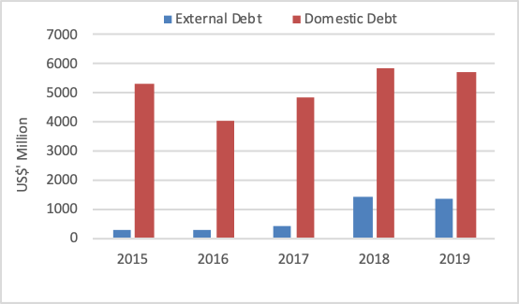**Figure 8.2: Debt Service Payments (2014**

**- 2018)** Whilst the Debt Management Strategy implemented by the Government to reduce the cost of refinancing short-term domestic debt with cheaper and longertenored external debt and lower domestic interest rates, resulted in the decrease in Domestic Debt Service in the year under review. As a result, the Total Public Debt Service payment slightly decreased from

US$7,256.90 million in 2018 to US$7,062.47 million in 2019, representing a decrease of US$194.43 million or 2.68 percent.

In terms of the fiscal burden associated with the relatively high debt service payments, it is expected that the various reforms and initiatives undertaken by the Government in the critical sectors of the economy, aimed at enhancing revenue generation, would subsequently

### **8.2 Debt Management Strategy**

Nigeria’s Medium-Term Debt Management Strategy (MTDS), 2016-2019, provided the basis for Government’s borrowings to meet its financing needs at least cost and with prudent degree of risk, as well as ensured the sustainability of the Public Debt Portfolio within the year under review. The focus of the Strategy was aimed at attaining the following targets:

▪ An increase in External financing, with a view to rebalancing the public debt portfolio and achieve an optimal debt composition of 60:40 for Domestic Debt and External Debt;

|  |  |
| --- | --- |
| ▪ | Attain a Domestic Debt Mix of 75:25 for long and short-term debts, respectively, so as to reduce the cost of debt service and roll-over risk; |
| ▪ | Keep the share of debt maturing within 1 year, as a percentage of Total Debt Portfolio at not more than 20%; |
| ▪ | Keep the Average Time-to-Maturity (ATM) for the Total Debt Portfolio at a minimum of 10 years. |

Accordingly, significant improvement was recorded in rebalancing the composition of the Total Public Debt portfolio, while the other targets were surpassed as at December 31, 2019. The ratio of Domestic to External Debt in the Total Public Debt was 67:33 as at December 31, 2019, relative to the targeted composition of 60:40 by end of 2019. The Domestic Debt Mix improved substantially to 81:19 for long and short-term debts respectively as at December 31, 2019, exceeding the targeted Domestic Debt mix of 75:25 for long and short-term debts by end of 2019. This indicates a remarkable improvement when compared to the Domestic Debt mix of 69:31 for long and short-term debts at the commencement of the Strategy in 2016.

The strategy of borrowing long, and restructuring of the domestic debt portfolio by refinancing matured NTBs with the proceeds of the Eurobonds and lengthening the FGN Bonds Yield Curve up to 30 years within the period contributed to the improvements recorded. The proportion of debt maturing within one year was 15.81 percent of the Total Public Debt as at December 31, 2019, relative to the target of not more than 20 percent of the Total Public Debt by end-2019. This also reflects a significant improvement compared to the proportion of debt maturing in one year at 29.15 percent of the Total Public Debt at the beginning of the Strategy. In the same vein, the Average Time-to-Maturity (ATM) for the Total Public Debt portfolio was 10.50 years as at December 31, 2019, which also exceeded the minimum target of 10 years by end-2019. This achievement has substantially reduced the refinancing risk for the Total Public Debt, compared to the level of 7.15 years at the commencement of the Strategy in 2016.

Overall, effective implementation of the country’s Debt Management Strategy has helped to moderate the cost of borrowing, reduced the share of short-term debt in the Portfolio and Refinancing Risk, further extended the Yield Curve in the domestic Bond Market to 30 years and lengthened the maturity profile of the Public Debt portfolio, as well as increased the Foreign Reserves of the country, through the issuance of Eurobonds and Diaspora Bond in the sum of USD10.16 billion between 2017 and 2018, which helped to stabilize the Naira Exchange Rate.

### 8.3 Nature and Fiscal Implications of Contingent Liabilities

Given the Federal Government of Nigeria (FGN’s) prioritisation of the development of infrastructure which requires new and more creative ways of financing, there will be a growing use of off-balance sheet products such as Guarantees, Letters of Comforts and like instruments, by the Government. These products which constitute Contingent Liabilities (CLs) are also deployed to encourage private sector participation in the development of critical infrastructure and projects and other sectors of the economy through Public-Private Partnerships (PPPs), Concessions and other structures, which provide significant social and economic benefit to Nigeria.

CLs are sources of fiscal risk to the Government and can cause a substantial burden on the budget if they crystallise. Thus, in order to ensure and promote transparency, prudence and accountability in the management of the CLs, the FGN is developing Guidelines to serve as policy framework and guiding principles on issuance of Guarantees, Indemnities and Letters of Comfort and like instruments.

The FGN’s exposure to Contingent Liabilities as at December 31, 2019 declined to N2,579.836 billion and accounted for 1.79 percent of GDP (N144,210.492 billion), compared to N2,716.361 billion or 2.13 percent of GDP (N127,762.545 billion) as at December 31, 2018.

Table 8.1 shows the actual Contingent Liability profile of the FGN for the period, 20182019, and projected liability for the Medium-term, 2020-2023.

Table 8.1: FGN Guarantees and Contingent Liabilities: Actual: 2018-2019 & Projections: 2020 – 2023

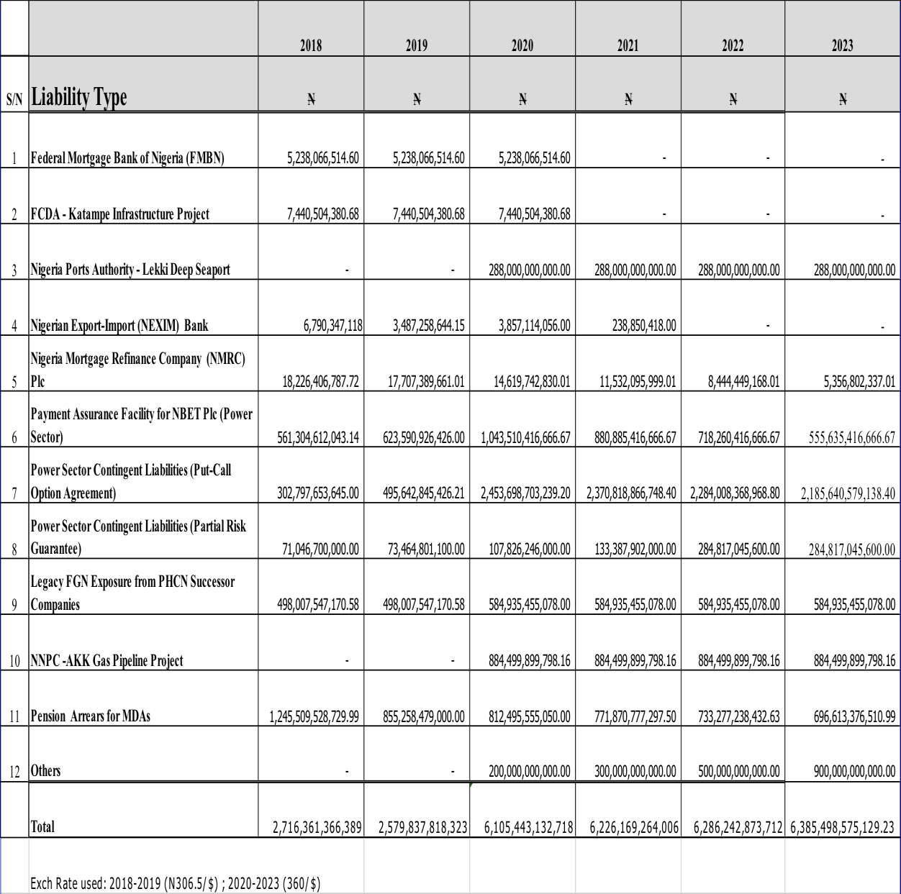

*Source: DMO*

**Notes:**

1. *The FGN provided a Guarantee for the Bond issued by FMBN to refinance mortgages provided for purchases of FGN non-essential residential houses. Out of the N32 billion Bonds issued*

*N5.238 billion is outstanding.*

1. *The Guarantee was issued on behalf of Federal Capital Development Authority (FCDA) in the sum of N61.2 billion in respect of a bank facility for Deans hanger Projects Limited for provision of infrastructure in Katampe District, Abuja. The current outstanding amount confirmed by FCDA*

*is N7,440,504.380.68*

1. *NPA LEKKI PORT-Amount guaranteed is USD800 Million (N288 billion at N360/$) Liability will commence upon the attainment of Financial Close. This is expected in 2020.*

1. *FGN Guarantee to NEXIM for $50 million Master line of credit from African Development Bank (AfDB) to finance part of the cost of the Export Oriented Small and Medium Enterprises financing programme of NEXIM. The facility will be fully repaid in 2021.*
2. *The Guarantee is to enable NMRC raise long term funds from the Capital Market by issuing Bonds for the purpose of refinancing mortgages created by Eligible Mortgage Lenders. N19 billion (N8 billion-Series 1 Bond and N11 billion Series 2 Bond) has been utilised out of total*

*Guarantee available in the sum of N440 billion.*

1. *FGN Guarantee to Central Bank of Nigeria for providing NBET a Payment Assurance Facility, for its obligations to Gencos in the sum of N1.301 trillion.*
2. *Figures are based on NBET's submissions on Put-Call option Agreements (PCOA) with Gencos.*

1. *Figures are based on NBET's submissions on Partial Risk Guarantees (PRG) issued to Gencos.*

1. *Figures provided by BPE on FGN's exposure in respect of the debt component of the purchase price of the PHCN successor companies.*
2. *FGN Guarantee for the Ajaokuta-Kaduna-Kano (AKK) Gas Pipeline Project undertaken by the Nigeria National Petroleum Corporation (NNPC). The Guarantee covers 85%*

*(US$2,456,944,166.11) of the total cost (US$2,890,522,548.36) of the Project.*

1. *Pension arrears for MDAs Data provided by PENCOM to DMO. Outstanding Retirement Benefits Liability of the FGN for certain categories of its employees. Amount has been projected to reduce by 5% annually.*
2. *Others: As part of efforts to further develop infrastructure, there will be a growing use of offbalance sheet products such as Guarantees, Letters of Comforts and like instruments, by the Government, as from 2020. Thus, it is expected that Contingent Liabilities will increase, as more off-balance sheet products are used to support infrastructural development.*

## 9.0 RISKS TO THE MEDIUM-TERM OUTLOOK

The global COVID-19 pandemic exposed vulnerabilities in public finances around the world, and sparked debt crises among seemingly solvent governments. Much of the increase in public debt stemmed from:

* National governments’ unwillingness to cut expenditures in the middle of a pandemic, with imminent recession;
* Private-sector / financial institutions unanticipated bailout requests; and
* Large issuances of foreign-denominated debt that grew rapidly as local currencies depreciated.

The outbreak of the COVID-19 pandemic led to the revision of the FGN’s 2020-2022 MTEF/FSP. The effect of this pandemic on the global economy remains to be fully quantified as this, with its resultant remnant effects, will be central to fiscal risks over the short to medium term. The Federal Government has responded and is adapting fiscal policies to contain the damage from COVID-19. In addition, we will review below a number of recurring risks, both within the domestic environment and the global economy, or shocks that may pose setbacks to FGN’s revenues, planned expenditures, and constrain economic growth or slow the pace of achieving some of the development objectives of the FGN. These are likely to have some effects on the medium-term economic forecasts. Consequently, in drafting the 2021-2023 fiscal strategy paper, we have identified and highlighted some of these risks. These will be reviewed, their likelihood assessed, and mitigating strategies proposed.

### 9.1 Global Economic Trends & Geo-Political Tensions

The uncertainty around the ultimate outcome of the global health crisis has not been fully ascertained. A number of analysis and revised forecasts show that it has triggered the greatest global recession since the Great Depression of 1930, resulting in enormous damage to people’s well-being, jobs and health. Economies are expected to contract as a result of slowdown in economic activities which in turn will do damage to labour productivity as well as potential output. This is largely due to the possibility of a second wave of infections, without any clinically approved vaccine in the horizon, resulting in renewed lockdowns before the end of 2020.

Political developments in the United States will test the US institutions to its limits. The November election will be critical to global medium-term outlook. Some consider this the US’ equivalent of Brexit as the outcome may portend political uncertainty in one of the world’s oldest democracies.

There will be implications for crude oil pricing on account of this geopolitical risk. The markets can expect prices to rally if there is any other trigger between the US and Iran, which could disrupt Middle East output and drive oil prices higher. Following the seizure of a British flagged oil tanker in the Strait of Hormuz last year, the UK also retaliated with a counter seizure of an Iranian vessel. With tensions reaching heightened levels, the UK has joined a US-led mission to protect ships traveling through the Strait of Hormuz from Iranian threat.

However, the US-China tensions have taken a new dimension post COVID-19, and it is expected to rise ahead of the US Presidential election in November, 2020. Both sides will continue to use economic tools such as sanctions, boycotts, and import/export control in this struggle. Even as trade conflicts persist, China is determined to expand its global footprint over the medium term as it leverages the Belt and Road initiative (BRI).

### 9.2 International Oil Market Developments

#### 9.2.1 Oil Prices

Oil Prices fell below US$10 per barrel and further slid into negative territory1 for the first time in history in 2020, a year described by many as the most turbulent for crude oil. Oil price Volatility has remained a major recurring risk. Oil & Gas represents under 10% of Nigeria’s GDP, but accounts for about 50% of government revenues and over 80% of export earnings. Thus, its volatility could potentially distort revenue outturns and affect budget performance. Prior to COVID-19 inspired Oil Price decline, the Nigerian economy was already fragile and vulnerable, with sluggish growth, low revenue/GDP ratio, constrained fiscal space, low foreign & domestic investments, declining foreign reserves, etc. As lockdowns forced manufacturing plants to shut down, and people stopped travelling, global demand for crude oil fell by about

29 million barrels a day. Oil prices remain volatile in the near term considering the possibility

1

West Texas Intermediate (WTI) Crude Oil

of a second wave of COVID-19 infections and lockdowns.

The medium-term outlook shows prices could recover to pre-crisis levels averaging US$50 - US$60 per barrel under the best-case scenario. Government will be conservative in setting benchmark for oil price in formulating its annual budget so as to be able to build up buffers to safeguard against price and possible production shocks and will stay within the $40 per barrel benchmark price for FY 2021 as well as the outer years

#### 9.2.2 Oil Demand & Supply Risks

The current global humanitarian crisis occasioned by the COVID-19 pandemic has contributed to an unprecedented drop in global demand for crude not envisaged at the start of the year and this affected the price of crude negatively. Organisation of Petroleum Exporting Countries (OPEC) members, as well as allied non-members like Russia and Mexico (referred to as OPEC+) finalized a production cut deal.

This marks the rejuvenation of the broader OPEC+ alliance, that was in uncertain territory in recent times as Saudi Arabia and Russia waged a grueling price war with each other. In its June 2020 report, the International Energy Agency (IEA) forecasts global oil demand to fall by 8.1mbpd in 2020, the largest fall in history. This is however expected to rebound by 5.7mbpd in 2021. On the Supply side, global supply is projected to tumble by 7.2mbpd on average in 2020 and recover slightly by 1.8mbpd by 2021 assuming that the OPEC+ cuts are fully complied with. The OPEC+ intervention has restored stability to the market and it is expected to be managed in the short to medium term.

### 9.3 Exchange Rate Risks

Depreciation of the Naira against the US dollar and other major currencies poses a key risk to government’s fiscal position. Over 80% of Nigeria’s foreign exchange earnings is derived from Crude oil and gas export. In effect, the risk of the Naira depreciating against the US Dollar is a resultant risk should there be a protracted oil price shock, due to the fact that oil revenue receipts are in US dollars. Businesses that rely heavily on forex for imports of production inputs and capital could also be constrained. To address the exchange rate risks, the Central Bank of Nigeria will pursue unification around its I&EFX market rate, which is the window where investors and exporters transact dollars at market determined rates. In addition, the CBN is endeavouring to significantly improve its foreign reserves to be able to enhance its ability to manage exchange rate risks by defending the Naira against depreciation, where possible.

### 9.4 Risks to Non-Oil Revenue

Health crisis from the global pandemic and the attendant lockdowns in many states and the FCT has led to a drop in economic activities without precedent in recent history. Improving domestic revenue mobilisation remains a critical focus for Government.

Government shall continue to drive reforms to improve Nigeria’s revenue profile, particularly increasing earnings from non-oil revenues as efforts aimed at diversification of the revenue base to reflect the GDP continue. Implementation of the Performance Management Framework has shown early results with slight improvement in the performance of Independent revenues from N454.34 billion in 2018 to N557.34 billion in 2019. This, alongside other measures and strategies outlined in section 7 of this document will be sustained over the medium term, which include improving operational efficiencies, enforcing cost-to-income ratios, and generally ensuring the GOEs operate in a more fiscally responsible manner. Plugging leakages remain key in improving non-oil revenue and efforts will be targeted at compliance within the FGN independent revenue value chain. Efforts to increase the number of tax payers and the tax base shall be pursued vigorously in the medium term, rather that increasing the tax rate (this will be subject to a medium to long term review).

### 9.5 Sensitivity of Budget aggregates to Macro-economic conditions

Fiscal aggregates are sensitive to changes in macroeconomic variables, including commodity prices, exchange rate, interest rates, GDP growth etc. The 2020 – 2022 MTEF/FSP was updated in Q2 2020 following the adverse effect of the oil price wars and the global pandemic on the key assumptions underpinning the 2020 budget as well as the medium-term outlook.

Generally, macroeconomic/fiscal forecasts and key assumptions are made in modeling FGNs policy and decision making. Therefore, the macroeconomic and fiscal forecasts contained herein as well as the 2021 Budget to follow therefrom, are based on available data and information for modeling at the time of preparation. Professional judgments of historical patterns are also considered.

Should the economic outlook differ from key assumptions and parameters presented in the 2021 – 2023 MTEF/FSP, the revenue and expenditure estimates and projections would also change, as the revenue and expenditure estimates and projections contained in this document and the planned 2021 budget to follow thereon, are based on a number of economic and other parameters. Government may have to reduce planned expenditure in the event that unanticipated changes in economic conditions occur, by way of managing budgetary pressures, should the impact of such change(s) flow through to FGN’s expenditure and revenue forecasts.

The impact of this risk is high, given the significant share of non-discretionary expenditure to total expenditure. To mitigate this risk, the medium-term revenue forecast relies significantly on observed historical relationships between the variable factors.

The analysis of the above risks, as well as others, is summarized in Table 9.1

Table 9.1: Risks Likelihood, Impact and Mitigation Strategies

|  |  |  |  |
| --- | --- | --- | --- |
| **Risk** | **Likelihood (H/M/L)** | **Impact (H/M/L)** | **Mitigation** |
| Domestic oil production shocks | L | H | Disruptions due to attacks/sabotage are now substantially abated. Government will continue with improved security architecture, leveraging technology to fully eradicate this risk.  In addition, government has approved investment opportunities which support medium term aspirations such as *ZabaZaba*  *Etan*, *Owowo, Bosi Bonga Southwest/Aparo, Ayala & Madu, Nnwa*  *Doro/Bolia Chota field developments* which are expected to boost production. These will also help to mitigate this risk, and ensure targets are realized save for force majeure or technical shut-ins. |
| Oil price shocks | H | H | Oil price outlook remains uncertain and volatile. Nigeria will comply with OPEC+ measures in managing price shocks. Nonetheless, the age long fiscal tool to address this is the adoption of a lower than forecast oil price benchmark for fiscal projections over the medium term. |
| Foreign Exchange  Supply / Rate Risk | M | H | The Central Bank of Nigeria will pursue unification around its I&EFX rate over the medium term, where investors and exporters transact dollars at market determined prices. The exchange rate gap is expected to narrow significantly with the implementation of the rate unification. Overall, CBN policies to liberalize the FX market, meeting forex demands while building external reserves is expected to mitigate this risk. |
| Failure to meet non-oil revenue projection | H | H | With economic activities slowing due to lockdowns and the contagion effect of the pandemic, a conservative approach to target setting will be in place, while collection efficiency of major revenue generating agencies will be improved upon.  Government will continue to enforce the implementation of the Performance Management Framework for GOEs by ensuring they operate in more fiscally responsible manner whilst reviewing their operational efficiencies, and cost-to-income ratios. |

|  |  |  |  |  |
| --- | --- | --- | --- | --- |
| Insecurity in parts of the country | | M | H | Banditry and other internal security issues are being tackled by the Nigeria Police and the Military High command. Economic activities in some states have been negatively affected by this, including possible food shortage as farmers are unable to go to farms in some cases. Governments ongoing efforts in restoring order, working with states and local communities to deploy peace-building & dialogue mechanisms are still ongoing with new strategies adopted, while socioeconomic/humanitarian interventions shall continue and are expected to mitigate this risk |
| Natural disaster | | L | H | The only natural disaster currently forecast is flash flooding, during the rainy season. No other imminent natural disaster warning for Nigeria is forecasted over the medium term by any of the relevant agencies monitoring such. However, there is a minimum balance of N20bn provided for emergency response by the FGN in the event of a natural disaster in any part of the country. This fund is domiciled in the Ecological Funds account. |
| Insurgency | | M | H | There has been some improvement leading to de-escalation of insurgency. Mitigation strategy largely remains the same from previous years, a twin track approach of dialogue and military force will be maintained in the event of an upsurge in major security breaches and relevant military operations required in the north east. |
| Failure of Power Sector  Recovery Programme  (PSRP) | | H | H | A World Bank facility ($750m performance – based loan) to support the implementation of the FGN PSRP has been approved. The CBN Payment Assurance Facility extension (N600bn) will also keep liquidity in the sector until June next year alongside budgetary provisions as contained in the PSRP financing plan A potential funding gap of up to N1.5trn in 2020 will be created in the event of no implementation of cost reflective tariffs.  Government has no fiscal space to accommodate further intervention in the sector. A tariff review is thus inevitable. |
| Managing  National  Pressures | Sub-  Fiscal | H | H | Decline in subnational revenues sources would increase their dependence on fiscal transfers cum bailouts from the FGN, with  damaging consequences for non-  discretional spending which will affect infrastructure investments and service delivery.    To mitigate this risk, the Federal  Government has included subnational  Governments’ needs in discussions with the  World Banks’s Performance for Results (P4R) facility up to $1.5bn, including upscaling the $750m SFTAS programme for disbursement to qualifying states, to prioritise investments in critical sectors such Health, Water, Sanitation etc, and strengthen infrastructure planning. |

# 10. CONCLUSION

The medium-term outlook for the FGN suggests that fiscal risk is somewhat elevated, largely due to COVID-19 disruptions. The potential for weaker-than-expected economic performance threatens the revenue forecast, as seen in the base year (2020 revised budget) and the updated medium-term projections. This fiscal strategy paper has been prepared against the backdrop of heightened global economic uncertainty. The COVID-19 Pandemic and its possible contagion effect from downward revision of advance economies’ outlook will certainly have effect on financial markets and slow economic recovery in the medium term.

Downside risks to economic development have been taken into consideration in the preparation of the 2021-23 MTEF/FSP. Government has identified key sectors that are expected to drive recovery and growth and there will be allocative efficiency for capital spend in those priority sectors over the medium term. Furthermore, emphasis shall be on completing ongoing projects and Government will ensure completion of critical ongoing projects within the medium term. This is to ensure we work down the current portfolio of ongoing projects by 2023 where possible.

Furthermore, Public Expenditure Reviews (PER) will be carried out for selected sectors to review their quality of spending over a three-year period with a view to addressing identified utilization issues across board. In addition, attention will continue to be paid to the costing of activities/projects, competitive bidding in public procurement, the Open Treasury Portal, continuous audit of MDAs’ operations and other public financial management reforms which are expected to yield significant results.

The long-term sustainability of public finances is considered priority and government is committed to stabilizing national debt as a share of GDP over the medium term. The outlook for contingent liabilities is also a source of vulnerability. The macroeconomic and fiscal policies outlined therefore, are in part, designed to reduce these risks, and ensure that government’s fiscal targets are achieved.

The government is working on both a new long-term vision, possibly up to 2050, to succeed the Vision 20:2020. Similarly, a successor medium-term development plan is under preparation as lifespan of the ERGP 2017-2020 draws to its end.

# ANNEXURE 1: 2021 – 2023 MEDIUM TERM FISCAL FRAMEWORK

|  |  |  |  |  |  |  |  |  |  |  |  |  |  |  |  |
| --- | --- | --- | --- | --- | --- | --- | --- | --- | --- | --- | --- | --- | --- | --- | --- |
| **2021-2023 Medium Term Fiscal Framework** | | | | | | | | | | | | | | | |
| 1 | **FISCAL ITEMS** | | | | **2020 Revised Budget** | | **2021 Proj.** | | **2022 Proj.** | | **2023 Proj.** | |  | 1 | |
| 2 | **Budget Oil Production Volume Net Incremental Oil Prodution for Repayment Arrears (mbpd)** | | | | **1.80** | | **1.86** | | **2.09** | | **2.38** | |  | 2 | |
| 3 | **Projected Budget Benchmark Price (US$ per barrel)** | | | | **28.00** | | **40.00** | | **40.00** | | **40.00** | |  | 3 | |
| 4 | **Average Exchange Rate (N/US$)** | | | | **360.0** | | **360.0** | | **360.0** | | **360.0** | |  | 4 | |
| 5 | **Oil production (mbpd)** | | | |  | |  | |  | |  | |  | 5 | |
| 6 | Joint Ventures | | | | 0.707 | | 0.716 | | 0.747 | | 0.804 | |  | 6 | |
| 7 | Modified Carry Arrangement | | | | 0.055 | | 0.067 | | 0.033 | | 0.038 | |  | 7 | |
| 8 | External Financing | | | | 0.041 | | 0.041 | | 0.047 | | 0.060 | |  | 8 | |
| 9 | Production Sharing Contracts | | | | 0.734 | | 0.812 | | 0.754 | | 0.800 | |  | 9 | |
| 10 | Independents | | | | 0.225 | | 0.190 | | 0.456 | | 0.627 | |  | 10 | |
| 11 | Service Contracts | | | | 0.003 | | 0.003 | | 0.002 | | 0.002 | |  | 11 | |
| 12 | Marginal Fields | | | | 0.035 | | 0.035 | | 0.050 | | 0.051 | |  | 12 | |
| 13 | Repayment Arrears* | | | | 0.080 | | 0.090 | | 0.116 | | 0.119 | |  | 13 | |
| 14 |  | | | |  | |  | |  | |  | |  | 14 | |
| 15 | **FEDERALLY COLLECTIBLE REVENUE** | | | | **N** | | **N** | | **N** | | **N** | |  | 15 | |
| 16 | **Gross Minerals Revenue** | | | | **3,549,154,361,474** | | **5,669,145,887,355** | | **6,122,425,740,058** | | **6,663,547,962,396** | |  | 16 | |
| 17 | Gross Oil Revenue (See Line Item 84) | | | | 3,033,363,682,134 | | 5,121,365,644,379 | | 5,915,121,505,768 | | 6,486,392,598,389 | |  | 17 | |
| 18 | Dividend Payment (NLNG) (See Line Item 107) | | | | 160,754,400,000 | | 198,086,400,000 | | 164,484,000,000 | | 169,516,800,000 | |  | 18 | |
| 19 | Solid Minerals (NLNG) (See Line Item 112) | | | | 4,515,225,139 | | 6,312,862,816 | | 6,944,149,098 | | 7,638,564,007 | |  | 19 | |
| 20 | Signature Bonus (See Line Item 116) | | | | 350,521,054,200 | | 343,380,980,160 | | 35,876,085,192 | | - | |  |  | |
| 21 | **Other Revenue (Gross)** | | | | **6,612,869,525,468** | | **6,119,151,366,514** | | **7,020,108,566,277** | | **7,427,249,273,199** | |  | 21 | |
| 22 | Gross Non-Oil Revenue (See Line Item 133) | | | | 6,078,846,844,325 | | 5,564,124,246,453 | | 6,379,234,801,696 | | 6,688,006,345,100 | |  | 22 | |
| 23 | Non-Federation Account Levies for Targeted Expenditure | | | | 240,853,804,117 | | 212,899,040,571 | | 241,610,295,817 | | 249,296,464,195 | |  | 23 | |
| 24 | Education Tax | | | | 277,024,798,007 | | 323,287,939,274 | | 377,277,025,133 | | 467,240,672,913 | |  | 24 | |
| 25 | National Information Technology Development Fund | | | | 16,144,079,019 | | 18,840,140,216 | | 21,986,443,632 | | 22,705,790,991 | |  | 25 | |
| 26 | **Total Federally Collectible Revenue** | | | | **10,162,023,886,942** | | **11,788,297,253,869** | | **13,142,534,306,335** | | **14,090,797,235,595** | |  | 26 | |
| 27 |  | | | |  | |  | |  | |  | |  | 27 | |
| 28 | **GROSS FEDERATION ACCOUNT INFLOWS** | | | | **9,116,725,751,599** | | **10,691,802,753,648** | | **12,301,300,456,562** | | **13,182,037,507,497** | |  | 28 | |
| 29 | **OIL REVENUE** | | | |  | |  | |  | |  | |  | 29 | |
| 30 | **Profit Oil from Crude Oil & Gas Sales** | | | | **656,864,742,350** | | **598,461,831,525** | | **739,151,653,232** | | **762,943,705,799** | |  | 30 | |
| 31 | NNPC JV Crude Oil & Gas (Profit Oil) | | | | 280,691,780,270 | | 309,956,265,210 | | 487,788,379,616 | | 474,612,095,840 | |  | 31 | |
| 32 | MCA Crude Oil & Gas (Profit Oil) | | | | 40,582,080,000 | | 70,040,193,847 | | 35,049,469,795 | | 39,759,863,982 | |  | 32 | |
| 33 | EF Crude Oil & Gas (Profit Oil) | | | | 30,252,096,000 | | 43,601,713,184 | | 49,062,741,696 | | 62,657,123,328 | |  |  | |
| 34 | PSC Crude Oil & Gas (Profit Oil) | | | | 145,007,962,453 | | 174,455,806,600 | | 166,976,821,980 | | 185,689,745,730 | |  | 34 | |
| 35 | PSC Crude Oil & Gas (New Terms) | | | | 160,000,000,000 | | - | | - | | - | |  | 35 | |
| 36 | SC Crude Oil & Gas (Profit Oil) | | | | 330,823,627 | | 407,852,684 | | 274,240,144 | | 224,876,918 | |  | 36 | |
| 37 | **Petroleum Profits Tax on Oil & Gas** | | | | **284,003,905,677** | | **1,554,775,136,822** | | **2,025,001,178,106** | | **2,350,075,894,874** | |  | 37 | |
| 38 | NNPC JV PPT | | | | - | | 388,180,241,562 | | 448,377,951,111 | | 497,642,138,838 | |  | 38 | |
| 39 |  | | *NNPC JV PPT (Gross)* | | *-* | | *1,494,665,748,602* | | *1,560,719,572,197* | | *1,678,752,750,200* | |  | 39 | |
| 40 |  | | *NNPC JV PPT (Cost Recovery)* | | *-* | | *1,106,485,507,040* | | *1,112,341,621,087* | | *1,181,110,611,361* | |  | 40 | |
| 41 | JV Partner PPT | | | | - | | 287,323,551,679 | | 331,880,738,930 | | 368,345,143,537 | |  | 41 | |
| 42 |  | | *JV Partner PPT (Gross)* | | *-* | | *1,106,322,850,781* | | *1,155,214,621,060* | | *1,242,580,510,120* | |  | 42 | |
| 43 |  | | *JV Partner PPT (Cost Recovery)* | | *-* | | *818,999,299,102* | | *823,333,882,130* | | *874,235,366,584* | |  | 43 | |
| 44 | PSC PPT | | | | 201,609,570,026 | | 437,872,127,210 | | 515,490,293,721 | | 574,863,347,162 | |  | 44 | |
| 45 |  | | *PSC PPT (Gross)* | | *1,314,419,496,138* | | *1,924,151,977,228* | | *1,788,814,399,556* | | *1,896,701,184,000* | |  | 45 | |
| 46 |  | | *PSC PPT (Cost Recovery)* | | *1,112,809,926,112* | | *1,486,279,850,018* | | *1,273,324,105,835* | | *1,321,837,836,838* | |  | 46 | |
| 47 | SC PPT | | | | 8,537,428,773 | | 12,163,003,521 | | 8,178,403,567 | | 6,706,290,925 | |  | 47 | |
| 48 | Independent Producers' Tax | | | | - | | 122,755,334,349 | | 345,250,510,455 | | 497,475,794,671 | |  | 48 | |
| 49 |  | | *Independent Producers' Tax (Gross)* | | *-* | | *684,932,223,600* | | *1,645,617,700,062* | | *2,261,862,496,714* | |  | 49 | |
| 50 |  | | *Independent Producers' Tax (Cost Recovery)* | | *-* | | *562,176,889,251* | | *1,300,367,189,607* | | *1,764,386,702,042* | |  | 50 | |
| 51 | MCA Profits Tax | | | | - | | 62,874,766,504 | | 34,804,910,909 | | 40,739,435,146 | |  | 51 | |
| 52 | External Financing Profits Tax | | | | - | | 39,141,061,512 | | 48,720,404,721 | | 64,200,818,530 | |  | 52 | |
| 53 | Marginal Fields Profits Tax | | | | - | | 70,193,302,917 | | 119,589,686,125 | | 123,053,049,241 | |  | 53 | |
| 54 |  | | *Marginal Fields Profit Tax (Gross)* | | *-* | | *141,839,598,600* | | *202,627,998,000* | | *206,680,557,960* | |  | 54 | |
| 55 |  | | *Marginal Fields Profit Tax (Cost Recovery)* | | *-* | | *71,646,295,683* | | *83,038,311,875* | | *83,627,508,719* | |  | 55 | |
| 56 | Repayment Arrears (Partners' Tax) | | | | 73,856,906,878 | | 134,271,747,569 | | 172,708,278,567 | | 177,049,876,825 | |  | 56 | |
| 57 |  | | *Repayment Arrears (Partners' Tax) Gross* | | *85,982,622,419* | | *139,094,833,222* | | *178,912,017,147* | | *183,409,567,053* | |  | 57 | |
| 58 |  | | *Repayment Arrears (Partners' Tax) Cost Recovery* | | *12,125,715,541* | | *4,823,085,654* | | *6,203,738,580* | | *6,359,690,228* | |  | 58 | |
| 59 | **Gas Income @ 30% CITA (Net of Cost recovery)** | | | | **426,614,336,799** | | **486,034,066,822** | | **508,947,701,024** | | **527,446,034,238** | |  | 59 | |
| 60 | NNPC JV Gas Income Tax | | | | 216,697,576,272 | | 227,621,495,432 | | 238,306,824,675 | | 248,936,946,263 | |  | 60 | |
| 61 | JV Partner Gas Income Tax | | | | 157,338,428,373 | | 168,481,054,685 | | 176,390,129,955 | | 184,258,341,580 | |  | 61 | |
| 62 | Independent Producers' Gas Income Tax | | | | 52,578,332,154 | | 89,931,516,705 | | 94,250,746,395 | | 94,250,746,395 | |  | 62 | |
| 63 | **Oil & Gas Royalties** | | | | **945,373,464,571** | | **1,601,208,541,268** | | **1,888,574,664,937** | | **2,168,580,743,747** | |  | 63 | |
| 64 | NNPC JV Royalty | | | | 326,807,785,038 | | 440,796,884,989 | | 465,460,955,770 | | 501,406,270,630 | |  | 64 | |
| 65 | JV Partner Royalty | | | | 237,286,563,894 | | 326,269,379,540 | | 344,525,250,543 | | 371,131,281,520 | |  | 65 | |
| 66 | PSC Royalty | | | | 85,386,635,447 | | 426,565,570,903 | | 396,562,560,866 | | 420,480,000,000 | |  | 66 | |
| 67 | SC Royalty | | | | 2,279,934,064 | | 3,248,149,623 | | 2,184,055,806 | | 1,790,925,761 | |  | 67 | |
| 68 | Independent Producers' Royalty | | | | 160,289,992,800 | | 192,837,384,000 | | 463,310,969,188 | | 636,809,937,984 | |  | 68 | |
| 69 | Marginal Fields Royalty | | | | 11,995,693,920 | | 17,089,884,000 | | 24,414,120,000 | | 24,902,402,400 | |  | 69 | |
| 70 | MCA Royalty | | | | 37,883,371,680 | | 65,382,520,956 | | 32,718,680,054 | | 37,115,833,027 | |  | 70 | |
| 71 | EF Royalty | | | | 28,240,331,616 | | 40,702,199,257 | | 45,800,069,373 | | 58,490,424,627 | |  | 71 | |
| 72 | Repayment Arrears (Royalties) - NNPC | | | | 31,981,921,482 | | 50,751,375,556 | | 65,279,426,729 | | 66,920,442,711 | |  | 72 | |
| 73 | Repayment Arrears (Royalties) - JV Partner | | | | 23,221,234,630 | | 37,565,192,444 | | 48,318,576,607 | | 49,533,225,087 | |  | 73 | |
| 74 | **Gas Royalties (net of Cost Recovery)** | | | | **-** | | **-** | | **-** | | **-** | |  | 74 | |
| 75 | **Concessional Rentals** | | | | **6,030,890,426** | | **6,052,601,135** | | **6,025,813,895** | | **6,025,813,895** | |  | 75 | |
| 76 | **Gas Flared Penalty** | | | | **103,508,708,449** | | **130,424,297,362** | | **136,564,930,959** | | **120,451,995,213** | |  | 76 | |
| 77 | **Miscellaneous (Pipeline Fees etc)** | | | | **6,295,658,511** | | **9,083,735,851** | | **9,173,673,830** | | **9,263,611,808** | |  | 77 | |
| 78 | **Exchange Gain** | | | |  | | **235,582,198,691** | | **286,759,733,183** | | **322,724,798,814** | |  | 78 | |
| 79 | **Incidental Oil Revenue (Royalty Recovery & Marginal Field Licences)** | | | | **604,671,975,351** | | **499,743,234,904** | | **314,922,156,602** | | **218,880,000,000** | |  | 79 | |
| 80 | Royalties Recovery and Marginal Fields | | | | 80,671,975,351 | | - | | - | | - | |  | 80 | |
| 81 | Good and Valuable Consideration of Diversted Assets | | | | 334,800,000,000 | | 390,303,234,904 | | 260,202,156,602 | | - | |  | 81 | |
| 82 | Recovery of Back Taxes from NPDC | | | | 189,200,000,000 | | - | | - | | - | |  |  | |
| 83 | Lease Renewal Bonus | | | |  | | 109,440,000,000 | | 54,720,000,000 | | 218,880,000,000 | |  |  | |
| 84 | **Total Oil & Gas Revenue** | | | | **3,033,363,682,134** | | **5,121,365,644,379** | | **5,915,121,505,768** | | **6,486,392,598,389** | |  | 84 | |
| 85 | **Deductions** | | | | **424,233,211,044** | | **395,607,269,903** | | **525,455,994,474** | | **327,199,964,748** | |  | 85 | |
| 86 | | Fiscal Deductions (Base JV Cash Call + EF + MCA + RA) | | | | - | | - | | - | | - | | |  | | 86 |
| 87 | | **Other Federally Funded Upstream Projects** | | | | **424,233,211,044** | | **395,607,269,903** | | **525,455,994,474** | | **327,199,964,748** | | |  | | 87 |
| 88 | | National Domestic Gas Development | | | | 80,704,587,044 | | 80,704,587,044 | | 80,704,587,044 | | 80,704,587,044 | | |  | | 88 |
| 89 | | Gas Infrastructure Development | | | | 60,920,374,000 | | 60,920,374,000 | | 218,574,450,000 | | 103,302,000,000 | | |  | | 89 |
| 90 | | Brass LNG Gas Supply Projects | | | | 411,750,000 | | - | | - | | - | | |  | | 90 |
| 91 | | Crude Oil Pre-Export Inspection Agency Expenses (NESS) | | | | 10,250,000,000 | | 10,250,000,000 | | 10,000,000,000 | | 5,000,000,000 | | |  | | 91 |
| 92 | | Frontier Exploration Services (NFES) | | | | 50,000,000,000 | | 50,000,000,000 | | 90,058,830,701 | | 93,473,868,844 | | |  | | 92 |
| 93 | | EGTL Funding | | | | - | | - | | - | | - | | |  | | 93 |
| 94 | | Renewable Energy Development (RED) | | | | 3,050,000,000 | | 3,050,000,000 | | 17,208,000,000 | | 15,037,200,000 | | |  | | 94 |
| 95 | | Pipeline Security & Maintenance Cost | | | | 57,896,500,000 | | 29,682,308,859 | | 29,682,308,859 | | 29,682,308,859 | | |  | | 95 |
| 96 | | Nigerian Crude Oil Finger Printing | | | | - | | - | | - | | - | | |  | | 96 |
| 97 | | Pre-Export Financing | | | | 60,000,000,000 | | 60,000,000,000 | | 79,227,817,869 | | - | | |  | | 97 |
| 98 | | PMS Under-Recovery | | | | - | | - | | - | | - | | |  | | 98 |
| 99 | | Other deductions (transfer to excess crude oil on PPT and Royalty) | | | |  | |  | |  | |  | | |  | | 99 |
| 100 | | Refinery Rehabilitation | | | | 100,000,000,000 | | 100,000,000,000 | | - | | - | | |  | | 100 |
| 101 | | Nigeria Morocco Pipeline | | | | 1,000,000,000 | | 1,000,000,000 | | - | | - | | |  | | 101 |
| 102 | | **13% Derivation** | | | | **339,186,961,242** | | **614,348,588,682** | | **700,656,516,468** | | **800,695,042,373** | | |  | | 102 |
| 103 | | **Special Federation Transfers:** | | | | **169,200,000,000** | |  | |  | |  | | |  | | 103 |
| 104 | | Presidential Power Initiative | | | | 72,000,000,000 | |  | |  | |  | | |  | | 104 |
| 105 | | Nigeria Sovereign Investment Authority (NSIA) | | | | 97,200,000,000 | |  | |  | |  | | |  | | 105 |
| 106 | | **Net Oil & Gas Revenue after Costs, Deductions & Derivation** | | | | **2,100,743,509,848** | | **4,111,409,785,794** | | **4,689,008,994,826** | | **5,358,497,591,268** | | |  | | 106 |
| 112107 | | **DIVIDEND BY COMPANIES/INVESTMENTS** | | | | **160,754,400,000** | | **198,086,400,000** | | **164,484,000,000** | | **169,516,800,000** | | |  | | 107 |
| 108 | | **SOLID MINERAL & OTHER MINING REVENUES** | | | |  | |  | |  | |  | | |  | | 108 |
| 109 | | Royalties on Mining & Other Minerals | | | | 2,638,138,336 | | 5,283,306,569 | | 5,811,637,226 | | 6,392,800,949 | | |  | | 109 |
| 110 | | Taxes on Minerals & Other Mining | | | | - | | - | | - | | - | | |  | | 110 |
| 111 | | Mining Rents, Premium & Fees | | | | 1,877,086,803 | | 1,029,556,247 | | 1,132,511,872 | | 1,245,763,059 | | |  | | 111 |
| 112 | | **Total Solid Minerals Revenue** | | | | **4,515,225,139** | | **6,312,862,816** | | **6,944,149,098** | | **7,638,564,007** | | |  | | 112 |
| 113 | | Less 13% Derivation | | | | 586,979,268 | | 820,672,166 | | 902,739,383 | | 993,013,321 | | |  | | 113 |
| 114 | | **Net Solid Minerals after Derivation** | | | | **3,928,245,871** | | **5,492,190,650** | | **6,041,409,715** | | **6,645,550,686** | | |  | | 114 |
| 115 | |  | | | |  | |  | |  | |  | | |  | | 115 |
| 116 | | **SIGNATURE BONUS** | | | | **350,521,054,200** | | **343,380,980,160** | | **35,876,085,192** | | **-** | | |  | | 116 |
| 117 | |  | | | |  | |  | |  | |  | | |  | | 117 |
| 118 | | **NON-OIL REVENUE** | | | |  | |  | |  | |  | | |  | | 118 |
| 119 | | **Corporate Tax** | | | | **1,798,617,662,965** | | **1,496,529,236,236** | | **1,886,017,658,963** | | **1,946,016,133,951** | | |  | | 119 |
| 120 | | Companies Income Tax | | | | 1,540,399,276,594 | | 1,274,801,531,567 | | 1,606,582,846,490 | | 1,657,691,869,925 | | |  | | 120 |
| 121 | | NLNG Tax | | | | 227,487,217,263 | | 202,070,326,095 | | 254,661,381,910 | | 262,762,734,768 | | |  | | 121 |
| 122 | | Stamp Duties | | | | 17,192,462,425 | | 12,398,869,904 | | 15,625,814,067 | | 16,122,906,451 | | |  | | 122 |
| 123 | | Capital Gains Tax | | | | 13,538,706,682 | | 7,258,508,670 | | 9,147,616,497 | | 9,438,622,807 | | |  | | 123 |
| 124 | | **Value-Added Tax** | | | | **2,190,615,599,087** | | **1,838,346,807,579** | | **1,958,312,755,901** | | **2,028,355,868,636** | | |  | | 124 |
| 125 | | **Surcharge on Luxury Items** | | | | - | | - | | - | | - | | |  | | 125 |
| 126 | | **Customs** | | | | **1,156,771,315,633** | | **1,267,349,611,699** | | **1,479,920,164,986** | | **1,526,999,762,879** | | |  | | 126 |
| 127 | | ***Main Federation Account*** | | | | ***1,004,239,295,104*** | | ***1,132,521,262,419*** | | ***1,326,909,060,441*** | | ***1,369,121,030,035*** | | |  | | 127 |
| 128 | | Import | |  | | 923,761,997,840 | | 1,031,726,870,063 | | 1,208,814,154,062 | | 1,247,269,258,362 | | |  | | 128 |
| 129 | | Excise | |  | | 78,668,818,674 | | 98,529,349,830 | | 115,441,088,258 | | 119,113,529,613 | | |  | | 129 |
| 130 | | Fees | | | | 1,808,478,590 | | 2,265,042,525 | | 2,653,818,121 | | 2,738,242,060 | | |  | | 130 |
| 131 | | ***Special levies (Federation Account)*** | | | | ***152,532,020,529*** | | ***134,828,349,280*** | | ***153,011,104,544*** | | ***157,878,732,843*** | | |  | | 131 |
| 132 | | **FGN Independent Revenue** | | | | **932,842,266,640** | | **961,898,590,939** | | **1,054,984,221,846** | | **1,186,634,579,635** | | |  | | 132 |
| 133 | | **Total Non-Oil Revenue** | | | | **6,078,846,844,325** | | **5,564,124,246,453** | | **6,379,234,801,696** | | **6,688,006,345,100** | | |  | | 133 |
| 134 | | **Costs and Deductions** | | | | **3,300,376,564,340** | | **2,972,821,040,786** | | **3,216,332,095,655** | | **3,423,721,077,031** | | |  | | 134 |
| 135 | | FIRS Tax Refunds | | | | 25,000,000,000 | | 25,000,000,000 | | 25,000,000,000 | | 25,000,000,000 | | |  | | 135 |
| 136 | | 4% | | Collection Cost (CIT, Stamp Duties & Capital Gains) | | 70,944,706,519 | | 58,861,169,449 | | 74,440,706,359 | | 76,840,645,358 | | |  | | 136 |
| 137 | | 4% | | Collection Cost (VAT & Surcharge on Luxury Items) | | 87,624,623,963 | | 73,533,872,303 | | 78,332,510,236 | | 81,134,234,745 | | |  | | 137 |
| 138 | | 3% | | Transfer to North East Development Commission (NEDC) from VAT | | 63,089,729,254 | | 52,944,388,058 | | 56,399,407,370 | | 58,416,649,017 | | |  | | 138 |
| 139 | | 0.5% | | Transfer to Nigerian Police Trust Fund from VAT | | 10,514,954,876 | | 8,824,064,676 | | 9,399,901,228 | | 9,736,108,169 | | |  | |  |
| 140 | | Value-Added Tax & Luxury Surcharge Net of Cost of Collection, and transfers to NEDC and Police Trust Fund | | | | 2,029,386,290,994 | | 1,703,044,482,541 | | 1,814,180,937,067 | | 1,879,068,876,704 | | |  | | 140 |
| 141 | | 7% | | Cost of Collection (Duty, Excise & Fees) | | 70,296,750,657 | | 79,276,488,369 | | 92,883,634,231 | | 95,838,472,102 | | |  | | 141 |
| 142 | | 7% | | Cost of Collection (Spec. Levies -Fed. Acct.) | | 10,677,241,437 | | 9,437,984,450 | | 10,710,777,318 | | 11,051,511,299 | | |  | | 142 |
| 143 | | FGN Independent Revenue | | | | 932,842,266,640 | | 961,898,590,939 | | 1,054,984,221,846 | | 1,186,634,579,635 | | |  | | 143 |
| 144 | | **Net Non-Oil Revenue after Costs & Deductions** | | | | **2,778,470,279,985** | | **2,591,303,205,667** | | **3,162,902,706,041** | | **3,264,285,268,070** | | |  | | 144 |
| 145 | |  | | | |  | |  | |  | |  | | |  | | 145 |
| 146 | | **NET FEDERATION ACCOUNT (MAIN POOL)** | | | | **4,893,871,873,398** | | **6,716,252,560,381** | | **7,863,988,644,285** | | **8,633,955,060,301** | | |  | | 146 |
| 147 | | Transfer to Police Trust Fund (0.5% of Fed. Acct.) | | | | 24,469,359,367 | | 41,588,404,181 | | 45,325,299,256 | | 47,673,792,327 | | |  | | 147 |
| 148 | | **NET FEDERATION ACCOUNT - MAIN POOL (after 0.5% transfer to Police Trust Fund)** | | | | **4,869,402,514,031** | | **6,674,664,156,200** | | **7,818,663,345,029** | | **8,586,281,267,974** | | |  | | 148 |
| 149 | | Net Oil Revenue after Costs, Deductions & Derivation | | | | 2,090,239,792,299 | | 4,090,852,736,865 | | 4,665,563,949,852 | | 5,331,705,103,312 | | |  | | 149 |
| 150 | | Dividend Payment (NLNG) | | | |  | |  | |  | |  | | |  | | 150 |
| 151 | | Net Solid Minerals Revenue after Derivation | | | | 3,908,604,642 | | 5,464,729,697 | | 6,011,202,666 | | 6,612,322,933 | | |  | | 151 |
| 152 | | Net Corporate Tax Distributable | | | | 1,694,159,591,664 | | 1,405,604,726,453 | | 1,777,644,067,841 | | 1,834,954,611,150 | | |  | | 152 |
| 153 | | Net Customs Revenue Distributable | | | | 929,272,831,724 | | 1,047,978,550,179 | | 1,227,855,299,079 | | 1,266,916,145,143 | | |  | | 153 |
| 154 | | Net Special Levies Distributable | | | | 141,145,505,197 | | 124,763,413,007 | | 141,588,825,590 | | 146,093,085,436 | | |  | | 154 |
| 155 | | Actual Balances in Special Accounts | | | | 10,676,188,505 | | - | | - | | - | | |  | | 155 |
|  | |  | |  | |  | |  | |  | |  | | |  | |  |

157

|  |  |  |  |  |  |  |  |  |
| --- | --- | --- | --- | --- | --- | --- | --- | --- |
| 163164 | **Distribution** | |  |  |  |  |  | 163 |
| 165 | FGN's Share of Federation Account (52.68%) | | 2,565,201,244,392 | 3,516,213,077,486 | 4,118,871,850,162 | 4,523,252,971,969 |  | 165 |
| 166 | States' Share of Federation Account (26.72%) | | 1,301,104,351,749 | 1,783,470,262,537 | 2,089,146,845,792 | 2,294,254,354,803 |  | 166 |
| 167 | Local Govt.'s Share of Federation Account (20.60%) | | 1,003,096,917,890 | 1,374,980,816,177 | 1,610,644,649,076 | 1,768,773,941,203 |  | 167 |
| 168 | **Total Federation Account Distribution (Net) (100.00%)** | | **4,869,402,514,031** | **6,674,664,156,200** | **7,818,663,345,029** | **8,586,281,267,974** |  | 168 |
| 169 |  | |  |  |  |  |  | 169 |
| 170 | **NET VAT POOL ACCOUNT DISTRIBUTABLE** | | **2,029,386,290,994** | **1,703,044,482,541** | **1,814,180,937,067** | **1,879,068,876,704** |  |  |
|  |  |  |  |  |  |  |  |  |
| 171  172 | FGN's' Share of VAT Pool Account (15%) | | 304,407,943,649 | 255,456,672,381 | 272,127,140,560 | 281,860,331,506 |  | 172 |
| 173 | States' Share of VAT Pool Account (50%) | | 1,014,693,145,497 | 851,522,241,271 | 907,090,468,533 | 939,534,438,352 |  | 173 |
| 174 | Local Govt.'s Share of VAT Pool Account (35%) | | 710,285,201,848 | 596,065,568,889 | 634,963,327,973 | 657,674,106,846 |  | 174 |
| 175 | **Total VAT Pool Account Distribution (Net) (100.00%)** | | **2,029,386,290,994** | **1,703,044,482,541** | **1,814,180,937,067** | **1,879,068,876,704** |  | 175 |
|  |  | |  |  |  |  |  |  |
| 176  188 | **TOTAL STATES** | | **2,315,797,497,246** | **2,634,992,503,807** | **2,996,237,314,325** | **3,233,788,793,155** |  | 188 |
| 189 | States' Share of Federation Account (26.72%) | | 1,301,104,351,749 | 1,783,470,262,537 | 2,089,146,845,792 | 2,294,254,354,803 |  | 189 |
| 190 | States' Share of VAT Pool Account (50%) | | 1,014,693,145,497 | 851,522,241,271 | 907,090,468,533 | 939,534,438,352 |  | 190 |
|  |  | |  |  |  |  |  |  |
| 193194 | **TOTAL LGCs** | | **1,713,382,119,738** | **1,971,046,385,067** | **2,245,607,977,049** | **2,426,448,048,049** |  | 194 |
| 195 | Local Govt.'s Share of Federation Account (20.60%) | | 1,003,096,917,890 | 1,374,980,816,177 | 1,610,644,649,076 | 1,768,773,941,203 |  | 195 |
| 196 | Local Govt.'s Share of VAT Pool Account (35%) | | 710,285,201,848 | 596,065,568,889 | 634,963,327,973 | 657,674,106,846 |  | 196 |
|  |  | |  |  |  |  |  |  |
| 198202 | **REDISTRIBUTE FGN'S SHARE OF FED. ACCT** | |  |  |  |  |  | 202 |
| 203 | **Gross FGN's Share of Federation Account (52.68%)** | | **2,565,201,244,392** | **3,516,213,077,486** | **4,118,871,850,162** | **4,523,252,971,969** |  | 203 |
| 204 | **Deductions** | | **203,541,025,087** | **279,000,961,729** | **326,820,127,822** | **358,906,557,001** |  | 204 |
| 205 | FCT 1% | | 48,694,025,140 | 66,746,641,562 | 78,186,633,450 | 85,862,812,680 |  | 205 |
| 206 | Ecology and Derivation 1% | | 48,694,025,140 | 66,746,641,562 | 78,186,633,450 | 85,862,812,680 |  | 206 |
| 207 | Statutory stabilisation 0.5% | | 24,347,012,570 | 33,373,320,781 | 39,093,316,725 | 42,931,406,340 |  | 207 |
| 208 | Development of Natural Resources 1.68% | | 81,805,962,236 | 112,134,357,824 | 131,353,544,196 | 144,249,525,302 |  | 208 |
| 209 | **Net FGN's Share of Federation Account (48.5%)** | | **2,361,660,219,305** | **3,237,212,115,757** | **3,792,051,722,339** | **4,164,346,414,967** |  | 209 |
| 210 | Net Ecology and Derivation (after 10% Transfer to NEDC) | | 43,824,622,626 | 60,071,977,406 | 70,367,970,105 | 77,276,531,412 |  | 210 |
| 211212 | **REDISTRIBUTE FGN'S SHARE OF VAT** | |  |  |  |  |  | 211212 |
| 213 | **Gross FGN's Share of VAT (15%)** | | 304,407,943,649 | 255,456,672,381 | 272,127,140,560 | 281,860,331,506 |  | 213 |
| 214 | **Deductions** | |  |  |  |  |  | 214 |
| 215 | FCT 1% | | 20,293,862,910 | 17,030,444,825 | 18,141,809,371 | 18,790,688,767 |  | 215 |
| 216 | **Net FGN's Share of VAT Pool Account (14%)** | | 284,114,080,739 | 238,426,227,556 | 253,985,331,189 | 263,069,642,739 |  | 216 |
| 217 | **AMOUNT AVAILABLE FOR FGN BUDGET (excluding GOEs)** | | **5,365,422,722,620** | **6,148,742,613,951** | **6,398,276,877,580** | **6,860,375,039,367** |  | 217 |
| 218 | a | **Share of Oil Revenue** | **1,013,766,299,265** | **1,984,063,577,379** | **2,262,798,515,678** | **2,585,876,975,106** |  | 218 |
| 219 | b | **Share of Dividend (NLNG)** | **80,377,200,000** | **198,086,400,000** | **164,484,000,000** | **169,516,800,000** |  | 219 |
| 220 | c | **Share of Minerals & Mining** | **1,895,673,251** | **2,650,393,903** | **2,915,433,293** | **3,206,976,622** |  | 220 |
| 221 | d | **Share of Non-Oil** | **1,624,934,376,103** | **1,488,924,372,031** | **1,780,323,104,557** | **1,838,332,105,977** |  | 221 |
| 222 |  | *Share of CIT* | *821,667,401,957* | *681,718,292,330* | *862,157,372,903* | *889,952,986,408* |  | 222 |
| 223 |  | *Share of VAT* | *284,114,080,739* | *238,426,227,556* | *253,985,331,189* | *263,069,642,739* |  | 223 |
| 224 |  | *Share of Customs* | *450,697,323,386* | *508,269,596,837* | *595,509,820,054* | *614,454,330,394* |  | 224 |
| 225 |  | *Share of Federation Acct. Levies* | *68,455,570,020* | *60,510,255,308* | *68,670,580,411* | *70,855,146,437* |  | 225 |
| 226 | e | Revenue from GOEs | 990,113,888,722 | 2,173,860,133,098 | 2,377,065,648,677 | 2,471,678,354,010 |  | 226 |
| 227 | f | GOEs Operating Surplus (80% of which is captured in Independent Revenue) | (520,531,126,098) | (825,023,025,138) | (902,637,079,581) | (979,770,761,775) |  | 227 |
| 228 | g | Independent Revenue | 932,842,266,640 | 961,898,590,939 | 1,054,984,221,846 | 1,186,634,579,635 |  | 228 |
| 229 | h | Transfers from Special Levies Accounts | 300,000,000,000 | 300,000,000,000 | 300,000,000,000 | 300,000,000,000 |  | 229 |
| 230 | i | Transfers from Special Accounts | 345,000,000,000 |  |  |  |  | 230 |
| 244 | j | Signature Bonus / Renewals / Early Renewals | 350,521,054,200 | 343,380,980,160 | 35,876,085,192 | - |  | 244 |
| 246 | k | Domestic Recoveries + Assets + Fines | 237,012,653,161 | 32,675,085,307 | 26,933,139,822 | 33,587,644,833 |  | 246 |
| 252 | l | Stamp Duty | 200,000,000,000 | 500,000,000,000 | 500,000,000,000 | 500,000,000,000 |  |  |
| 254 | n | Grants and Donor Funding | 42,703,200,000 | 337,063,214,232 | 269,962,377,192 | 243,219,957,192 |  | 254 |
| 255 | o | Transfers from Special Accounts for COVID-19 Intervention Across the Federation | 186,370,000,000 |  |  |  |  |  |
| 256 | p | Grants and Donations for COVID-19 Crisis Intervention Fund | 50,000,000,000 |  |  |  |  |  |
| 258 | **AMOUNT AVAILABLE FOR FGN BUDGET (including GOEs)** | | **5,835,005,485,245** | **7,497,579,721,911** | **7,872,705,446,676** | **8,352,282,631,601** |  | 258 |
| 259 |  | |  |  |  |  |  | 259 |
| 260 | **TOTAL FEDERAL GOVERNMENT EXPENDITURE** | | **10,810,548,872,072** | **12,658,009,802,282** | **13,273,365,740,079** | **13,373,376,899,585** |  | 260 |
| 261 | **STATUTORY TRANSFER** | | **428,032,186,792** | **481,410,141,366** | **514,365,958,830** | **536,438,479,811** |  | 261 |
| 262 | a | NDDC (15% NDDC States Share of Federation Account) | 45,947,397,566 | 62,981,740,926 | 73,776,450,420 | 81,019,648,283 |  | 262 |
| 264 | b | NEDC (10% of North East States' Share of FAAC) | 21,761,560,225 | 29,459,250,140 | 34,508,396,805 | 37,896,349,798 |  |  |
| 267 | c | National Judicial Council | 110,000,000,000 | 110,000,000,000 | 110,000,000,000 | 110,000,000,000 |  | 267 |
| 270 | d | Universal Basic Education Commission (2% of CRF) | 52,915,486,001 | 69,512,766,866 | 80,920,741,071 | 88,548,321,154 |  | 270 |
| 273 | e | Independent National Electoral Commission | 36,000,000,000 | 40,000,000,000 | 40,000,000,000 | 40,000,000,000 |  | 273 |
| 276 | f | National Assembly | 128,000,000,000 | 128,000,000,000 | 128,000,000,000 | 128,000,000,000 |  | 276 |
| 279 | g | Public Complaint Commission | 4,700,000,000 | 4,200,000,000 | 4,200,000,000 | 4,200,000,000 |  | 279 |
| 282 | h | Human Rights Commission | 2,250,000,000 | 2,500,000,000 | 2,500,000,000 | 2,500,000,000 |  | 282 |
| 285 | i | Basic Health Care Fund (1% of CRF) | 26,457,743,000 | 34,756,383,433 | 40,460,370,535 | 44,274,160,577 |  |  |
| 288 | **Sub-Total (Statutory Transfers)** | | **428,032,186,792** | **481,410,141,366** | **514,365,958,830** | **536,438,479,811** |  | 288 |
| 289 |  | **of which: Capital Expenditure in Statutory Transfers (%)** | **45.97%** | **50.91%** | **53.78%** | **55.50%** |  | 289 |
| 290 |  |  |  |  |  |  |  | 290 |

|  |  |  |  |  |  |  |  |  |
| --- | --- | --- | --- | --- | --- | --- | --- | --- |
| 291 | **DEBT SERVICE** | | **2,678,810,000,000** | **3,124,380,000,000** | **3,496,510,000,000** | **3,496,510,000,000** |  | 291 |
| 292 | a | Service on Domestic Debt | 1,873,340,000,000 | 2,183,490,000,000 | 2,379,490,000,000 | 2,379,490,000,000 |  | 292 |
| 293 | b | Service on Foreign Debt | 805,470,000,000 | 940,890,000,000 | 1,117,020,000,000 | 1,117,020,000,000 |  | 293 |
| 295 | **Sub-Total** | | **2,678,810,000,000** | **3,124,380,000,000** | **3,496,510,000,000** | **3,496,510,000,000** |  | 295 |
| 296 |  | |  |  |  |  |  | 296 |
| 297 | **SINKING FUND** | |  |  |  |  |  | 297 |
| 298 | a | Sinking Fund to retire maturing bond to Local Contractors | 272,900,000,000 | 220,000,000,000 | 286,670,000,000 | 286,670,000,000 |  | 298 |
| 299 | **Sub-Total** | | **272,900,000,000** | **220,000,000,000** | **286,670,000,000** | **286,670,000,000** |  | 299 |
| 300 | **RECURRENT (NON-DEBT)** | | **4,942,269,251,935** | **5,746,271,340,557** | **5,925,973,889,898** | **6,106,155,964,810** |  | 300 |
| 301 | a | Personnel Costs (MDAs) | 2,827,648,399,908 | 3,053,860,271,901 | 3,145,476,080,058 | 3,239,840,362,459 |  | 301 |
| 302 | b | Personnel Costs (GOEs) | 218,805,923,102 | 701,162,016,535 | 745,547,741,391 | 784,918,705,581 |  |  |
| 303 | c | Overheads (MDAs) | 243,178,783,662 | 302,426,076,635 | 302,426,076,635 | 302,426,076,635 |  | 303 |
| 304 | d | Overheads (GOEs) | 89,606,753,712 | 312,081,710,125 | 332,949,169,853 | 354,254,491,131 |  |  |
| 306 | e | Pensions, Gratuities & Retirees Benefits | 536,717,450,127 | 552,818,973,631 | 569,403,542,840 | 586,485,649,125 |  | 306 |
| 308 | f | Other Service Wide Votes (including GAVI/Immunization) | 397,334,060,757 | 408,922,291,731 | 415,171,279,123 | 423,230,679,878 |  | 308 |
| 309 | g | Other Service Wide Votes (COVID-19 Crisis Intervention Fund- | 213,977,880,667 |  |  |  |  | 309 |
| 310 | h | Presidential Amnesty Programme | 65,000,000,000 | 65,000,000,000 | 65,000,000,000 | 65,000,000,000 |  | 310 |
| 315 | **Sub-Total** | | **4,592,269,251,935** | **5,396,271,340,557** | **5,575,973,889,898** | **5,756,155,964,810** |  | 315 |
| 316 |  | |  |  |  |  |  | 316 |
| 317 | **SPECIAL INTERVENTIONS (Recurrent)** | | **350,000,000,000** | **350,000,000,000** | **350,000,000,000** | **350,000,000,000** |  | 317 |
| 318 | **Sub-Total** | | **350,000,000,000** | **350,000,000,000** | **350,000,000,000** | **350,000,000,000** |  | 318 |
| 324 |  | |  |  |  |  |  | 324 |
| 325 | **AGGREGATE CAPITAL EXPENDITURE** | | **2,685,307,684,387** | **3,331,034,365,867** | **3,326,461,757,547** | **3,245,337,394,631** |  | 325 |
| 327 | a | Capital Supplementation | 261,354,210,000 | 234,196,000,000 | 234,196,000,000 | 235,196,000,000 |  | 327 |
| 328 | b | Capital Expenditure in Statutory Transfers | 196,770,251,042 | 245,086,045,507 | 276,615,866,196 | 297,734,939,667 |  | 328 |
| 329 | c | Special Intervention Programme (Capital) | 20,000,000,000 | 20,000,000,000 | 20,000,000,000 | 20,000,000,000 |  | 329 |
| 330 | d | Amount Available for MDAs Capital Expenditure (Including N100bn reallocation of existing capital for COVID-19) | 1,349,989,018,202 | 1,484,987,920,022 | 1,559,237,316,023 | 1,637,199,181,825 |  | 330 |
| 333 | e | COVID-19 Crisis Intervention Fund- Incremental Capital | 99,652,119,333 |  |  |  |  | 333 |
| 334 | f | COVID-19 Intervention Across the Federation | 186,370,000,000 |  |  |  |  |  |
| 335 | g | Top 10 GOEs Capital Expenditure | 141,170,085,810 | 335,593,381,300 | 395,931,657,853 | 352,734,395,522 |  |  |
| 336 | h | Grants and Donor Funded Projects | 42,703,200,000 | 337,063,214,232 | 269,962,377,192 | 243,219,957,192 |  | 336 |
| 337 | i | Multi-lateral / Bi-lateral Project-tied Loans | 387,298,800,000 | 674,107,804,805 | 570,518,540,282 | 459,252,920,426 |  |  |
| 338339 | **Capital Expenditure (Exclusive of Transfers)** | | **2,488,537,433,345** | **3,085,948,320,359** | **3,049,845,891,350** | **2,947,602,454,964** |  | 338339 |
| 340 |  | |  |  |  |  |  | 340 |
| 341 | **TOTAL FGN BUDGET (Excluding GOEs & Project-tied Loans)** | | **9,973,667,309,448** | **10,635,064,889,518** | **11,228,418,630,701** | **11,422,216,386,925** |  |  |
| 342 | **TOTAL FGN BUDGET (Including GOEs & Project-tied Loans)** | | **10,810,548,872,072** | **12,658,009,802,282** | **13,273,365,740,079** | **13,373,376,899,585** |  | 342 |
| 343 | **Fiscal Deficit (excluding GOEs and Project-tied Loans)** | | **(4,608,244,586,828)** | **(4,486,322,275,567)** | **(4,830,141,753,120)** | **(4,561,841,347,558)** |  |  |
| 344 | **Total Fiscal Deficit (including GOEs and Project-tied Loans)** | | **(4,975,543,386,828)** | **(5,160,430,080,372)** | **(5,400,660,293,402)** | **(5,021,094,267,984)** |  | 344 |
| 345 | **GDP** | | **139,517,515,936,044** | **142,694,417,135,112** | **146,794,565,467,177** | **151,464,431,638,719** |  | 345 |
| 346 | **DEFICIT/GDP (excluding GOEs and Project-tied Loans)** | | **(3.30%)** | **(3.14%)** | **(3.29%)** | **(3.01%)** |  | 346 |
| 347 | **DEFICIT/GDP (including GOEs and Project-tied Loans)** | | **(3.57%)** | **(3.62%)** | **(3.68%)** | **(3.32%)** |  |  |
| 348 |  |  |  |  |  |  |  | 348 |
| 349 | **TOTAL FGN EXPENDITURE** | | **10,810,548,872,072** | **12,658,009,802,282** | **13,273,365,740,079** | **13,373,376,899,585** |  | 349 |
| 350 | **Total Non-Debt Expenditure** | | **7,858,838,872,072** | **9,313,629,802,282** | **9,490,185,740,079** | **9,590,196,899,585** |  | 350 |
| 351 | Capital Expenditure as % of Non-Debt Expenditure | | 34% | 36% | 35% | 34% |  | 351 |
| 352 | Capital Expenditure as % of total FGN Expenditure | | 25% | 26% | 25% | 24% |  | 352 |
| 353 | Capital Expenditure (Inclusive of Transfers, but exclusive of GOEs Capital & Project-tied loans) as % of FGN Expenditure | | 22% | 22% | 21% | 21% |  |  |
| 354 | Recurrent Expenditure as % of total FGN Exp (incl. GOEs + Project-tied Loans) | | 75% | 74% | 75% | 76% |  | 354 |
| 355 | Debt Service to Revenue Ratio (incl. GOEs + Project-tied Loans) | | 46% | 42% | 44% | 42% |  | 355 |
| 356 | Deficit as % of FGN Revenue (incl. GOEs + Project-tied Loans) | | 85% | 69% | 69% | 60% |  | 356 |
| 357 |  | |  |  |  |  |  |  |
| 358 | **ADDITIONAL FINANCING** | |  |  |  |  |  | 358 |
| 359 | a | Sales of Government Property | - | - | - | - |  | 359 |
| 360 | b | Privatization Proceeds | 126,041,863,844 | 205,153,707,813 | 83,562,450,000 | 164,933,750,000 |  | 360 |
| 361 | c | Non-Oil Asset Sales | - | - | - | - |  | 361 |
| 364 | d | Multi-lateral / Bi-lateral Project-tied Loans | 387,298,800,000 | 674,107,804,805 | 570,518,540,282 | 459,252,920,426 |  | 364 |
| 365 | f | Borrowing from Special Accounts | 263,630,000,000 |  |  |  |  |  |
| 366 | g | New Borrowings | **4,198,572,722,984** | **4,281,168,567,753** | **4,746,579,303,120** | **4,396,907,597,558** |  | 366 |
| 367 |  | *Domestic Borrowing* | *2,213,892,722,984* | *2,140,584,283,877* | *2,373,289,651,560* | *2,198,453,798,779* |  | 367 |
| 368 |  | *Foreign Borrowing* | *1,984,680,000,000* | *2,140,584,283,877* | *2,373,289,651,560* | *2,198,453,798,779* |  | 368 |
| 382 | **Sub-Total** | | **4,975,543,386,828** | **5,160,430,080,372** | **5,400,660,293,402** | **5,021,094,267,984** |  | 382 |
| 383 |  | |  |  |  |  |  | 383 |
| 384 | **Grand -Total (Revenue + Financing)** | | **10,810,548,872,072** | **12,658,009,802,282** | **13,273,365,740,079** | **13,373,376,899,585** |  | 384 |

|  |  |  |  |  |  |  |  |  |
| --- | --- | --- | --- | --- | --- | --- | --- | --- |
| 385 | **Unfunded Deficit** | | - | - | - | - |  | 385 |
| 386 |  | | - | - | - | - |  | 386 |
| 387 | **MEMORANDUM ITEMS** | |  |  |  |  |  | 387 |
| 388 | **SPECIAL TRANSFERS FOR TARGETED AGENCIES NET OF COSTS** | |  |  |  |  |  | 388 |
| 389 | **Education Tax Net of Cost of Collection** | | **272,281,613,975** | **317,752,643,509** | **370,817,334,975** | **459,240,636,401** |  | 389 |
| 390 | **Transfer of Levies Acct to CBN for Beneficiaries Net of Cost of Coll:** | | **223,994,037,829** | **197,996,107,731** | **224,697,575,110** | **231,845,711,701** |  | 390 |
| 391 | 7% Port Devt. Levy - NPA, Raw Materials, Shippers, NEXIM | | 67,381,122,994 | 59,560,514,274 | 67,592,758,681 | 69,743,036,767 |  | 391 |
| 392 | 5% Sugar Levy : Nat. Sugar Devt. Council | | 11,427,941,723 | 10,101,554,499 | 11,463,835,460 | 11,828,525,919 |  | 392 |
| 393 | 1% Com. Import Sup. Scheme (CISS): Service Providers | | 88,633,874,984 | 78,346,559,712 | 88,912,262,909 | 91,740,762,503 |  | 393 |
| 394 | 0.50% Ecowas Trade Lib Sch. (ETLS): ECOWAS Sec. | | 46,360,515,483 | 40,979,669,401 | 46,506,128,069 | 47,985,592,881 |  | 394 |
| 395 | Cement Levy | | 980,383,722 | 866,595,213 | 983,462,985 | 1,014,749,160 |  | 395 |
| 396 | 10% Steel | | 918,815,779 | 812,173,171 | 921,701,665 | 951,023,073 |  | 396 |
| 397 | 35% Nat. Automative Council | | 5,817,268,303 | 5,142,085,444 | 5,835,539,615 | 6,021,181,290 |  | 397 |
| 398 | 1% Nigerian Export Supervision Scheme (NESS) | | 2,474,114,840 | 2,186,956,015 | 2,481,885,726 | 2,560,840,108 |  | 398 |
| 399 | **Transfer of Nat. Information Tech. Devt. Fund Net of Cost of Collection** | | **15,498,315,859** | **18,086,534,607** | **21,106,985,886** | **21,797,559,351** |  | 399 |
| 400 | **Transfer to North East Development Commission** | | **89,720,691,992** | **89,078,302,354** | **98,726,467,520** | **67,002,930,285** |  | 400 |
| 401 | 3% VAT Net Cost of Collection | | 63,089,729,254 | 52,944,388,058 | 56,399,407,370 | 58,416,649,017 |  | 401 |
| 402 | FGN's Contribution (10% of North East States' Share of FAAC) | | 21,761,560,225 | 29,459,250,140 | 34,508,396,805 | - |  | 402 |
| 403 | 10% of Ecology and Derivation transferred to NEDC | | 4,869,402,514 | 6,674,664,156 | 7,818,663,345 | 8,586,281,268 |  | 403 |
| 404 | **Total Transfers to Nigeria Police Trust Fund** | | **35,278,961,992** | **42,651,472,788** | **49,030,051,821** | **53,225,959,238** |  |  |
| 405 | 0.5% Federation Account Transfer to Nigeria Police Trust Fund | | 34,984,314,243 | 42,405,327,478 | 48,719,844,450 | 52,905,883,471 |  | 405 |
| 406 | 0.005% of Net Companies Profit Transfer to Nigeria Police Trust Fund | | 294,647,749 | 246,145,310 | 310,207,371 | 320,075,767 |  |  |
| 407 | **Grants & Aids for Technical/Donor Assistance** | | **42,703,200,000** | **337,063,214,232** | **269,962,377,192** | **243,219,957,192** |  | 407 |
| 408 | **NNPC's Share of Incremental JV Funding** | | **172,062,243,955** | **203,881,857,925** | **-** | **-** |  | 408 |
| 409 | Govt Equity Share of Alternative Funded JV Projects | | 172,062,243,955 | 203,881,857,925 | - | - |  | 409 |
| 410 | Gas Infrastructure Dev. (US$120 million) (Alt. Funding) | | - | - | - | - |  | 410 |
| 411 | **Transfer to NLNG Special Account** | | 80,377,200,000 | 198,086,400,000 | 164,484,000,000 | 169,516,800,000 |  |  |
| 417 | **Transfer to FIRS & NCS for Costs of Collection, NDDC Share of ECA** | | **332,739,433,623** | **330,283,089,712** | **379,395,947,174** | **397,243,532,433** |  | 417 |
| 418 | **FIRS** | | **188,958,277,675** | **163,683,943,126** | **185,112,364,498** | **191,883,148,255** |  | 418 |
| 419 | FIRS Tax Refunds | | 25,000,000,000 | 25,000,000,000 | 25,000,000,000 | 25,000,000,000 |  | 419 |
| 420 | 4% Cost of Collection (CIT, Stamp Duties, etc) | | 70,944,706,519 | 58,861,169,449 | 74,440,706,359 | 76,840,645,358 |  | 420 |
| 421 | 4% Cost of Collection (VAT) | | 87,624,623,963 | 73,533,872,303 | 78,332,510,236 | 81,134,234,745 |  | 421 |
| 422 | 4% Cost of Collection (Amnesty Tax Income) | |  |  |  |  |  |  |
| 423 | 4% Cost of Collection (Education Tax & NITDF) | | 5,388,947,193 | 6,288,901,374 | 7,339,147,903 | 8,908,268,152 |  | 423 |
| 424 | **NCS** | | **97,833,758,382** | **103,617,405,659** | **120,507,132,256** | **124,340,735,895** |  | 424 |
| 425 | 7% Cost of Collection (Duty, Excise & Fees) | | 70,296,750,657 | 79,276,488,369 | 92,883,634,231 | 95,838,472,102 |  | 425 |
| 426 | 7% Cost of Collection (Spec. Levies -Fed. Acct.) | | 10,677,241,437 | 9,437,984,450 | 10,710,777,318 | 11,051,511,299 |  | 426 |
| 427 | 7% Cost of Coll. (Spec. Levies - Non-Fed. Acct.) | | 16,859,766,288 | 14,902,932,840 | 16,912,720,707 | 17,450,752,494 |  | 427 |
| 428 | Additional Funding from CISS Account | | - | - | - | - |  | 428 |
| 429 | **NDDC** | | **45,947,397,566** | **62,981,740,926** | **73,776,450,420** | **81,019,648,283** |  | 429 |
| 430 | 15% NDDC States Share of Federation Account | | 45,947,397,566 | 62,981,740,926 | 73,776,450,420 | 81,019,648,283 |  | 430 |
| 432 | **UBEC** | | **-** | **-** | **-** | **-** |  | 432 |
| 433 | Universal Basic Education Commission (2% of CRF) | | - | - | - | - |  | 433 |
| 435 | **STATES AND LGCs SHARE OF FAAC, VAT POOL, SIGNATURE BONUS E** | | **T 4,029,179,616,985** | **4,606,038,888,874** | **5,241,845,291,375** | **5,660,236,841,204** |  | 435 |
| 436 | **STATES** | | **2,315,797,497,246** | **2,634,992,503,807** | **2,996,237,314,325** | **3,233,788,793,155** |  | 436 |
| 437 | States' Share of Federation Account | | 1,301,104,351,749 | 1,783,470,262,537 | 2,089,146,845,792 | 2,294,254,354,803 |  | 437 |
| 438 | States' Share of VAT Pool Account | | 1,014,693,145,497 | 851,522,241,271 | 907,090,468,533 | 939,534,438,352 |  | 438 |
| 439 | States' Share of Stabilisation (ECA) | | - | - | - | - |  | 439 |
| 440 | States' Share of Amnesty Tax Income | |  |  |  |  |  |  |
| 441 | States' Share of Signature Bonus | | - | - | - | - |  | 441 |
| 442 | States' share of Proceeds from JV Assets transfer to NPDC | | - | - | - | - |  | 442 |
| 443 | **LOCAL GOVERNMENT COUNCILS** | | **1,713,382,119,738** | **1,971,046,385,067** | **2,245,607,977,049** | **2,426,448,048,049** |  | 443 |
| 444 | Local Govt.'s Share of Federation Account | | 1,003,096,917,890 | 1,374,980,816,177 | 1,610,644,649,076 | 1,768,773,941,203 |  | 444 |
| 445 | Local Govt.'s Share of VAT Pool Account | | 710,285,201,848 | 596,065,568,889 | 634,963,327,973 | 657,674,106,846 |  | 445 |
| 446 | Local Govt.s' Share of Stabilisation (ECA) | | - | - | - | - |  | 446 |
| 447 | Local Govt.s' Share of Signature Bonus | | - | - | - | - |  | 447 |
| 448 | Share of Proceeds from JV Assets transfer to NPDC | | - | - | - | - |  | 448 |
| 449 | **TOTAL MEMORANDUM ITEMS** | | **5,108,950,217,393** | **6,026,471,152,965** | **6,519,352,123,993** | **7,022,229,197,493** |  | 449 |
|  |  | *\* Relates to oil production volumes, the proceeds of which will be applied to repay the arrears of JV Cash Calls, and hence not available for sale to fund the budget.* | | | | |  | |
|  |  | *\*\* In the medium term, the provisions for Power Sector Reform Programme are embeded in the Capital Budget of NBET* | | |  |  |  | |
|  |  |  |  |  |  |  | |

# ANNEXURE 2: TAX EXPENDITURES STATEMENT POLICY OVERVIEW 2019

###### Contents

***Preface ........................................................................................................................... 51 Introduction ................................................................................................................... 51***

***1. Legal Framework; Benchmark Tax Treatment and Tax Expenditures ........................ 53***

**1.1. Legal Framework ......................................................................................................... 53 1.2. Benchmark Tax Treatment and Tax Expenditures ......................................................... 53 1.3. Tax Expenditure Evaluation Framework for Nigeria ...................................................... 54 1.4. Scope Limitation for First Tax Expenditures Statement ................................................. 54**

***2. Tax Expenditures and Benchmarks Used: Definitions/Estimation Methodologies ..... 55***

**2.1. Methodological Approach ........................................................................................... 55 2.2. Data availability and approaches to mitigate data gaps ................................................ 55 2.3. Value Added Tax Benchmark ....................................................................................... 56 2.4. Corporate Income Tax Benchmark ............................................................................... 57**

***3. Revenue Forgone Estimates .................................................................................... 57***

**3.1. CIT/PPT revenue forgone estimates ............................................................................. 57**

3.1.1. Preliminary estimate of CIT forgone ................................................................................................. 57

3.1.2. Methodology ..................................................................................................................................... 58

3.1.3. Caveats .............................................................................................................................................. 58

**3.2. VAT forgone revenue estimates ................................................................................... 58**

***4. Conclusions ............................................................................................................. 59***

PREFACE

The annual Tax Expenditures Statement (the “Statement”) sets out the estimated cost of tax expenditures provided under Nigeria’s revenue and other laws. The preparation of the Statement is a requirement under the Fiscal Responsibility Act, 2007 (“FRA 2007”). The Statement is to be prepared in accordance with the process specified in the Call Circular issued on 30 April 2020 by the Honorable Minister of Finance, Budget and National Planning. The 2019 Statement will be the first of what will be annual Statements.

Tax expenditure reporting is international best practice as it improves budgetary and fiscal transparency and the Statement will become a central component of the Federal Government’s reporting on the Nigerian tax system. The Statement is designed to provide an estimate of the cost of the main tax expenditures for the 2019 year in terms of revenue forgone. In accordance with FRA 2007, the Statement should also provide an indicative estimate of the cost of the main tax expenditures for the following three years. The 2019 Statement will focus only on the main tax expenditures, but, over time, a more comprehensive annual Statement will be prepared. It is intended that the Statement will contribute to public discussion on the Government’s tax policies and the use of the tax system to achieve the Government’s social and economic policy objectives.

This Policy Overview outlines the requirements of the Statement and delivers preliminary estimates of revenues forgone from CIT and VAT. These insights are intended to support the Government’s Medium-Term Expenditure Framework (MTEF) and provide directional policy guidance. The Government agencies charged with responsibility for the Statement will continue to work during the summer of 2020 to ensure that the first annual Statement is submitted with the Budget papers as required by FRA 2007. It is also intended that a separate Tax Policy Recommendations memo will be presented based on the insights from the Statement.

INTRODUCTION

The principal purpose of the tax system is to raise revenue to finance Government expenditure. The tax system can include concessionary measures aimed at achieving the Government’s policy goals but at the cost of lower tax revenues. The lower tax revenue resulting from these tax measures is an indirect way of incurring Government expenditure and these measures are thus referred to as “tax expenditures”. Because they distort relative prices, tax expenditures create incentives for persons to change behavior. This makes tax expenditures effective tools for incentivizing the decisions of individuals and firms; however, these incentives make the tax system non-neutral and can result in sub-optimal decisions. Consequently, as with direct Government expenditure, the policy objectives underlying individual tax expenditures must be clearly understood and the associated costs monitored. It is equally important that, when granting tax incentives, a mechanism to monitor the policy outcomes is implemented.

Tax expenditures should be managed with equal rigor as Budget appropriations – in the same ways as Budget financial outlays are subject to strong controls to prevent abuse and waste. Nigeria’s commitment to this global best practice is enshrined in FRA 2007. The computations presented in this Overview are illustrative of taxes forgone and the potential magnitude of tax expenditures.

The Statement supplements the Government’s Annual Budget by providing information on the cost of tax expenditures. The Annual Budget focuses on fiscal expenditures and all sources of income including the tax revenue that the Government collects under the tax laws whereas the Statement focuses on the revenue that the Government forgoes due to tax expenditures.

The purpose of the Statement is to provide data on the cost of tax expenditures for the purposes of evaluating the effectiveness of individual tax expenditures in achieving their policy goals. In other words, the Statement facilitates the undertaking of a cost/benefit analysis of tax expenditures. Ultimately, the Statement will provide for greater transparency, and inform discussion on the equity and efficiency of the tax system. As required under FRA 2007, the Statement will also include an indicative estimate of the cost of the main tax expenditures for the following three years.

It is not the purpose of the Annual Budget to evaluate direct Government expenditures; that is a process separate from the Budget. Importantly, the same applies for the Statement; it is not the purpose of the Statement to evaluate tax expenditures, but, rather, to provide estimates that can be used to evaluate tax expenditures. Proper management of tax expenditures is likely to improve revenue collections.

This Statement Policy overview is confined to revenue forgone on VAT and CIT. The document lists the provisions in the revenue and other laws that depart from the benchmark tax treatment (i.e. tax expenditures) for the VAT and CIT and estimates the tax forgone for the 2019 year. The estimate of the future costs of tax expenditures are indicative because of the factors mentioned in Section 2.1 below.

There are three steps involved in the preparation of the estimates in the Statement:

1. The determination of the benchmark tax treatment for the relevant tax.

1. The identification of departures from the benchmark tax treatment (i.e. tax expenditures).

1. The estimation of the cost of tax expenditures in terms of revenue forgone.

While the current analysis is against a benchmark based on current law, a separate analysis against global best practices benchmarks may show the full potential of revenue. As mentioned above, good analysis and management can drive better revenue collections. The preliminary calculations in this Policy Overview suggest that Nigeria’s non-oil revenue potential is at least double its current collections. Revenue forgone from Customs Duty, Excises, Petroleum Production Tax, Personal Income Tax and concessions under the Oil and Gas Zones legislation remains to be computed. Further, current estimates will be improved in the statement as disaggregated data becomes available.

The Policy Overview is divided into three parts:

1. Part 1 sets out the legislative requirements for the Statement and explains the key concepts of “benchmark tax treatment” and “tax expenditure”.

1. Part 2 sets out the benchmark tax treatment for the VAT and CIT, and the methodology used to estimate the cost of VAT and CIT tax expenditures.

1. Part 3 sets out the revenue forgone estimates and projections for CIT and VAT.

1. LEGAL FRAMEWORK; BENCHMARK TAX TREATMENT AND TAX EXPENDITURES

1.1. Legal Framework

The preparation of the Statement is required under the FRA 2007. In particular, Section 29 FRA 2007 obliges the Finance Minister to provide an evaluation of the budgetary and financial implications of any proposed tax expenditure in the year that it becomes effective and in the following three years. Importantly, Section 29 also provides that the Finance Minister can approve an expenditure measure only if it does not adversely impair the revenue estimates in the annual budget or if it is accompanied by a countervailing measure or measures, such as increased tax rates or expansion of the tax base, resulting in increased revenue. In other words, Section 29 requires that the introduction of any new tax expenditure to be revenue neutral. The Statement will provide input into this analysis by setting out an estimate of the revenue cost of existing tax expenditures.

This Policy Overview has been prepared by the Budget Office to provide preliminary guidance to accompany the government’s MTEF, and to set out the framework for the annual Statements. It has been prepared in accordance with the instructions and requirements specified in the FGN 2021 Tax Expenditures Statement Call Circular (April 2020).

1.2. Benchmark Tax Treatment and Tax Expenditures

The benchmark tax treatment is the standard tax treatment applicable generally to taxpayers, activities, or goods and services, and is set separately for each tax. It is based on the norms applicable under the Nigerian tax system. This approach is considered simpler, and less open to debate, than the alternative of defining the benchmark for each tax by reference to the “optimal” design of the tax from an economic and policy perspective, such as the Haig Simons notion of comprehensive income for the purposes of the CIT. The benchmark for each tax takes account of the key structural features of the tax: (i) tax base; (ii) tax rate; (iii) tax unit; and (iv) tax period. However, most tax expenditures relate to measures affecting the tax base or tax rates.

In broad terms, a tax expenditure is any measure in the revenue or other laws that provides for a tax treatment of a particular activity, sector, or goods or services, or a particular class of taxpayer, that differs from the benchmark tax treatment and that results in a reduction in a taxpayer’s liability. This is consistent with section 56 of the FRA 2007, which defines “tax expenditure projections” to mean “the projected amount expected to be utilized in the granting of tax relief or [a] tax holiday”. Tax expenditures can take various forms, including exemptions, concessionary deductions, tax credits, concessionary tax rates, duty or tax waivers, or deferral of a tax liability. Importantly, a tax measure is a tax expenditure only if it is a departure from the benchmark tax treatment. Some exemptions and concessionary rates form part of the benchmark tax treatment and, therefore, are not tax expenditures. For example, the zerorating of exports under the VAT is not a tax expenditure as it is a structural feature of the VAT, which taxes domestic consumption.

Some tax expenditures give rise to a permanent reduction in the tax liability of a taxpayer. Examples include tax exemptions, concessionary tax rates, and duty or tax waivers. Other tax expenditures provide a timing advantage to taxpayers by either deferring the recognition of income or advancing the allowance of deductions. Examples include accelerated depreciation and investment tax credits. A timing difference is an advantage to a taxpayer because of the time value of money.

There may be policy aspects of the benchmark tax treatment that the Government may decide to cost to determine whether they are working as intended or to help formulate policies in the future, and the methodology used for costing tax expenditures may be useful also for this purpose. For example, in future, the tax expenditure methodology may be used to cost departures in the Nigerian tax laws from global best practice. However, the 2019 Statement will focus only on tax expenditures.

1.3. Tax Expenditure Evaluation Framework for Nigeria

As stated above, the Statement will provide data that can be used in the evaluation of tax expenditures. Ideally, the cost of tax expenditures should be measured against the benefits obtained from the tax expenditure having regard to the objectives for which they are designed. This Policy Overview establishes a framework for the evaluation of both the performance of existing measures that result in tax expenditures and future measures that may result in tax expenditures. The following objectives may be used to evaluate Tax Expenditures that are established through the Annual Statements:

|  |  |
| --- | --- |
| **Objectives to further broad economic and social policy** | **Objectives that are internal to the tax system** |
| To encourage investment in specific sectors | To extend or modify the unit of taxation |
| To encourage or attract investment | To provide income support or tax relief |
| To encourage export-oriented industry | To reduce administration or compliance costs |
| To encourage investment in specific regions | To assess tax liability over a multi-year period |
| To encourage backward integration | To prevent double taxation |
| To encourage employment | To recognize non-discretionary expenses (ability to pay) |
| To support competitiveness | To recognize expenses incurred to earn employment income |
| To support business activity | To implement a judicial decision |
| To encourage savings | To promote the fairness of the tax system |
| To encourage investment in education | To ensure neutral tax treatment across similar situations |
| To achieve other economic objectives | To implement intergovernmental tax arrangements |
| To achieve a social objective |  |
| To provide relief for special circumstances |  |

The revenue cost of tax expenditures in the Statements will provide input into the evaluation process. The actual evaluation of tax measures is a separate process documented in other policy specific documents that can incorporate non-tax policy drivers in addition to tax expenditures that further policy goals.

1.4. Scope Limitation for First Tax Expenditures Statement

The scope and coverage of tax expenditure reporting varies from country to country. Because of data limitations, in the initial period of preparation of the Statement, the focus will be on the incentives for specific types of investment or business activity, and to specific categories of goods and services, as provided for in the VAT and CIT legislation, and to the extent that data becomes available, on other principal areas of taxation. However, over time, the aim is for the Statement to become a more comprehensive coverage of Nigeria’s tax expenditures.

2. TAX EXPENDITURES AND BENCHMARKS USED: DEFINITIONS/ ESTIMATION METHODOLOGIES

2.1. Methodological Approach

As required by the Call Circular, the tax expenditure estimates included in the Statement are to be determined on a “revenue forgone” basis. This means that the estimates should be based on the difference between the existing and benchmark tax treatments assuming taxpayer behavior is the same, i.e. there is no behavioral response to a reduction or removal of the tax expenditure.

The following are noted with respect to the tax expenditure estimates for the annual Statements, and have been used for the purposes of the preliminary calculations in this Policy Overview:

1. The estimate is not an estimate of the revenue increase if the tax expenditure is removed.

1. Estimates should not be added together as one tax expenditure may affect another.

1. A tax expenditure estimate is not necessarily the same as a direct expenditure estimate.

1. Care should be taken in comparing the estimate of a particular tax expenditure estimate for 2019 with that in a future year as, over time, there may be changes in policy, benchmarks, methodology, data, or assumptions.

1. The reliability of estimates varies, with some estimates being an indication of the size of the tax expenditure.

1. The estimates are made for each tax expenditure individually. Consequently, there is no calculation of possible interaction effects, e.g. the secondary effect of VAT exemption on certain imported or locally produced capital goods on the corporate income tax due on exempted entities has not been estimated.

2.2. Data availability and approaches to mitigate data gaps

The Statement will include the best estimates of the cost of the main tax expenditures based on the best, currently, available data for the 2019 year. The purpose of undertaking preliminary calculations for this Policy Overview was to test data availability and better define requirements for the purposes of the annual Statements. In some cases, the available data related to previous periods and some assumptions were required to make them usable for the 2019 year. Further, some tax expenditures were unquantifiable as there was insufficient data to produce a reliable estimate.

The following data limitations in estimating tax expenditures should be noted:

1. VAT: The VAT estimates are based on the Supply-Use Tables prepared by the Nigerian

Bureau of Statistics (NBS) for 2010 (the most recent Supply-Use Tables available) adjusted, where possible, to 2019. The VAT tax expenditure estimates are produced using a “top-down” approach.

1. Corporate Income Tax and Petroleum Profit Tax: The CIT/PPT estimates are based on data provided by the Federal Inland Revenue Service (FIRS) on CIT collections and returns filed by entities which benefit from the Pioneer Industry Scheme (PSI). The returns of the PSI entities provide a good estimate of the cost of PSI tax expenditures. These are derived from reasonable assumptions of profit level indicators and effective tax rates based on the performance of PSI entities. To estimate overall CIT tax expenditure these estimates are used, in conjunction with information obtained from return data from the limited number of returns filed online. The estimates will be improved in the first annual Statement with the availability of disaggregated data. It is noted that tax expenditures in relation to CIT/PPT are the most complex given varying profit ratios of different business areas, variations of profitability between time periods and difficulties of estimating the level of taxable profits from accounting profits across business areas.

1. Export Processing Zones/Oil and Gas Free Zones: The calculation of tax expenditures related to EPZ and OGFZ concessions is the most challenging due to the lack of data from the relevant regulatory authorities. Further, given that the beneficiaries are not required to file any tax returns, the only source of information is the relevant authorities, which have powers to require returns. This Policy Overview includes an estimate of revenue forgone from Export Processing Zones; this shows the need for more analysis which will be undertaken in the first annual Statement.

2.3. Value Added Tax Benchmark

The Nigerian benchmark VAT rate was 5% for 2019. Following international best practice, VAT applies on the final consumption of all goods and services consumed in the country, whereas exports are zero-rated. The VAT is a multistage tax and is charged on the supply of goods and services at all stages in the supply chain. Registered businesses are eligible for input tax credits on the VAT paid on their inputs; as a result, the tax applies only on the value added throughout the supply chain. Because consumers cannot claim credits for the VAT they incur, they pay all of the tax. Nigeria denies input tax credits to capital purchases and, therefore, businesses incur unrecoverable tax on their capital investments, even on fully taxable and zero-rated supplies. Input tax credits are an integral part of the VAT system because they are the mechanism by which the tax applies only on the value-added and, therefore, are not a tax expenditure.

There was no small supplier threshold in Nigeria in 2019. Consequently, all entities registered for VAT were required to charge VAE on supplies of goods or services made that were not exempt or zero rated.

There are two bases under the VAT on which a supply of goods and services are not taxed. Businesses cannot charge VAT on commodities that are “exempt”. However, they become the final consumer and therefore cannot claim input tax credits for the VAT they incur on the provision of the exempt supply. When the commodity is zero-rated, the VAT does not apply throughout the supply chain, including purchases by final consumers. In contrast to “exempt supplies” businesses can claim full input tax credits used in the production of the zero-rated supply. Because exports are consumed in a foreign jurisdiction, zero-rating them is a structural component of the VAT and, therefore, is not a tax expenditure. However, zero-rating domestically consumed commodities is a tax expenditure.

2.4. Corporate Income Tax Benchmark

The benchmark CIT treatment is a flat rate of tax imposed at a rate of 30% on the taxable income of a company for an accounting year. The taxable income of a company is the tax base for the CIT and is the total income derived by the company during the accounting year reduced by the total deductions allowed to the company for the year. The benchmark CIT does not include capital gains as these are subject to separate taxation under the CGT Act. Expenditures incurred to derive income charged to tax are allowed as a deduction. Operating expenditure is deducted outright in the tax year in which it is incurred, and capital expenditure is deducted on a depreciation or amortization basis over the useful life of the expenditure. A net loss for a tax year is carried forward as a deduction in the following tax year.

Nigerian companies are subject to CIT on their worldwide income with a credit for foreign tax provided as relief from double taxation. Non-Nigerian companies are subject to CIT only on Nigerian source income. Dividends, interest, royalties, and rent paid to non-residents are subject to final withholding tax at the rate of 10%. Tax treaties allocate taxing rights over income and gains arising from transactions between residents of the two Contracting States to the treaty. In broad terms, tax treaties do this by either excluding or limiting source country taxation over income and gains derived by a resident of the other Contracting State. Nigeria’s taxing rights under a tax treaty form part of the CIT benchmark as it applies to residents of the other Contracting State to the treaty. This is particularly relevant to the taxation of business profits, dividends, interest, and royalties under tax treaties. For example, the benchmark taxation of interest paid to non-residents is withholding tax imposed at the rate of 10% of the gross amount of interest. However, the lower tax treaty rate of 7.5% is the benchmark rate applicable to interest paid to a resident of South Africa.

3. REVENUE FORGONE ESTIMATES

3.1. CIT/PPT revenue forgone estimates

3.1.1. Preliminary estimate of CIT forgone

The preliminary estimate of revenue forgone from inventoried general CIT incentives and concessions in 2019 is NGN 1.18 trillion, based on 30% effective tax rate. For contrast, the total CIT collection was NGN 1.65 trillion.

Banks and financial institutions accounted for 94 percent of the estimated total CIT forgone. The table below shows the top four deductions claimed by this sector:

|  |  |
| --- | --- |
| **Concession claimed** | **NGN** |
| Interest on securities | 192,314,482,681 |
| Interest on loan for agriculture, fabrication and cottage industry | 3,332,476,774,810 |
| Deductibles under S. 23(1) CITA | 59,410,943,239 |
| Research and development | 113,732,080,157 |

Conglomerates and Information & Communication companies also seem to benefit disproportionately, but further disaggregated information is needed to determine the extent. Oil Producing entities benefit from significant PPTA concessions but the tax foregone will be calculated when sufficient data are received.

CIT forgone under NEPZA and PSI schemes was NGN 8.49 billion and NGN 10.49 billion, respectively, although these amounts are subject to change as more data become available.

The oil and gas sector shows significant deductions taken, which requires further analysis to assess the full impact PPT and OGZ concessions.

The exercise has also revealed compliance issues that need to be addressed.

3.1.2. Methodology

FIRS provided sectoral data on only CIT returns filed online and on allowed deductions (incentives and concessions) presumably for both online and manual filings. The total tax assessed for online returns represented 61.25 percent of total CIT collections, the latter taken as the proxy for the total tax assessed entire filing population (i.e., for both online and manual return filings). This ratio was applied on a pro-rata basis to derive allowed deductions for online filings. The assessable profits were then adjusted by the allowed deductions to calculate the benchmark taxable amount, to which a benchmark tax rate of 30 percent was applied to obtain benchmark tax. The difference between the benchmark tax and the original assessed tax represented the tax forgone on online return filings. The results were then scaled up by the same ratio to derive the total CIT foregone for the entire population.

3.1.3. Caveats

* Some non-oil/gas companies, such as those in “agriculture and plantations” and “other manufacturing” sectors, benefit from PPTA deductions; the interaction between the charge to PPT and CIT in the same entity requires further investigation.
* The allowed deductions are not detailed; for instance, there is no distinction between accelerated depreciation and current charge.
* While a 30% CIT rate has been assumed, there are companies eligible for the 20% rate but data were not available on the distribution.
* An assumption was made that online returns map perfectly to the overall return filing behavior.
* Lack of firm-level data exposes the estimates to aggregation bias.
* Preliminary analysis of PSI status companies on NIPC website and data provided indicate a higher number of businesses benefiting from tax concessions than those reported. Data were provided on 26 businesses whereas the NIPC quarterly reports indicate at least 41 PSI beneficiaries in 2019.
* For PSI, the tax forgone was reported by FIRS. However, this is likely to be only the assessed tax forgone without considering some addbacks for tax expenditures as under the WBG methodology.

3.2. VAT forgone revenue estimates

Preliminary analysis suggests that the Nigerian VAT revenue foregone from policy choices and other leakages is significant. In 2019 Nigeria’s VAT revenue (net of input tax credits) was about 1.2 trillion Naira compared to the country’s revenue potential of about 4.3 trillion Naira. Moreover, it appears that a significant proportion of Nigeria’s VAT revenue comes from the imposition of tax on capital inputs.

These estimates are based on supply use tables from 2010 grown to 2019 using the growth in VAT over the same period. In the nine years following the release of the most current supply use tables the compound average growth rate for VAT in Nigeria was about 8.7%. By way of contrast, inflation was estimated to be well over 11%. Nigeria’s nominal VAT is not keeping pace with inflation.

The 2019 estimates are based on a VAT rate of 5%, the prevailing rate throughout that year. In 2020 Nigeria raised its VAT rate to 7.5%. The preliminary estimates of the potential revenue foregone suggests that broadening the tax base and granting input tax credits throughout the supply chain has greater revenue potential than the 2 ½ percentage point rate increase.

Investments in construction, machinery and equipment and other types of capital formation are the backbone of productivity growth. However, with the exception of the special economic zones and the oil and gas sector, these critical investments are subject to VAT in Nigeria. In fact, if all the capital purchases in the country were denied input tax credits, as stipulated in the law, over 90% of the Nigerian VAT revenue may have come from tax on capital.

Typically, basic food, healthcare and education account for the largest proportions of VAT relief in most countries. This distribution is a sharp contrast to Nigeria. Chart 3.1.1 shows the VAT leakage by sector. The 10 sectors shown in the chart are the largest beneficiaries of Nigerian VAT revenue relief; they account for about 90% of the foregone revenue. Crop production accounts for over 40% of the foregone VAT revenue in the country, followed by public administration at 12%. Real estate, education, and telecommunications account for 8%, 6% and 6% respectively.

Chart

3.1.1

%

0

%

5

10

%

%

15

20

%

25

%

30

%

35

%

40

%

45

%

50

%

Other Services

Motion Pictures, Sound recording and Misic…

Professional, Scientific and technical services

Telecommunications

Education

Financial Institutions

Real Estate

Food, Beverage and Tobacco

Public Administration

Crop Production

Illustrative Distribution of Forgone VAT

4. CONCLUSIONS

The most significant conclusion is the large size of Nigeria’s revenue forgone from just two of the main taxes, i.e., CIT and VAT. Nigeria’s non-oil revenue potential is at least twice its current collections. The preliminary estimate of revenue forgone from CIT incentives and concessions in 2019 is NGN 1.1 trillion; for contrast, 2019 CIT *collections* was NGN 1.6 trillion. The preliminary estimate of revenue forgone from VAT policy choices and compliance gaps is estimated to be NGN 3.1 trillion and could possibly be more. It is worth reiterating that revenue forgone from Customs Duty, Excises, Petroleum Production Tax, Personal Income Tax and concessions under the Oil and Gas Zones legislation is still to be computed.

Current estimates will be improved as disaggregated data becomes available; data requests have been made to the relevant MDAs and their responses are awaited. Going forward, data being used for the Tax Expenditure Statement have to be validated and undergo Data Quality Assurance.

Finally, it is critical to recognize that preparation of the Tax Expenditure Statement is the responsibility of the Nigerian MDAs, supported by World Bank. We see the work going forward as a joint modelling exercise to be carried out by the WB and Nigerian teams. The WB team remains committed to provide the model and train willing officials of the relevant MDAs. A draft computational model has been built. Further data simulations will require expertise from FIRS, NCS, NBS and TSD. As we move ahead to help the Tax Expenditure Committee come up with a robust Tax Expenditure Statement by the Budget submission, outstanding data issues need to be resolved in July 2020, so that computational work can be carried out in August 2020.